**Chichester District Council**

**Air Quality Action Plan**

**2021 - 2026**

**Prepared by Chichester District Council in fulfilment of Part IV of the Environment Act 1995**

**Local Air Quality Management**

**February 2021**

**Logo
**

Foreword by Councillor Penny Plant, Cabinet Member for Environment and Chichester Contract Services:

Since the 2015 AQAP was adopted by the council air quality has risen steadily up the political agenda. The evidence base for the health impact of this ‘invisible killer’ has grown hugely over this period. Air pollution has occupied many newspapers’ front pages and the public’s desire to see action has likewise increased.

The health impacts of air pollution are now known to be systemic in humans. Perhaps unsurprisingly much of what we breathe can pass through our lungs into our bloodstream to be distributed through our bodies. Air pollution is implicated in health effects across the whole span of our lives and the whole function of our bodies with a massive body of statistical and clinical evidence supporting these assertions.

Local community expectations have also grown. In tackling air pollution there are linkages to tackling climate change and, as we move to adopt this plan in a post-Covid era, the ‘lockdown’ period has undoubtedly caused us to reflect on what we value which includes ‘clean air’ with the Prime Minister stating that ‘clean air will be to the 21st century what clean water was to the 19th.’

There are now strong indications that local air quality has improved and is on an improving trend. The impacts of the post-Covid economy are yet to make themselves known. Nevertheless the good news is that Chichester district’s air quality is increasingly compliant with the UK’s air quality standards which are designed to protect the most vulnerable in our society.

Notwithstanding the improvements we continue to see air quality as an important public health issue where even air quality that is compliant with standards is known to have health impacts. We have strengthened our partnerships since the 2015 AQAP and will continue to strive to deliver meaningful projects that seek to tackle air pollution.

I hope you will find this action plan a proportionate and suitable response to the challenge of tackling air pollution and an approach that is realistically within the gift of what this authority and its partners can deliver.

|  |  |
| --- | --- |
| Councillor Penny Plant Signature | Councillor Penny Plant |

Councillor Penny Plant

Cabinet Member for Environment and Chichester Contract Services

|  |  |
| --- | --- |
| **Local Authority Officer** | Simon Ballard |
| **Department** | Environment and Planning |
| **Address** | Chichester District Council  Pallant House  1 East Pallant  Chichester  PO19 1TY |
| **Telephone** | 01243 534694 |
| **E-mail** | [sballard@chichester.gov.uk](mailto:sballard@chichester.gov.uk) |
| **Report Reference Number** | AQAP 2021 – 2026 |
| **Date** | July 2021 |

**Executive summary**

Chichester District Council (CDC) has produced this revised Air Quality Action Plan (AQAP) as part of its duty under the Environment Act 1995 subsequent to the declaration of four Air Quality Management Areas (AQMAs). The AQMAs are declared in relation to air quality in locations failing to meet the UK air quality objective for Nitrogen Dioxide (NO2). The declaration of an AQMA places a statutory obligation on us to produce an AQAP.

This Plan presents and responds to the evidence gathered from our air quality monitoring and modelling and an analysis of the sources of air pollution contributing to the problem. The data does provide some good news in that Nitrogen Dioxide concentrations have fallen in recent years and our recent computerised modelling suggests that this trend will continue. Two of our four AQMAs could be ‘undeclared’ (Orchard Street and Stockbridge A27 roundabout) and Rumbolds Hill is currently borderline compliant with the relevant standard. St Pancras, Chichester remains non-compliant.

Nevertheless, despite the positive news, we cannot be complacent as air pollution does impact on health at concentrations below the UK’s air quality standards and is the biggest environmental impact on health across the UK. Similarly the emphasis through LAQM has been on Nitrogen Dioxide. During the lifetime of this AQAP the Government will, through commitments made in the Environment Act, adopt a binding standard for PM2.5 particulates. This pollutant is a very important from a public health perspective such that this AQAP includes actions targeted at local sources of PM2.5.

Since our 2015 AQAP there have been various events that have made the context for an AQAP significantly different to five years ago. The science that quantifies the health impacts of air pollution continues to become more refined with figures now being available for regional health impacts and air pollution being associated with a wide range of impacts on human health.

This AQAP sets out actions that will positively impact on our local air quality. These actions are both within and beyond the powers of this Council and likewise its finances. As such the actions proposed in this document will rely on effective engagement with our partners both to galvanise effective action and to seek monies to fund related projects. In this context our key partners are West Sussex County Council, Highways England and the local community.

Tackling gaseous transport emissions locally requires a move away from liquid fuelled vehicles. Using the evidence available key transport sectors can be targeted with policies to regulate, support and incentivise the shift. This particularly applies to diesel fuelled vehicles.

Maintaining or reducing pollutant levels and improving health in the context of new housing and employment related development requires evidence-based land-use and transport planning policies and actions.

The Action Plan details the most immediate and developed actions, outlines the actions in development and highlights those wider actions contributing to improved air quality. Where possible it sets out the known timescales, and reporting metrics for those actions. However the document is required to be flexible and be able to respond to funding and policy changes.

Update on progress with the AQAP measures, including the new measures, will be incorporated into the Annual Status Report on air quality in Chichester District; the most recent version is available on the Council website[1].

**Responsibilities and Commitment**

This AQAP was prepared by CDC’s Environmental Protection Team with the support and agreement of the following:

|  |  |
| --- | --- |
| CDC | Planning Policy |
| CDC | Development Control |
| Pan-Sussex | Sussex-air |
| WSCC | Highways |
| WSCC | Public Health |

This AQAP will be subject to an annual review, appraisal of progress and reporting to CDC’s Environment Panel by the authority’s Annual Status Reports (ASRs), as part of our statutory Local Air Quality Management duties. All ASRs will be published on CDC’s website.

Contents

1. Introduction 9

2. Review and Assessment of air quality 9

3. The National context 10

4. The Environment Act 11

5. The Road to Zero 11

6. Public Health and air quality 11

7. Land-use planning and air quality 12

8. Gear Change 12

9. Strategic alignment 12

West Sussex Transport Plan review 12

Chichester Car Park Strategy (2010 to 2020) 12

Sussex-air 13

CDC Climate Change Action Plan 13

10. Delivery under the previous AQAP 14

Priority 1: Measure, model and report on air quality 14

Priority 2: Strengthen partnerships, seek funds, pool resources and exploit synergies 14

Priority 3: Encourage low emission technology 14

Priority 4: Encourage and Foster behavioural change/modal shift 15

Priority 5: Be innovative, capitalise on opportunities and build on success 15

11. Chichester District Air Quality Management Areas 16

Description of Orchard Street, Chichester AQMA 16

Description of St Pancras, Chichester AQMA 17

Description of Stockbridge A27 Roundabout AQMA 18

Description of Rumbold’s Hill, Midhurst AQMA 18

Relevant exposure locations 19

12. Summary of Air Quality Monitoring in Chichester District: 19

Introduction 19

Air quality monitoring at ‘background sites’ 21

Nitrogen Dioxide overall data trend 22

13. Air quality within the AQMAs 23

Orchard Street AQMA 23

St Pancras AQMA 24

Stockbridge 24

Rumbolds Hill 26

Ozone monitoring 27

14. Air Quality Modelling Data in Chichester District 28

15. Required reductions in emissions 36

16. The Way Forward 38

17. Conclusions and recommendations from the Monitoring and Modelling 38

18. Air Quality Actions - Key Themes 39

19. Priorities for Action 41

Appendix 1: Response to Consultation 53

Appendix 2: Reasons for Not Pursuing Action Plan Measures 54

Appendix 3: Rumbolds Hill, Air Quality Management Area 55

Appendix 4: Calculation to determine the Road NOx Emission necessary to achieve compliance at St Pancras, Chichester: 56

Appendix 5: Calculation to estimate PM2.5 concentrations in Chichester District: 57

# Introduction

The purpose of the Air Quality Action Plan (AQAP) is to set out the evidence for air pollution in the district so to design and publish proportionate and targeted actions aimed at tackling air pollution. In Chichester district we have declared four Air Quality Management Areas and the evidence and response is separately described in the pages that follow. The document is informed by discussions with our key partners. As the source of local air pollution in Chichester district is traffic then our Highways colleagues at West Sussex County Council (as the local Highway Authority) and National Highways are key partners.

Whilst the Council cannot significantly affect air quality at a macro level, its actions, priorities and leadership can make a difference to local residents and businesses and thereby air quality. It can access funds, lobby for investment and influence others to work towards cost-effective outcomes; use its own land and estate in ways that encourage ‘green’ and healthier behaviour and signal to the local community the sort of activity that it wants to encourage through investment, leadership and publicity.

This plan will be reviewed every five years.

# Review and Assessment of air quality

Part IV of the Environment Act 1995 requires local authorities to review and assess air quality on a regular basis. Pollution levels within the local authority area are assessed against air quality standards and objectives[2] (see Table 1 below) which are prescribed in national legislation for the protection of human health and the environment. The air quality standards are designed to protect those most vulnerable to the effects of air pollution and CDC reports annually to DEFRA in its statutorily required Annual Status Report[3].

|  |
| --- |
| **National Air Quality Objectives[4]:** |
|  |
| National air quality table titles: concentration measured as 10; Date to be achieved by and maintained thereafter; european obligations; date to be achieved by and maintained thereafter |
| **Nitrogen Dioxide (NO2)** |
| Nitrogen dioxide |
| **Particulates (PM10)** |
| Particulates |

Table 1**: The UK National Air Quality Objectives for the protection of human health:**

There is no air quality standard within LAQM for PM2.5, instead the Objective for this pollutant states that (authorities should) ‘work towards reducing emissions/concentrations of fine particulate matter’ (PM2.5).

# The National context

Since the adoption of CDC’s 2015 AQAP the public profile of air quality has grown very significantly. The metrics for the impact of air quality on human health have become ever more detailed so illuminating a wider understanding of the importance of good air quality. Air quality has become commonplace on the front-page of national newspapers, web-sites and social media feeds. The UK government states that ‘air pollution is the top threat to public health after cancer, heart disease and obesity’[5] with associated costs to our health of £1.7Bn/year at 2020 rising to £5.3Bn from 2030.’ Poor air quality is estimated to reduce life expectancy by an average of six months in the UK, is associated with lung disease, heart attacks and there is increasing evidence for association with cognitive decline and reduced lung-volume for children brought-up in areas of poor air quality.

The UK government published a Clean Air Strategy (CAS) in 2019 which proposes tackling pollution from a wide range of sources including transport, agriculture, industry, domestic solid-fuel burning and domestic cleaning products. As some of the biggest sources of pollution have been tackled the contribution of some of the smaller sources has become relatively more significant so requiring new action. The opportunity here is to tackle pollution from many sources to make our air healthier to breathe, protect nature and boost the economy.

Across the UK 242 local authorities have one or more AQMA(s). Local government is responsible for many relevant policy areas including health, housing, transport, education, local economics, greenspace and quality of life. The CAS states ‘in summary the current legislative framework has not driven sufficient action at a local level’ and seeks through revised legislation to make the statutory basis for tackling air pollution at a local level more effective. This greater effectiveness is evolving[6] as this document moves towards adoption.

The UK has a national emission reduction commitment for PM2.5. The Local Air Quality Management (LAQM) Policy Guidance suggests that ‘Local Authorities are expected to work towards reducing emissions and concentrations of PM2.5 in their area as practicable.’ The Guidance is not specific about LA’s involvement in this regard only that the LA should work with Public Health to define this role. Nevertheless there is growing national and local interest in this pollutant and so this document seeks to respond to that ‘interest’ in as far as is practicable. Many actions that seek to reduce NO2 (the emphasis of this Plan) will also help to reduce particulate matter (PM) emissions too. The Policy guidance does however suggest that the authorities should seek ‘to move towards a specific objective in line with the annual average EU[7] limit value for PM2.5 of 25µgm-3 [8].

The greater national context as this document is being written might be described as one of uncertainty. The impact of the UK leaving the EU and the impact of Covid on economic activity are yet to be fully understood.

# The Environment Act

The Environment Act (EA) delivers key aspects of the Clean Air Strategy. As this AQAP was being written the detail of how the EA, as it becomes law (an Act), will impact on Local Air Quality Management (LAQM) was yet to be clear. Nevertheless the EA will, we understand, set a legally binding target for PM2.5, an additional long-term air quality target, which will require Councils and other relevant public bodies to work together to resolve air quality issues and make it easier for LAs to enforce restrictions on smoke emissions from domestic burning[9]. The EA also gives the government the power to make vehicle manufacturers recall vehicles if they do not comply with relevant environmental standards. The EA details wider measures which are important both nationally and for Chichester District but that nonetheless won’t be within the gift of LAs to deliver or enforce.

# The Road to Zero

The Road to Zero Strategy outlines how the government will support the transition to zero emission road transport and reduce emissions from conventional vehicles during the transition. The Strategy is supported by funding, offered as grants, for the purchase of EVs and the installation of EV charge points. CDC has already accessed the Plugged in Car Grant (£9K) to procure two Renault Zoe EV’s for Parking Services and the On-Street Residential Charge Point grant (£61K) for the eighteen EV charge points installed across the district. Since the publishing of the Strategy it has since brought it’s deadline to 2030 when all new cars in the UK will be EV (or zero-emission) only.

# Public Health and air quality

Each year PHE publishes a Public Health Outcomes Framework[10]. Chichester has one of the lowest fraction of mortality (4.5% in 2019) attributable to particulate pollution (PM2.5) of any area in the South East[11]. Nevertheless particulates cause statistically measurable harm to human health at any airborne concentration. Whilst the sources of such pollution are significantly related to non-local sources there are still many actions that can be taken at a local level that will assist in reducing airborne concentrations.

# Land-use planning and air quality

The adopted Local Plan provides the broad policy framework and a long-term strategy to manage development, protect the environment, deliver infrastructure and promote sustainable communities within Chichester District (excluding the area within the South Downs National Park) to 2029. CDC is in the process of revising its Local Plan and the Environmental Protection team and Planning Policy team are working together to ensure ‘air quality’s’ policy presence within the revised Local Plan.

Sussex-air has developed Planning Guidance, ‘Air Quality and Emissions Mitigation Guidance (2019)’[12] Officers are working to associate this document with the emerging Revised Local Plan so as to provide a proportionate place for air quality in planning policy.

The Environmental Protection team is also working towards the implementation of the Chichester City Local Cycling and Walking Infrastructure Plan. Discussions with the policy planners are at an advanced stage and there is the intention to include route details, from the LCWIP, in the Revised Local Plan.

# Gear Change

In 2020 the DfT published Gear Change ‘A bold vision for cycling and walking’. Gear Change comes with a £2Bn budget for cycling and walking over the life of the current parliament. The document celebrates the many co-benefits of walking and cycling with the aim that ‘Cycling and walking will be the natural first choice for many journeys with half of all journeys in towns and cities being cycled or walked by 2030’.

Working in partnership with WSCC the Council’s LCWIP puts CDC in a good position to seek the benefit of the monies that come with Gear Change.

# Strategic alignment

## West Sussex Transport Plan review

The existing West Sussex Transport Plan 2011-26 (LTP3) is being reviewed to update WSCC’s strategic approach to investment in, and management of, the transport network. The draft Plan is currently in public consultation for adoption in 2022.

The Council and Sussex-air will engage with WSCC to ensure the presence of air quality related policy in that Plan. This will include sustainable transport, walking and cycling and supporting the uptake of EVs.

## Chichester Car Park Strategy (2010 to 2020)

CDC’s Car Park Strategy is currently under review with the intention of rewriting and updating the document. Covid has significantly impacted on car parking and the work to update the Strategy had been paused for several months during the pandemic. Some initial draft information had been submitted to CDC by the consultant relating to the refresh of the Parking Strategy.

**West Sussex Climate Change Strategy (2020 – 2030)[13]**

West Sussex County Council’s Climate Change Strategy lists air quality amongst the benefits sought from tackling climate change through reducing transport by petrol and diesel to reduce Nitrogen Dioxide emissions.

**West Sussex Electric Vehicle Strategy (2019 – 2030)[14]**

WSCC published an ambitious Electric Vehicle Strategy in 2019 with the aims to create a public facing electric vehicle charging network powered by renewable energy.

## Sussex-air

Sussex Air is a partnership of all the Local Authorities in Sussex which includes strong links to academic institutions (Brighton University and Imperial College, London). ​  
​The purpose of the partnership is to:​

* Help Local Authorities to meet their statutory obligations to assess and report on local air quality through knowledge and best-practice sharing.​
* Provide information to the public on air quality in their area.​​
* Collaboratively develop and deliver projects to improve local air quality and to reduce people’s exposure to poor air quality. ​​

## CDC Climate Change Action Plan

The Climate Change Action Plan (CCAP) was agreed by the Council in January 2021 and is the development of an initial plan that was agreed by Council in January 2020. This initial plan set a target for reducing greenhouse gases across the district of Chichester. The target is 10% reduction year on year until 2025 with year-end 2019 as the start point. While the primary greenhouse gas, carbon dioxide, does not fall under the air quality action plan, steps to reduce carbon dioxide emissions will have the additional benefit of reducing air pollution, particularly those from road transport. Nitrogen dioxide is both a greenhouse gas and air pollutant that falls under this air quality action plan and is found in exhaust fumes.

The CCAP outlines actions that the Council will take to reduce greenhouse emissions from transport. These actions will focus on behaviour changes rather than infrastructure projects which are largely under the remit of the highways authority, West Sussex County Council, and the Highways Agency. A public information campaign is planned which will promote low or zero carbon modes of transportation. The Council will also seek to provide information on funding opportunities that are available from central Government and useful contacts to other organisations so that they can promote low or zero carbon modes of transportation to their staff. The Council is working on collating and improving its staff incentives to use low or zero carbon modes of transport. This complements its policy of procuring electric vehicles unless there is a strong business case not to and its installation of public electric vehicle charge-points across the district.

# Delivery under the previous AQAP

We have been working hard since the adoption of the 2015 AQAP seeking monies to deliver meaningful actions to tackle local air pollution. Actions delivered under the auspices of the 2015 – 2020 AQAP are described under the priorities outlined in that document as follows:

## Priority 1: Measure, model and report on air quality

Under this priority we have:

* Added a further real-time air quality monitoring station for Nitrogen Dioxide (NO2) on Westhampnett Road , Chichester,
* delivered air quality modelling to help facilitate an evidence base upon which to build this 2021 AQAP (this work is described in detail at section 12),
* continued to maintain and run four real-time air quality monitoring stations,
* continued to publish real-time air quality monitoring information on the internet at <http://www.sussex-air.net/> and
* continued to meet our annual statutory reporting requirement to DEFRA in a timely manner.

## Priority 2: Strengthen partnerships, seek funds, pool resources and exploit synergies

Under this priority we have:

* Bid directly and been partners in an annual bid to DEFRA’s annual Air Quality Grant fund,
* twice bid to the West Sussex Business Rates Pool monies for cycling (receiving a total of £131K),
* chaired the pan-Sussex air quality group of local authorities and academics known as Sussex-air,
* been active co-authors of the Sussex-air document ‘Air quality and emissions mitigation for Sussex (2020)’[15],
* established stronger partnership working with West Sussex Public Health and
* attended and worked with the WSCC convened Inter-Authority Air Quality Working Group.

## Priority 3: Encourage low emission technology

Under this priority we have:

* installed 18 electric vehicle charging points across Chichester district’s car parks (see case study below),
* worked up the business case and introduced a policy for integrating electric vehicles in the CDC fleet,
* catalysed and led, under the above described policy, the procurement of two electric vehicles for Parking Services,
* implemented the Easit scheme at CDC to encourage public transport use,
* implemented a car lease scheme at Chichester District Council which significantly incentivises the uptake of electric cars and
* won monies for the expansion of the Chichester car club.

## Priority 4: Encourage and Foster behavioural change/modal shift

Under this priority we have:

* Delivered to adoption a Local Cycling and Walking Infrastructure Plan,
* delivered a small section of bike path at Franklin Place/Jubilee Gardens, Chichester,
* provided grant monies to support the development of the aspirational Selsey to Chichester bike path (‘Selsey Greenway’),
* delivered a feasibility study for the conversion of a footway into a dual-use path on Oaklands Way, Chichester and
* carried out promotional activities on Bike to Work Day.

## Priority 5: Be innovative, capitalise on opportunities and build on success

Under this priority we have:

* Been awarded £62K of Office for Low Emissions Vehicles grant money for the installation of eighteen electric vehicle charge points,
* been awarded £131K[16] of grant monies from the Business Rates Pools money from WSCC (see case study 3 below) and
* been allocated CDC unspent £13K of S106 monies to enlarge the community car club in Chichester.

**Case studies**

|  |
| --- |
| **Case study 1: Making the business case for electric vehicles in the CDC fleet**  The Environmental Protection (EP) Team was awarded free DfT consultancy to establish the initial business case in principal for electric vehicles in the CDC fleet under a scheme then known as the Plugged in Fleet Initiative. EP officers then worked with the CDC finance team to build a whole-life costing spreadsheet for the procurement of EVs, this used input data from the Energy Savings Trust, CDC Estates, OLEV, vehicle providers and mileage records from vans in the existing fleet. The spreadsheet evidenced that it would be possible to pay back the excess capital cost of an EV compared to a conventional liquid fuelled vehicle through EVs significantly lower running and servicing costs and based on Parking Services mileage records. This enabled Parking Services to procure two Renault Zoe EVs in 2019.  The policy was approved by Cabinet in November 2015 such that the adopted policy is: ‘That the Council purchases electric vans and cars instead of conventionally fuelled vehicles unless there are significant business reasons why this is not appropriate.’ A supporting pack of information to support the policy has since been added to the CDC intranet and a briefing provided to the Corporate Management Team. |

|  |
| --- |
| **Case study 2: Electric vehicle charge points**  EP Officers took a paper to Cabinet in December 2015 which resulted in Cabinet resolving to support a bid to the Office for Low Emission Vehicles (OLEV) for grant to support the installation of eighteen electric vehicle charge points with the support of up to £45K of match funding. A business model was then approved by the Senior Leadership Team to prove that the service could be provided and be revenue neutral to the authority. Two Frameworks for the provision of EVCPs were then assessed and a provider chosen, a specification for the EVCPs was written and a provider invited to tender. The resulting costs were used as the basis for a bid to OLEV who awarded CDC £62K. The install was managed by EP and the eighteen EVCPs are now operational. |

|  |
| --- |
| **Case study 3: Chichester City Local Cycling and Walking Infrastructure Plan**  A successful bid to the West Sussex Business Rates Pool led to a grant award of £70K for cycling related projects. Following a Cabinet resolution to spend the monies a tender specification was written and a consultant awarded the contract to produce the Chichester City LCWIP. Two public consultation workshop sessions were held and, working in partnership with WSCC Highways, a draft LCWIP was produced. The draft for consultation document passed through Environment Panel, Development Plan and Infrastructure Panel, Overview and Scrutiny before approval for public consultation. 240 consultation responses were received and the document amended ready to pass back through the committees for approval by Cabinet for adoption in the spring of 2021. The Environmental Protection Team is working with Planning Policy colleagues to maximise the presence of the LCWIP schemes (routes) in the Revised Local Plan and Infrastructure Business Plan to maximise the opportunity for scheme delivery. |

# Chichester District Air Quality Management Areas

Chichester District Council (CDC) has four locations which exceeded the annual air quality standard for nitrogen dioxide (NO2) and for which four AQMAs are declared. The AQMA locations are as listed below:

Table 2: Chichester District’s AQMA details:

|  |  |  |
| --- | --- | --- |
| **AQMA location (road):** | **Year declared:** | **Link to declaration order:** |
| Orchard Street, Chichester (A286) | 2007 | <https://www.chichester.gov.uk/media/7896/Orchard-Street-AQMA-Order/pdf/Orchard_Street_Order.pdf> |
| St Pancras, Chichester (A286) | 2007 | <https://www.chichester.gov.uk/media/7898/St-Pancras-AQMA-Order/pdf/St_Pancras_Order.pdf> |
| Stockbridge A27 roundabout, Chichester (A27) | 2006 | <https://www.chichester.gov.uk/media/7897/Stockbridge-AQMA-Order/pdf/Stockbridge_Order.pdf> |
| Rumbold’s Hill, Midhurst (A286, A272) | 2020 | <https://www.chichester.gov.uk/media/33350/Rumbolds-Hill-AQMA-Order/pdf/AQMA_-_Rumbolds_Hill_-_Midhurst-.pdf> |

## Description of Orchard Street, Chichester AQMA

Orchard Street is a residential street which is also part of the A286 trunk-road. The AQMA is only declared for the Eastern length of the street between Orchard Gardens and the junction with Northgate roundabout, the street is broadly flat. The street also has Immanuel Church and Chichester Lancastrian Infants School and Central Church of England Academy school West of the AQMA boundary. The street is partially canyonised and experiences increased traffic volumes at peak hours.

**Plan 1**[17]**:** Orchard Street AQMA, Chichester:

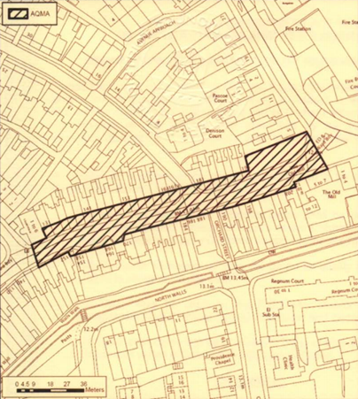

## Description of St Pancras, Chichester AQMA

St Pancras is also part of the A286. Only the Western most section of St Pancras, between Eastgate Square and the junction with New Park Road, is declared an AQMA, the street is one-way traffic flowing West to East and is broadly flat. The AQMA contains mixed residential and retail properties where the ratio of the building heights to road width creates a canyonised street feature. Traffic generally flows freely though is subject to acceleration into the AQMA from being stopped at two pedestrian crossings, exiting East Street and traversing the sharp corner between the Hornet and St Pancras.

**Plan 2:** St Pancras AQMA, Chichester:

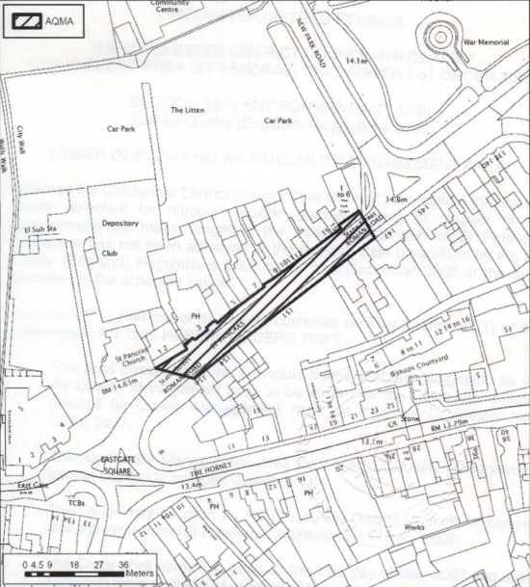

## Description of Stockbridge A27 Roundabout AQMA

Stockbridge roundabout is a four-arm roundabout at the junction of the A286 and A27 and where the junctions are on North-West to South-East and North East to South West axes and the topography is broadly flat. The junction features residential receptor locations in close proximity and a high degree of vehicle acceleration and deceleration in-to and out-of the junction. The junction generally does not feature significant queues but at peak hour does feature queueing. The junction is also the dominant route to the peninsula’s sandy beaches and features significant congestion on sunny ‘beach days’ and when Goodwood is hosting large events which give rise to significant volumes of additional traffic.

**Plan 3:** Stockbridge A27 Roundabout AQMA, Chichester:

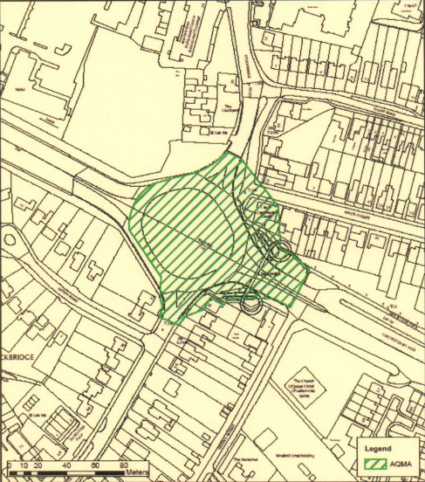

## Description of Rumbold’s Hill, Midhurst AQMA

Rumbold’s Hill is designated as both the A286 and A272 and the AQMA is declared for the full length of Rumbold’s Hill which runs, at its northern end, between North Street, Midhurst and the Petersfield Road and Bepton Road junction at its southern most extent. The road is on a gentle slope rising from it’s northern end to the south and is narrow such that some vehicles are forced to stop to allow on-coming traffic to pass and such that it is a canyonised in relation to the adjacent residential and commercial buildings. Due to the constraints in the highway width, delivery vehicles stopping on North Street, the need for vehicles to stop to allow passage for on-coming vehicles and traffic lights and junctions close to either end of Rumbold’s Hill then there is frequent queuing and stop start traffic.

**Plan 4:** Rumbold’s Hill AQMA, Midhurst:

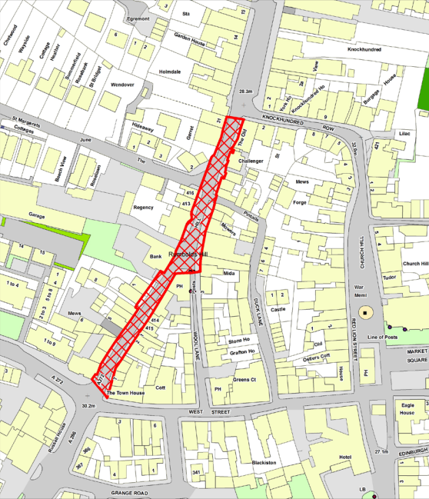

## Relevant exposure locations

The UK’s Air Quality Objectives (AQO) only apply to prescribed locations and for the Annual Mean Standard for NO2 the key location is residential facades. As such table 3 below details the numbers of residential facades within the relevant AQMA boundary.

Table 3: Numbers of residential properties exposed in each AQMA:

|  |  |
| --- | --- |
| **AQMA Location:** | **Number of residential properties exposed:** |
| Stockbridge A27 Roundabout, Chichester | 1 in AQMA (comprising 9 flats) (7 properties abutting) |
| Orchard Street, Chichester | 73 properties (inc 2 properties abutting) |
| St Pancras, Chichester | 32 properties (inc 6 flats and 1 property abutting) |
| Rumbold’s Hill, Midhurst | 25 properties (including 16 flats) 1 property abutting |

# Summary of Air Quality Monitoring in Chichester District:

## Introduction

CDC currently has eighteen air quality monitoring locations using diffusion tubes to monitor Nitrogen Dioxide and four real-time air quality monitoring stations to monitor pollutants as listed in table 4 below:

Table 4: Real-time air quality monitoring stations and the pollutants that they measure

|  |  |
| --- | --- |
| **Air quality monitoring station location:** | **Pollutants measured:** |
| A27 Stockbridge layby[18], Chichester | PM10, NO2 |
| Orchard Street, Chichester | NO2 |
| Westhampnett Road, Chichester | NO2 |
| Lodsworth, Chichester | O3 |

Note: The whole data-set of real-time air quality monitoring data for CDC and all Sussex air quality monitoring stations is available at: <http://www.sussex-air.net/>

Whilst we are appropriately resourced for air quality monitoring we are unable to monitor ‘everywhere’. Over the years we have monitored in many additional locations. In locations where we have found air pollution concentrations to be highly compliant with the Objectives then we have discontinued monitoring there and often redeployed that resource to monitor at other locations of interest.

An annual summary of our air quality monitoring data is reported in the statutorily required Annual Status Report[19] (ASR). This report is submitted to DEFRA who audit the report and our progress on delivery of the AQAP. The ASR includes plans of all monitoring locations.

Air quality monitoring is the pre-eminent evidence in considering local air quality in relation to the UK’s air quality objectives. It tells us what airborne concentrations of pollutants there have been over defined periods, specific to the monitoring locations. CDC has approximately twenty years’ worth of monitoring data and the recent years’ reports are available on CDC’s webpages. This data is the foundation of making an informed policy response to the local air quality challenges that are expressed through the data-set. It was also the principle evidence for the declaration of the AQMAs.

Monitoring in the same locations across time allows us to see trends in the data-set. These trends are important in considering the weight of ‘air quality’ as a policy area and how it influences related policy areas such as land-use planning, highways planning and transport.

Air quality monitoring only tells us about the past, what airborne concentrations of pollutants ‘have been’. Of course our AQAP is all about influencing the future of air quality. As such we need to augment our understanding of past air quality, garnered from our air quality monitoring data, with an understanding of what we predict air quality to do in the future. As such we commissioned a consultancy to provide CDC with air quality modelling expertise. The outputs of the modelling are discussed at section 12 in this report. Nevertheless the air quality model is calibrated by reference to our monitoring data and so again we see the importance of our monitoring data in shaping our understanding of both the past, present and future of Chichester district’s air pollution.

Covid-19 has significantly impacted on economic activity, especially through the mandated lockdown periods. The significantly lower traffic volumes through-out 2020 and into 2021 will impact on air pollution concentrations, nevertheless all of the monitoring data presented in this report is preCovid-19 and therefore unaffected by this consideration.

## Air quality monitoring at ‘background sites’

Broadly speaking air pollution consists of two components; local air pollution, from traffic, industry, bonfires, domestic emissions and agriculture etc – and – a ‘background’ component, which is pollution that may come from many hundreds of miles away and which arrives on the advected air mass, or, more simply put, is pollution blown by the wind from distant locations[20]. It is very difficult to measure only the background pollution but it is possible to monitor in locations where the impact of local pollution is minimal[21]. CDC has two such locations, at North Street, Chichester and Cleveland Road, Chichester where we have long-term diffusion tube monitoring locations. We only have ‘background sites’ for NO2.

Graph i below shows the last nine years’ worth of data from these two locations.

**Graph i:** Urban background air quality monitoring sites (NO2).

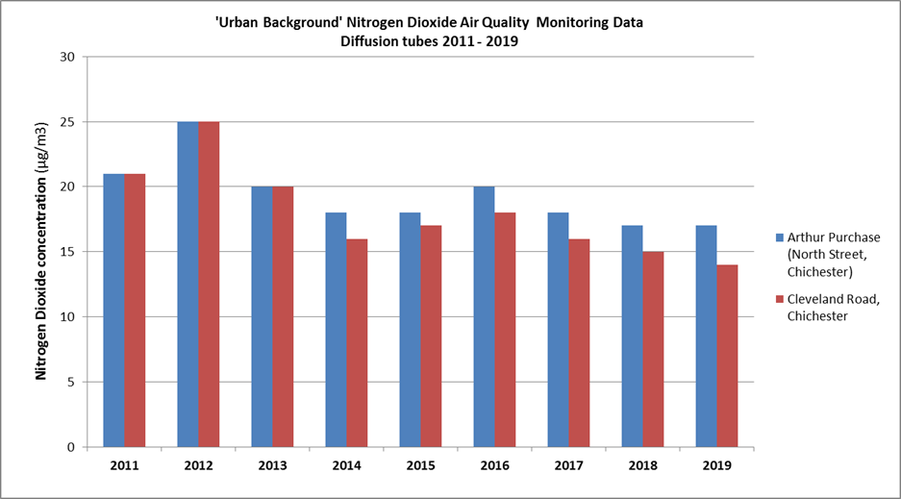

The graph clearly shows a trend of gently, but significantly improving air quality. This is important as it suggests that wider policy measures at a national and international level of government(s) are causing improvements in the air quality that is ‘imported’ into Chichester District. Of course there are many variables at play here but a recent and significant variable is likely to be the impact of Covid-19 on economic output. Whilst there is an increasing de-coupling of economic output and environmental impact, it seems likely that the economic slow-down associated with the Covid-19 pandemic has caused a drop in emissions with a commensurate improvement in air quality. As such it seems probable that local background air pollution concentrations will be sustained or be improved. Nevertheless DEFRA’s predictions for background NO2 concentrations, stated as an average value for Chichester district show a slowing of the improvement in background NO2 levels compared to 2017 – 2021 (see Graph ii). These values are not adjusted for the impact of Covid-19.

**Graph ii**: DEFRA background pollution concentrations 2017 - 2027[22], [23]

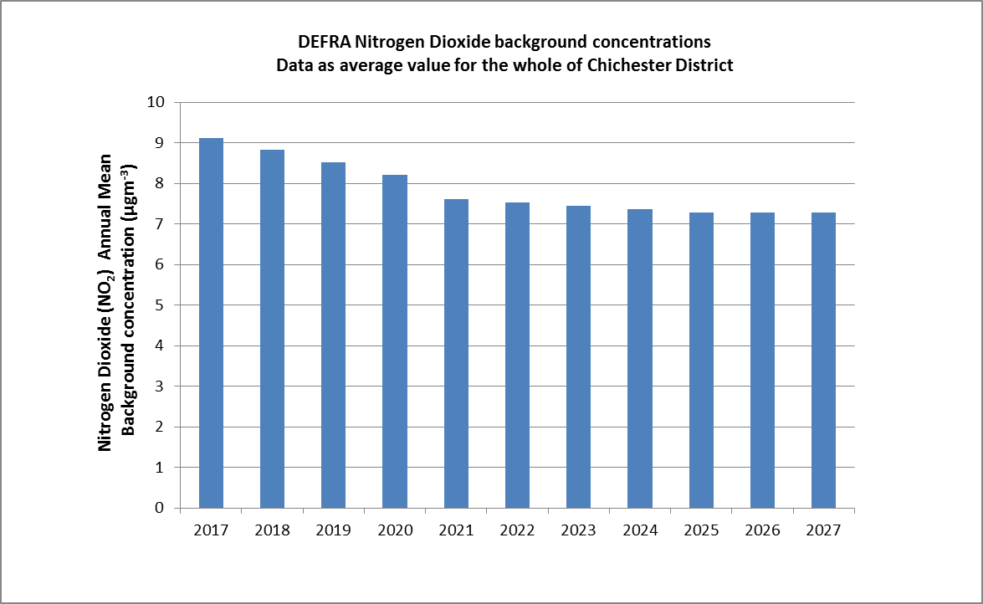

## Nitrogen Dioxide overall data trend

There are many variables that affect air quality monitoring data such that all data is very specific to the location at which it was measured. As such, without detailed scientific analysis of the data, ‘seeing’ trends accurately is fraught with challenges. One way of partially seeing through the ‘noise’ created by these variables is to average all of the available data. Graph iii below illustrates that approach[24].

**Graph iii**: Average of all CDC diffusion tube data 2011 - 2019.

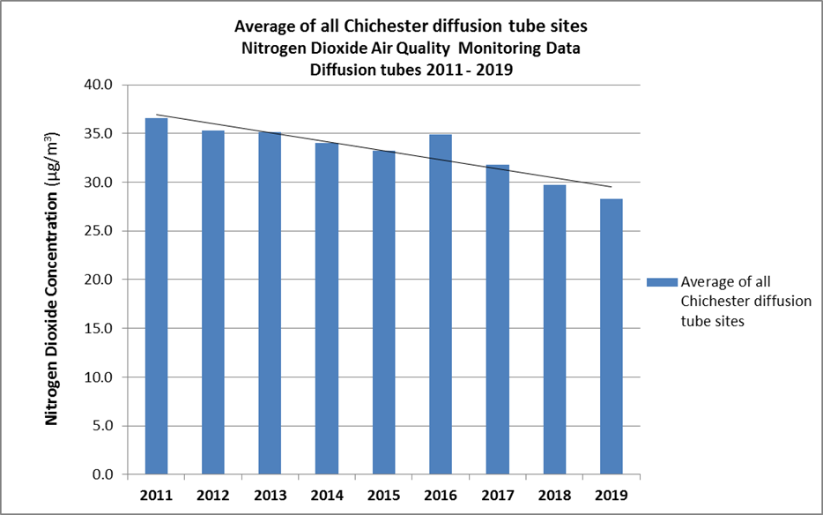

Within its limitations Graph iii suggests a clear trend towards improving air quality (for Nitrogen Dioxide) in Chichester district. Transport and, in particular diesel fuelled road vehicles, are the dominant source of NO2 for our monitoring locations.

This trend is further amplified by the data from the real-time air quality monitoring stations, shown in Graph iv below:

**Graph iv**: Annual mean Nitrogen Dioxide (NO2) concentrations for all air quality monitoring stations

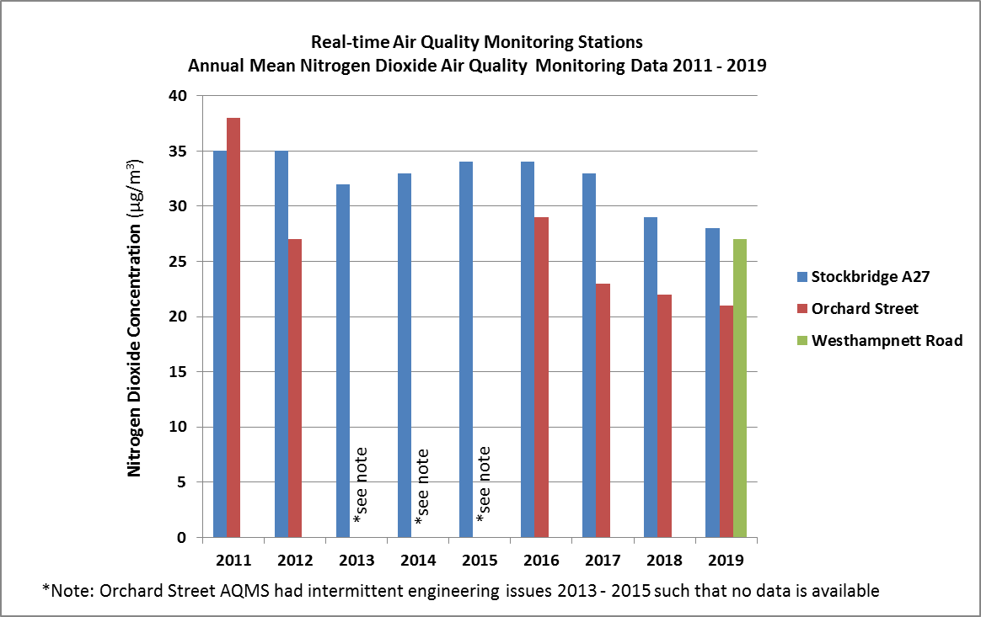

From all air quality monitoring data for NO2 across the period of the previous AQAP 2015 – 2020 it appears that air quality has improved ie NO2 concentrations have decreased.

## Air quality within the AQMAs

### Orchard Street AQMA

CDC has two monitoring locations in Orchard Street, one as a diffusion tube and one as a real-time air quality monitoring station. Data from both monitoring locations is presented in Graph v below:

**Graph v:** All Orchard Street air quality monitoring data 2014 – 2019:

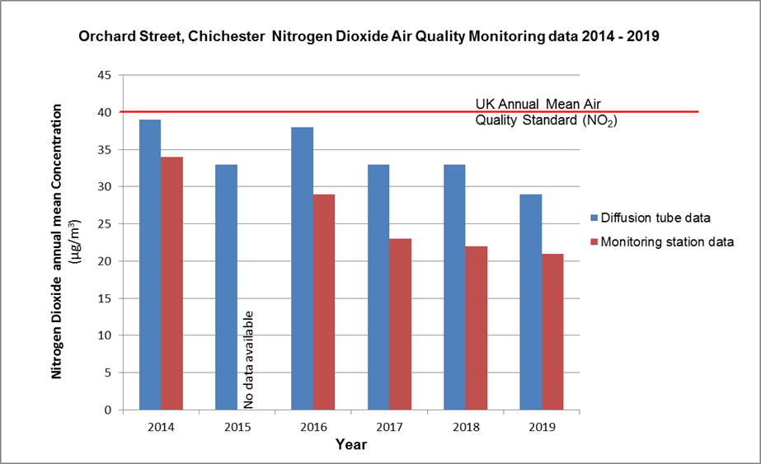

The monitoring data shows clear long-term compliance with significant headroom beneath the standard such that a return to previous concentrations is highly unlikely. As such the monitoring data strongly suggests that the AQMA at Orchard Street is no longer commensurate with the data. On the basis of the monitoring data the AQMA should be ‘un-declared’. This is consistent with CDC’s ASR 2019 and is further discussed at Section 29 of this report in relation to the air quality model’s outputs for future years in this location.

### St Pancras AQMA

CDC has two NO2 monitoring locations in the St Pancras AQMA, one at either end (East and West) and on opposing sides (North and South) of the canyonised section containing the AQMA. Graph vi below shows the monitoring data from this location though the data from only the original monitoring location is shown as the second location is under 12 months old[25].

**Graph vi:** St Pancras air quality monitoring data 2011 – 2019:

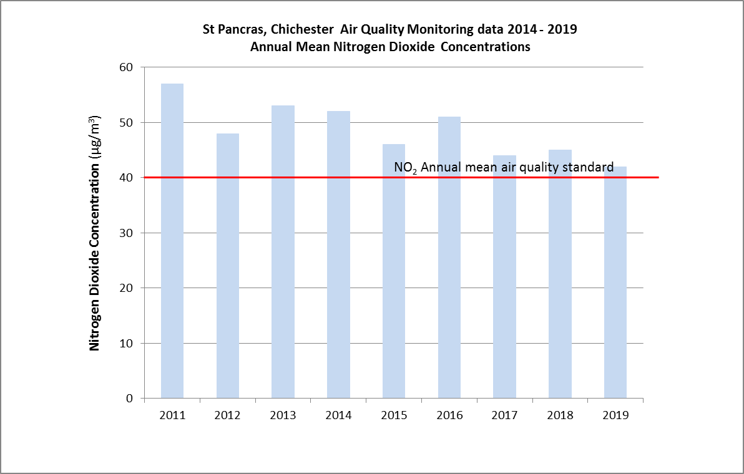

Whilst the monitoring data from St Pancras AQMA shows a trend towards improving air quality it is not yet compliant with the air quality standard. Monitoring will continue in this location in order for us to understand whether the trend of improving air quality ultimately leads to compliance.

### Stockbridge

CDC has four monitoring locations in and around the Stockbridge A27 junction. Four as diffusion tubes and one as a real-time air quality monitoring station[26]. Data from all monitoring locations is presented in Graphs vii to ix below:

**Graph vii:** Stockbridge diffusion tube monitoring data 2011 – 2019:

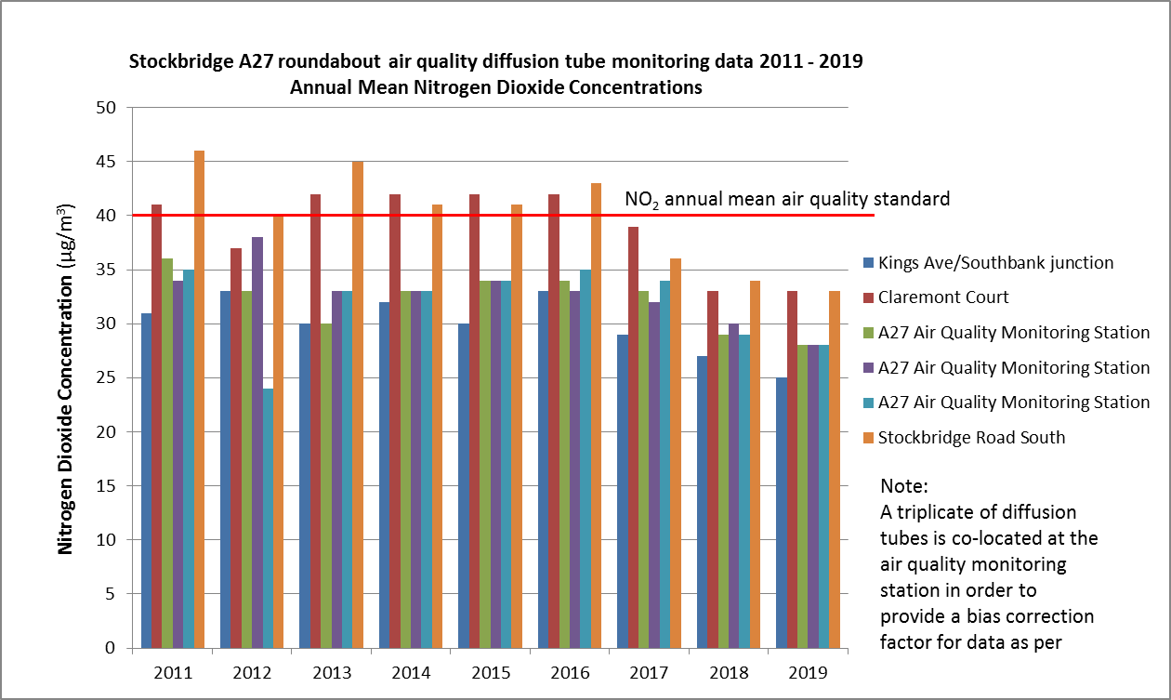

**Graph viii:** Stockbridge annual mean PM10 concentrations 2011 – 2019:

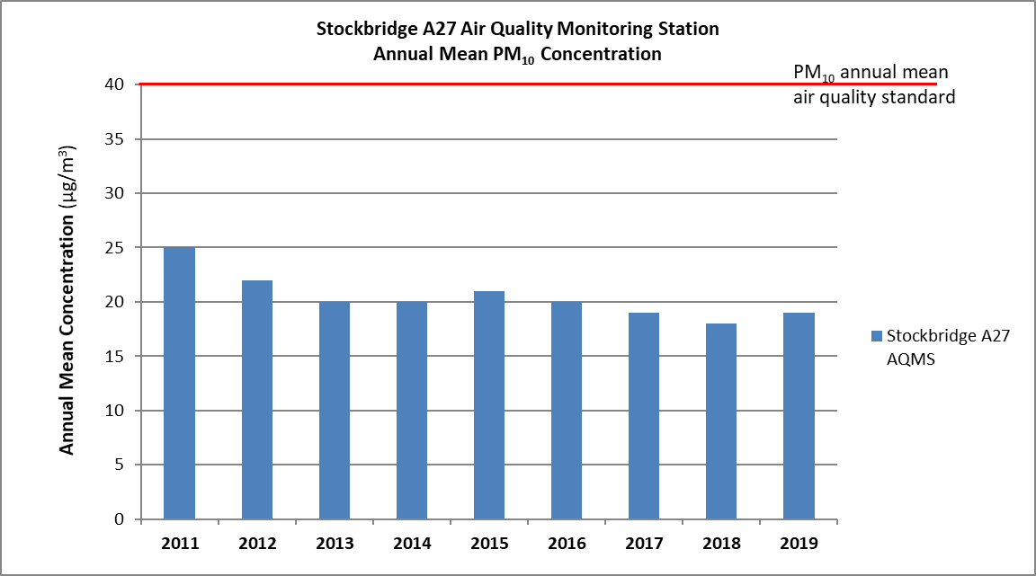

**Graph ix:** Stockbridge PM10 exceedences of the 24-hour mean standard 2011 - 2019:

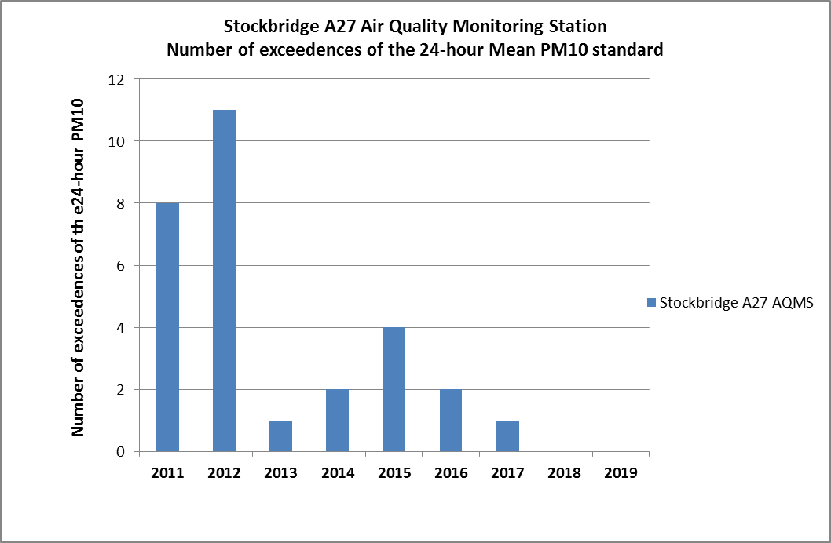

From the monitoring data it is clear that air quality at this location has improved significantly and all Stockbridge monitoring locations have been compliant with the standard since 2017. This commentary is supported by the real-time data for both NO2 and PM10 which show significant improvements 2011 to 2019.

CDC does not monitor PM2.5. Nevertheless we are aware of the importance of this pollutant in relation to public health and note that the Government’s Environment Act commits the UK to adopting an ambient air quality standard for PM2.5. As such the DEFRA guidance provides a methodology for estimating PM2.5 from PM10 monitoring data. Applying this methodology gives us an estimated 2019 annual mean concentration of PM2.5 at the Stockbridge air quality monitoring station (where we monitor PM10) of 13.2µgm-3. This is considered to be a worst-case location for this estimate given the proximity to the A27 with its ~48K annual average daily traffic flow. The calculation for this is presented at Appendix 5. This is comfortably compliant with the annual average EU[27] limit value for PM2.5 of 25µgm-3 as suggested by the Policy Guidance.

Both the monitoring data and modelling data (presented at section 29 below) have been discussed with National Highways (NH) (as the A27 is managed by NH). Officers of both organisations agree that the monitoring data indicates that this AQMA could be un-declared.

### Rumbolds Hill

Rumbolds Hill was declared as an AQMA in January 2020. As such CDC has several monitoring locations there in order to best inform our understanding of air quality there. The two monitoring locations that are both outside of the AQMA (Midhurst Stationery and the British Heart Foundation (BHF)) suggest that the topography of Rumbolds Hill is important in relation to the air quality there. The BHF monitoring site largely carries an identical volume of traffic and yet because it is outside of the narrow streetscape of Rumbolds Hill its air quality is very significantly better.

**Graph x:** Rumbolds Hill air quality monitoring data 2015 - 2019

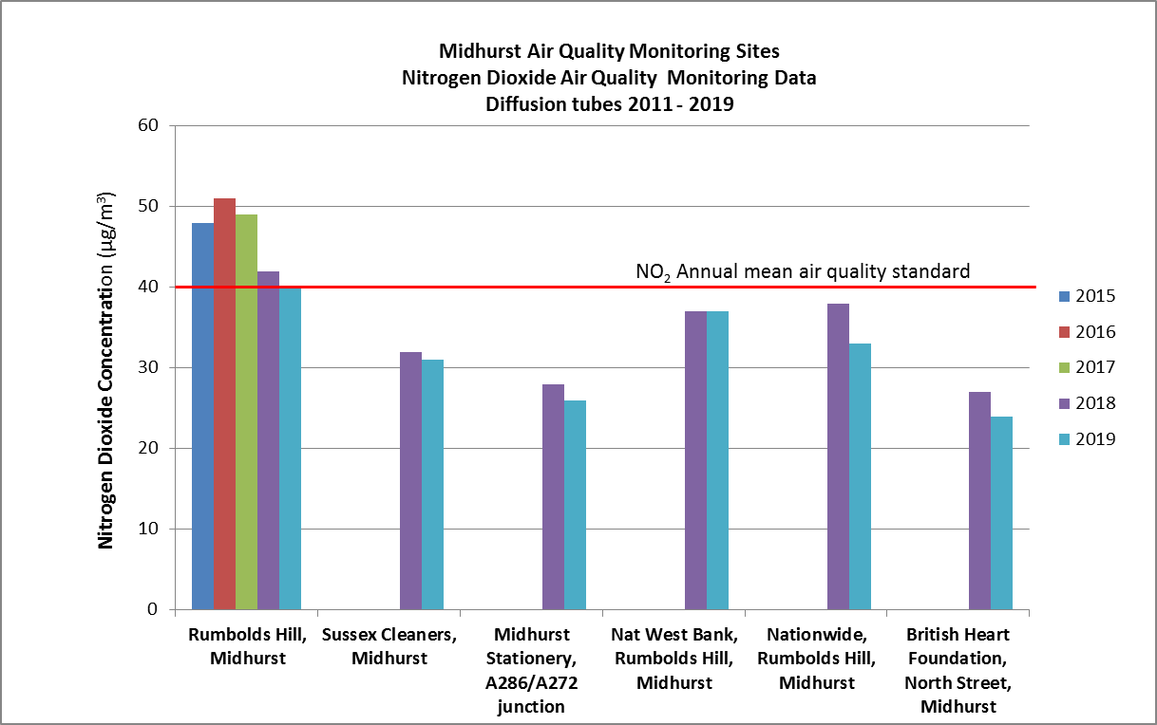

Nevertheless the 2019 air quality data for the long-term diffusion tube site at Rumbolds Hill is borderline compliant with the air quality standard.

# Ozone monitoring

The Council monitor ground-level Ozone at Lodsworth in the north of the district as the pollutant mostly affects rural air quality away from other sources of pollution. Ozone is an important pollutant both in relation to public health, its impact on crop-yields and other eco-system effects. Whilst the National Air Quality Objective for Ozone (see table 5 below) is not part of Local Air Quality Management we have monitored it since 2006[28]. The data at Lodsworth is commonly non-compliant with the Air Quality Objective (see Graph xi below).

There is discussion about this pollutant in relation to the warming climate. As the pollutant is produced by photochemical atmospheric reactions driven by bright sunshine then it is predicted that ground level ozone will worsen due to climate change.

Table 5: National air quality standard for Ozone:

|  |  |  |  |
| --- | --- | --- | --- |
| **Pollutant:** | **Objective:** | **Concentration measured as:** | **Date to be achieved by:** |
| Ozone | 100µgm-3 not to be exceeded more than ten times a year | 8 hour mean | 31 December 2005 |

Nevertheless, given the non-statutory nature of the monitoring it is intended to withdraw from ozone monitoring.

**Graph xi:** Ozone monitoring data from Lodsworth real-time Ozone monitoring station:

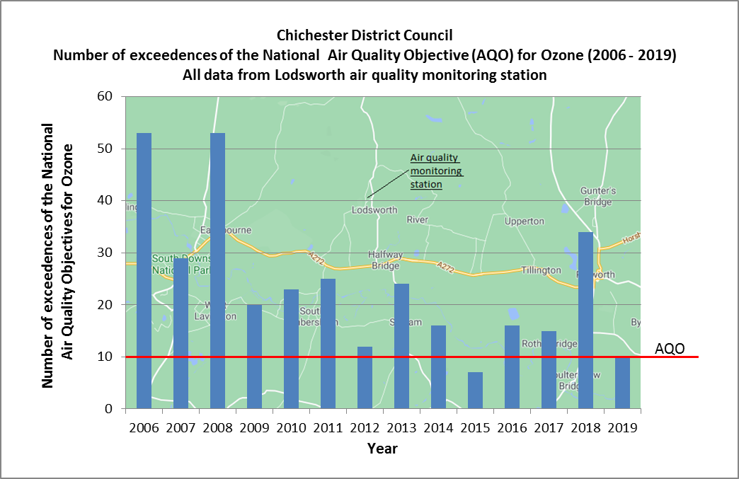

# Air Quality Modelling Data in Chichester District

1. **Introduction**

Air quality modelling is an important tool for air quality scientists as it allows us to predict future air quality for specified pollutants and provide us with a spatial picture of air pollution. This compares to air quality monitoring which informs us about the past and (spatially) only for the monitoring point where the data was collected.

Modelling also allows insights into the sources of pollution that make up the overall burden in any modelled location. This is known as ‘source-apportionment’ and allows for policy makers more discrimination into what sources of pollution are most important. This is evidence upon which we can build a targeted response pointed at the worst polluters on a location by location basis. Furthermore modelling allows us to predict the impact of proposed actions to inform our understanding before we commit our resources to any one action.

CDC does not have an in-house capability for air quality modelling and as such commissioned external consultants to deliver the modelling. The full report is available as a separate document, see website.

**Scope and description of the air quality modelling work**

Our consultant was instructed to provide modelling data for a range of locations for the years 2018, 2020 and 2025. The locations specified were:

The Locations of the AQMAs ie:

* Orchards Street,
* Stockbridge A27 roundabout, Chichester,
* St Pancras, Chichester and
* Rumbold’s Hill, Midhurst.

Additional locations were specified, with the reason for them being specified for modelling provided in brackets, as follows:

* The Hornet, Chichester (the Council’s diffusion tube monitoring data indicated a potential for the site to breach the NO2 annual mean standard),
* Whyke A27 roundabout, Chichester (HE A27 Chichester Bypass Environmental Study Report Appendices (February 2016) detail air quality monitoring that exceeded the NO2 annual mean air quality standard and air quality modelling submitted with planning application reference 19/01286/FUL predicted an annual mean concentration of NO2 for 2019 of 39.6µgm-3).

Modelling was undertaken using software known as the Advanced Dispersion Modelling Software (ADMS Roads). Other details of the modelling approach include:

* The pollutants modelled were; NO2, PM10 and PM2.5 all as annual mean concentrations,
* for the base year 2018 and future years 2020 and 2025,
* predictions for specified property facades in and around the locations specified above,
* using the most relevant meteorological data-set (for Charlwood, 2018),
* using CDC air quality monitoring data,
* using DEFRA background air quality data,
* using WSCC, DfT and NH traffic data and future year growth factors agreed with WSCC,
* using the DEFRA Emissions Factors Toolkit,
* traffic data included 11 categories of vehicles (including bus fleet data supplied by WSCC) and
* the ADMS model was set-up to reflect the urban topography and acceleration and braking of vehicles at junctions.

As per best practice specified in the DEFRA guidance (TG(16)) the model was run for each location and then verified for the baseline year of 2018. This is done by comparing the model’s output predictions for 2018 to the relevant monitoring location’s data. An adjustment factor is then derived which is applied to the model on a location specific basis. The verified model was then run to make predictions as presented below.

Because the traffic data input into the model was broken down into 11 vehicle classes then the ADMS model also provides separate predictions for each class of vehicle. This is known as ‘source apportionment’ and allows for an understanding of the relative contribution of pollution from each vehicle class.

**Baseline model results**

The model output data for a ‘do nothing’ scenario is as presented in Table 6 below:

Table 6: Baseline model output NO2 Chichester locations:

|  |  |  |  |  |  |  |  |
| --- | --- | --- | --- | --- | --- | --- | --- |
|  | **Chichester** | | | | | | |
|  | **NO2 concentration - annual mean (µgm-3)** | | | | | | |
| **Receptor location:** | **2018** | **2020** | **2021** | **2022** | **2023** | **2024** | **2025** |
| **1** | 34.5 | 31.5 | 29.4 | 27.9 | 26.4 | 25.1 | 23.8 |
| **2** | 39.9 | 36.4 | 33.8 | 31.9 | 30.1 | 28.5 | 27.0 |
| **(3,4,5)** | 31.8 | 29.1 | 27.2 | 25.8 | 24.5 | 23.3 | 22.1 |
| **6** | 34.6 | 31.5 | 29.5 | 27.9 | 26.4 | 25.1 | 23.8 |
| **8** | 32.3 | 30.4 | 29.0 | 27.9 | 26.8 | 25.8 | 24.5 |
| **9** | **41.5** | 39.0 | 37.2 | 35.8 | 34.4 | 33.1 | 31.3 |
| **10** | **50.2** | **47.0** | **44.7** | **42.6** | **40.7** | 38.8 | 36.6 |
| **12** | 36.6 | 34.4 | 32.8 | 31.6 | 30.3 | 29.2 | 27.6 |
| **CI1** | 31.8 | 29.1 | 27.2 | 25.8 | 24.5 | 23.3 | 22.1 |
| **CI4** | 24.7 | 23.4 | 22.5 | 21.8 | 21.1 | 20.5 | 19.7 |
| **15** | **40.0** | 37.6 | 35.9 | 34.6 | 33.3 | 32.0 | 30.3 |
| **W1** | **43.5** | 39.5 | 36.8 | 34.8 | 32.9 | 31.2 | 29.5 |
| **W2** | 31.3 | 28.6 | 26.8 | 25.5 | 24.3 | 23.1 | 22.0 |
| **O1** | 30.7 | 28.4 | 26.8 | 25.7 | 24.7 | 23.7 | 22.7 |
| **O2** | **42.4** | 39.0 | 36.6 | 35.0 | 33.4 | 31.9 | 30.3 |

Note: Exceedances of the Air Quality Standard are shown in bold and those within 10% (>36µgm-3) are underlined).

Table 7: Baseline model output NO2 Midhurst locations:

|  |  |  |  |  |  |  |  |
| --- | --- | --- | --- | --- | --- | --- | --- |
|  | **Midhurst** | | | | | | |
|  | **NO2 concentration - annual mean (µgm-3)** | | | | | | |
| **Receptor location:** | **2018** | **2020** | **2021** | **2022** | **2023** | **2024** | **2025** |
| **14** | 39.9 | 36.9 | 35.4 | 33.8 | 32.6 | 31.8 | 29.1 |
| **18** | 36.2 | 33.6 | 32.2 | 30.8 | 29.6 | 28.9 | 26.6 |
| **19** | 37.7 | 34.9 | 33.4 | 32.0 | 30.9 | 30.1 | 27.6 |
| **20** | 34.7 | 32.2 | 30.9 | 29.6 | 28.5 | 27.8 | 25.6 |
| **21** | 32.6 | 30.3 | 29.1 | 27.9 | 26.9 | 26.3 | 24.2 |

Note: Exceedances of the Air Quality Standard are shown in bold and those within 10% (>36µgm-3) are underlined).

The receptor locations in Tables 8 and 9 above are defined as below:

Table 8: Chichester Receptor location descriptions:

|  |  |  |  |  |
| --- | --- | --- | --- | --- |
| **Chichester receptor locations:** | | | | |
| **Receptor ID** | **NGR X** | **NGR Y** | **Location description:** | |
| 1 | 485773.91 | 103960.26 | Kings Ave/ Southbank Junction | Stockbridge Roundabout AQMA |
| 2 | 485771.47 | 103847.47 | Claremont Court | Stockbridge Roundabout AQMA |
| (3,4,5) | 485880.84 | 103791.63 | AQMS on Chichester Bypass (A27) and Stockbridge Roundabout | Stockbridge Roundabout AQMA |
| 6 | 485695.78 | 103730.9 | Stockbridge Rd South (A286) | Stockbridge Roundabout AQMA |
| 8 | 487340.41 | 105474.71 | Westhampnett Rd | - |
| 9 | 486502.25 | 104793.87 | The Hornet | (South of) St Pancras AQMA |
| 10 | 486532.97 | 104860.06 | St Pancras | St Pancras AQMA |
| 12 | 485913.44 | 105186.34 | 174 Orchard St | Orchard St AQMA |
| CI1 | 485880.84 | 103791.63 | Stockbridge, near to the Chichester Bypass and Stockbridge R’about | Stockbridge Roundabout AQMA |
| CI4 | 485981.41 | 105222.45 | Orchard St | Orchard St AQMA |
| 15 | 486575.92 | 104799.25 | 32 The Hornet | (South of) St Pancras AQMA |
| W1 | 486916.28 | 103709.01 | Nursing Home, Whyke Rd (B2135) | NE of Whyke/A27 roundabout |
| W2 | 486843.81 | 103719.1 | 22/23 Whyke Close | NW of Whyke/A27 roundabout |
| O1 | 487745.06 | 105015.62 | Church Rd property | NW of Oving Rd/A27 intersection |
| O2 | 487803.03 | 104975.94 | 187/188 Oving Rd property | SE of Oving Rd/A27 intersection |

Table 9: Midhurst receptor locations:

|  |  |  |  |
| --- | --- | --- | --- |
| **Midhurst receptor locations** | | | |
| **Receptor ID** | **NGR X** | **NGR Y** | **Location description:** |
| 14 | 488559.88 | 121478.29 | Rumbold’s Hill |
| 18 | 488544.69 | 121434.01 | Rumbold’s Hill (Stationary Shop) |
| 19 | 488583.53 | 121511.69 | Rumbold’s Hill (Natwest) |
| 20 | 488601.94 | 121538.76 | Rumbold’s Hill (Nationwide) |
| 21 | 488629.56 | 121614.62 | North Street (BHF) |

The model outputs for PM10 and PM2.5 are not presented here as the modelling output data predicted no exceedance of the short-term or annual-mean standards[29] though the data is available in the air quality model reports[30].

**Baseline model outputs discussion**

The model predicts improving air quality year-on-year to the final years modelled (2025). Full compliance with the UK Air Quality Standards is predicted by 2024 with St Pancras being the last site to comply. The model outputs are all verified against diffusion tube data for 2018, an adjustment factor is then applied to the model such that it accords well with monitored pollution concentrations in the baseline year (2018). The adjusted model performs well i.e. it predicts pollution concentration values close to monitored concentrations. Nevertheless the model verification set-up is such that it predicts for a height of 3m which is the same height as the diffusion tubes’ exposure locations. When the model is run for pollution concentrations for LAQM purposes the pollution concentrations are modelled at a height of 1.5m ie in the breathing zone. Whilst this has not generally caused any anomalies it has caused some model performance issues for St Pancras. Further discussion of this point is as below.

**Orchard Street, Chichester AQMA**

Orchard Street (Receptor location 12) is predicted to continue to have improved air quality and increased compliance with the air quality standard. The modelled data confirms the conclusion that the AQMA is no longer commensurate with the measured and modelled data. As such the AQMA could be undeclared.

**St Pancras, Chichester AQMA**

St Pancras (receptor location 10) is predicted to continue to have improving air quality leading to marginal compliance with the Air Quality Standard in 2024. Nevertheless the modelling does not compare to the monitoring data for this site; the modelled prediction for 2018 is 50.2µgm-3 whereas the diffusion tube result for 2018 is 45 µgm-3, similarly the modelled result for 2019 is 47µgm-3 against the measurement of 42 µgm-3. This apparent discrepancy, not observed to the same degree for other modelled locations, is explained by artefacts in the modelling software. In fact the model verification shows that the model performs well for St Pancras. The apparent discrepancy arises from the model verification being run for a height of 3m, which is the height of the diffusion tube exposure location, whereas the actual model run is for a height of 1.5m, ie the breathing zone. Nevertheless the modelled data’s discrepancy with the monitoring data at 1.5m is large and as such this needs to be borne in mind when designing a proportionate policy response. As such a watching brief is recommended to see how air quality in St Pancras changes in the period of this Plan, though it appears that the modelling here is significantly more pessimistic than the monitoring suggests.

**Stockbridge, Chichester AQMA**

Stockbridge AQMA (receptor locations 1 to 6) is predicted to continue to have improved air quality and significantly increased compliance with the AQS in 2025. This confirms the monitoring data and suggests that the AQMA could be undeclared.

**Rumbolds Hill, Midhurst AQMA**

Rumbolds Hill (receptor locations 14 – 20) is predicted to move from marginal compliance to full compliance at 2025. Again should this modelled trend be borne out in monitoring data then the AQMA could be undeclared.

**The Hornet**

The Hornet (receptor location 9 & 15) is predicted to continue to have improved air quality and move further from being a candidate AQMA with little apparent risk of being declared as an AQMA.

**Whyke A27 roundabout**

Whyke nursing home (receptor location W1) ) is predicted to continue to have improved air quality and move from being a candidate AQMA to compliance with the air quality standard for NO2.

**Oving Road A27 cross-roads**

Oving Road (receptor location O2) is predicted to continue to have improved air quality and move further from being a candidate AQMA.

**Source apportionment results**

Following analysis of the output data from the baseline model source-apportionment (as described in the ‘scope and description’ section above) was carried out for the locations of most concern as modelling indicated their potential to continue to be non-compliant with the NO2 annual mean standard.

Source apportionment was refined for buses as WSCC supplied detail of the operator Stagecoach’s fleet (vehicle type, age and route). No data was available for hackney cabs or licensed private hire vehicles and so their impact on local air quality was not able to be modelled.

Output for source apportionment is for total ‘NOx’ for each location ie not for ‘NO2’. This best represents how vehicles emit this pollution. The sub-species of NOx are then oxidised in the environment to become NO2. The baseline model outputs include source apportionment pie charts for the years 2018, 2020 and 2025. As such readers wishing to see the pie-charts should follow the link from this report to the baseline modelling report, though in any case the summary tables are included in the section that follows.

Note: None of the source apportionment includes background NOx but instead focus is on the local vehicular emission sources. Source apportionment is not carried out for Orchard Street AQMA as the location is now highly compliant with the AQS.

No exceedances of the particulate (PM10 and PM2.5) AQS were identified at any of  
the modelled locations in 2018, 2020 and 2025 and so the data is not presented or discussed in detail in the AQAP but is available in the modelling reports.

Table 10: St Pancras AQMA source apportionment:

|  |  |  |  |
| --- | --- | --- | --- |
|  | **NOx source apportionment** | | |
| **Vehicle type:** | **2018** | **2020** | **2025** |
| **Petrol Cars (%)** | 7.4% | 7.3% | 9.5% |
| **Diesel Cars (%)** | 50.5% | 51.4% | 50.3% |
| **Taxis (%)** | - | - | - |
| **Petrol LGVs (%)** | 0.1% | 0.0% | 0.0% |
| **Diesel LGVs (%)** | 26.6% | 25.9% | 22.6% |
| **Rigid HGVs (%)** | 2.7% | 2.0% | 1.2% |
| **Artic HGVs (%)** | 0.8% | 0.5% | 0.3% |
| **Buses/Coaches (%)** | 11.6% | 12.0% | 13.9% |
| **Motorcycles (%)** | - | - | - |
| **Full Hybrid Petrol Cars (%)** | 0.1% | 0.2% | 0.5% |
| **Plug-In Hybrid Petrol Cars (%)** | 0.0% | 0.0% | 0.1% |
| **Full Hybrid Diesel Cars (%)** | 0.2% | 0.5% | 1.4% |
| **Battery EV Cars (%)** | - | - | - |

Table 11: Stockbridge A27 roundabout source apportionment

|  |  |  |  |
| --- | --- | --- | --- |
|  | **NOx source apportionment** | | |
| **Vehicle type:** | **2018** | **2020** | **2025** |
| **Petrol Cars (%)** | 5.3% | 5.6% | 8.0% |
| **Diesel Cars (%)** | 36.2% | 39.1% | 42.1% |
| **Taxis (%)** | - | - | - |
| **Petrol LGVs (%)** | 0.1% | 0.1% | 0.1% |
| **Diesel LGVs (%)** | 35.9% | 37.1% | 35.5% |
| **Rigid HGVs (%)** | 16.1% | 12.8% | 8.1% |
| **Artic HGVs (%)** | 4.5% | 3.0% | 2.3% |
| **Buses/Coaches (%)** | 1.6% | 1.7% | 2.2% |
| **Motorcycles (%)** | - | - | - |
| **Full Hybrid Petrol Cars (%)** | 0.1% | 0.2% | 0.4% |
| **Plug-In Hybrid Petrol Cars (%)** | 0.0% | 0.0% | 0.1% |
| **Full Hybrid Diesel Cars (%)** | 0.2% | 0.4% | 1.2% |
| **Battery EV Cars (%)** | - | - | - |

Table 12: Rumbold’s Hill AQMA, source apportionment

|  |  |  |  |
| --- | --- | --- | --- |
|  | **NOx source apportionment** | | |
| **Vehicle type:** | **2018** | **2020** | **2025** |
| **Petrol Cars (%)** | 3.3% | 3.3% | 4.4% |
| **Diesel Cars (%)** | 30.6% | 31.8% | 31.6% |
| **Taxis (%)** | - | - | - |
| **Petrol LGVs (%)** | 0.0% | 0.0% | 0.0% |
| **Diesel LGVs (%)** | 20.8% | 20.7% | 18.6% |
| **Rigid HGVs (%)** | 7.0% | 5.4% | 3.3% |
| **Artic HGVs (%)** | 5.5% | 3.8% | 2.8% |
| **Buses/Coaches (%)** | 32.1% | 34.1% | 37.8% |
| **Motorcycles (%)** | 0.2% | 0.2% | 0.2% |
| **Full Hybrid Petrol Cars (%)** | 0.1% | 0.1% | 0.2% |
| **Plug-In Hybrid Petrol Cars (%)** | 0.0% | 0.0% | 0.0% |
| **Full Hybrid Diesel Cars (%)** | 0.1% | 0.3% | 0.9% |
| **Battery EV Cars (%)** | - | - | - |

**Source-apportionment conclusions**

**St Pancras, Chichester AQMA**

NOx emissions from the diesel car and diesel LGV sector dominate the St Pancras  
AQMA location with the ratio of NOx emissions at approx. 77% in 2018 but  
reducing to 73% toward 2025. Bus and coach emissions are lower but significant  
over the period, increasing slightly from 11.6% to 14%. The ratio of HGV emissions  
is relatively small with a decline over this period from approx. 3.5% to 1.5%.

**Stockbridge A27 roundabout, Chichester AQMA**

NOx emissions from the diesel car and diesel LGV sector dominate the Stockbridge  
AQMA /A27 location with the ratio of NOx emissions between approx. 72% to  
77.5% over the period between 2018 and 2025. HGV emissions are significant at  
20.5% in 2018, however reduce to approx. 10.5% by 2025. Bus and coach emissions  
are small in comparison at 1.6% in 2018 and increasing to 2.2% by 2025.There is  
an increase in Hybrid Diesel vehicle emissions as a contribution over the period  
2018 – 2025 with emissions rising from 0.2% to 1.2% by 2025.

**Rumbolds Hill, Midhurst AQMA**

NOx emissions from the Bus, diesel car and diesel LGV sectors dominate the  
Midhurst location with the ratio of NOx emissions at approx. 85% over the period  
between 2018 and 2025. HGV emissions decline as a proportion of the total NOx  
emissions over this period with a reduction from approx. 12.5% to 6%.

**Scenario modelling**

As described above; baseline modelling (presented and discussed above) provides outputs for the future years modelled (2018, 2020 and 2025). The modelling assumption at this point is that no interventions (no air quality actions) are made in an attempt to improve air quality (though the input data includes assumptions about fleet improvements and the number of vehicle movements due to additional housing and a larger local population). The source-apportionment (presented above) allows us to understand how the different classes of vehicles that make up the vehicle fleet contribute pollution to air quality in a specific area. This understanding can assist us in designing interventions that are targeted and proportionate.

To design effective policy it is necessary to focus air quality actions on issues which it is theoretically possible for the Council and its partners to affect. As such the two scenarios chosen for modelling were improved bus emission standards and modal-shift.

For St Pancras and Rumbolds Hill AQMAs buses are identified as significant contributors of NOx at 37.8% and 13.9% of all vehicle emissions respectively.

**Chichester Buses Low Emission Zone Scenario modelling**

WSCC provided details of Stagecoach’s current fleet’s engine standards and an indication of which routes the vehicles were run on. This enabled model runs to establish the predicted NOx contribution from the buses to the St Pancras AQMA and all Chichester receptor locations both with the fleet as existing (baseline) and with the fleet fully upgraded to Euro VI engine standard.

The full details of this scenario are in the air quality modelling ‘Report 2: Scenario Modelling’ see website. For several receptor locations this scenario makes a significant difference in the predicted NO2 concentration compared to the baseline. For The Hornet, St Pancras and Orchard Street the predicted reduction in the annual mean concentration is of the range -2.9 µgm-3 to -3.5µgm-3 at 2021. As such, from a pure air quality perspective this scenario is a priority action for this plan.

**Modal shift scenario**

Modal-shift is getting people out of their cars to greener modes of transport and, where possible, to walk and cycle. Walking and cycling are zero emission forms of transport and are ideal, subject to many variables, for local journeys. AQAPs commonly seek to affect transport mode choice and in particular to promote walking and cycling. As such two modal–shift scenarios, of 2% and 5%, were modelled.

The maximum annual mean NO2 concentration reduction predicted by the 5% modal-shift (to zero emission transport) at 2021 was -0.9 µgm-3 for Chichester and and -0.4 µgm-3 for Midhurst. Nevertheless mode-shift has a multitude of co-benefits for physical health, mental health and climate change and remains a priority for this AQAP.

# Required reductions in emissions

DEFRA require that authorities detail the reduction in emissions required for a location to become compliant with the relevant air quality standard.

**Orchard Street AQMA**

Air quality monitoring data from Orchard Street indicates that air quality at that location has been compliant with the annual mean NO2 standard for over five years. Furthermore the five year trend in air quality there is towards greater compliance and the degree of compliance is now significant.

Air quality modelling data for Orchard Street builds on the evidence from the air quality monitoring and suggests that at 2020 the degree of compliance will be approximately 7 µgm-3 (or 17.5% ) and by 2025 the degree of compliance will be 10µgm-3 (or 25%).

Given the length of time that air quality at Orchard Street has been compliant and the margin of compliance currently and predicted for the future then this AQMA will be undeclared.

**Stockbridge A27 roundabout AQMA**

Worst-case air quality monitoring data from the Stockbridge AQMA indicates that air quality at that location has been compliant with the annual mean NO2 standard for three years. Furthermore the five year trend in air quality there is towards greater compliance and the degree of compliance is now significant.

Air quality modelling data for Stockbridge AQMA builds on the evidence from the air quality monitoring and suggests that at 2020 the degree of compliance will be approximately 10 µgm-3 (or 25% ) and by 2020 the degree of compliance will be 15µgm-3 (or 38%).

Given the length of time that air quality at Stockbridge has been compliant and the comfortable degree of compliance currently and predicted for the future then this AQMA will be undeclared.

**Rumbold’s Hill, Midhurst AQMA**

At the current time Rumbold’s Hill’s air quality monitoring data indicates that air quality there is at parity with the Air Quality Standard. As such air quality at this location is compliant, albeit very marginally. Given the reduction in traffic volumes through the period of Covid-19 then we anticipate that the 2020 monitoring data will not be a reliable metric by which to establish any indication of a trend in pollution concentrations. As such it seems likely that the first data useful in making judgements about pollution trends at this location will be available in the spring of 2022.

In any case the air quality modelling for this location suggests a trend of increasing compliance.

As such there is no required reduction in pollution levels in this location in order to achieve compliance. Nevertheless a watching brief is recommended of a minimum period of four years prior to making any decisions as to whether the AQMA remains or could be un-declared.

**St Pancras AQMA**

Air quality monitoring at St Pancras continues to measure non-compliance with the Annual Mean Standard for Nitrogen Dioxide and air quality modelling suggests borderline compliance at 2025. Nevertheless the model performance issues described above make us more reliant on the monitoring data for this site.

The 2019 - 2020 monitored annual mean for NO2 was 42µgm-3.

**Required Reduction in Emissions for St Pancras**

DEFRA Guidance suggests that AQAPs contain an estimate of the reduction in emissions necessary to deliver compliance with the AQS should be presented in AQAP’s.

The monitoring and modelling data described above shows that only the air quality at St Pancras, Chichester is currently non-compliant and is predicted to be non-compliant until 2025. As such it is only necessary that CDC calculates the reductions in emissions necessary to achieve the AQS for St Pancras, Chichester as all other locations are already compliant, albeit for the case of Rumbolds Hill the compliance is borderline.

The calculation for the reduction necessary at St Pancras, Chichester is presented[31] at Appendix 4 and is calculated as 7.2% decrease in road NOx emissions based on the 2019 diffusion tube measurement made at St Pancras of 42µgm-3 and allowing for a background concentration of 13.87µgm-3 as NOx. This is the reduction in NOx emissions necessary for the air quality at St Pancras to become compliant with the relevant Air Quality Standard (ie 40µgm-3 stated as an annual mean NO2 concentration). The necessary road NOx reduction is useful in the context of the scenario modelling reported above which predicts what is achievable through improved emissions from buses and from transferring car journeys to walking and cycling (‘Smarter Choices’). There are many other sources of NOx and although it was not possible to model these they remain important in seeking to reduce ambient pollution. The private licensed hire fleet and hackney cabs are such an example.

# The Way Forward

Traffic is the dominant source of local air pollution for Chichester and Midhurst (where our AQMAs are located) and so our overall focus is on measures that tackle transport emissions. We are aware that road transport plays a vital role in all of our lives and so the overall approach here is not anti-car but more pro-choice, leadership and fostering change. Like many complex problems there is no single solution but more the aggregation of marginal gains from many measures to assist in tackling the issue. Our priorities should simultaneously assist in tackling climate change/greenhouse gas emissions as we recognise that the two issues of poor air quality and climate change are highly interrelated.

Whilst our AQMAs are all discreet locations in Chichester and Midhurst the effect of air quality actions should be beneficial in tackling air pollution and climate change gases in all locations.

# Conclusions and recommendations from the Monitoring and Modelling

* Move to undeclare Orchard Street and Stockbridge A27 Roundabout AQMAs,
* maintain a watching brief for St Pancras and Rumbolds Hill AQMAs,
* maintain a watching brief for all other locations of interest including; The Hornet, Whyke, A27 roundabout and Oving Road cross-roads,
* Keep Orchard St monitoring station until such time its equipment fails and then it will be decommissioned,
* decommission the real-time ozone monitoring station at Lodsworth and
* develop on-going actions to continue to tackle the remaining issues.

# Air Quality Actions - Key Themes

**Theme 1: Support for development of sustainable transport measures**

A wide range of measures are required to support the development of alternative low emission and low carbon transport, including transport management measures and investing in public transport infrastructure. Many of these measures will be developed in partnership with the WSCC as the Transport Authority.

* We will continue to develop and move to implement our LCWIP.
* WSCC are in the process of considering how they will roll out EV charge points largely for households who do not have the benefit of off-street parking. This work is in conjunction with district and borough councils and we will consider CDC’s position with regard to this work once the full details are known.
* We will continue to seek monies for the delivery of sustainable transport related projects.
* We will support progression of the programme of projects identified by WSCC through the Chichester Area Sustainable Transport Package.
* Consider the implementation of secure bike parking in relevant locations.
* Consider the introduction of bike hire schemes.
* Consider cargo bikes to reduce last-mile delivery emissions and cargo consolidation

**Theme 2: Support for the uptake of low and zero emission vehicles**

This will look at measures such as low emission vehicle infrastructure development to encourage the uptake of electric and other low emission vehicles. This theme will also cover low emissions behaviours such as eco-driving and anti-idling policies.

To foster change towards zero emission vehicles we will:

* Work with WSCC and bus operators to encourage reductions in bus emissions, support the tightening of emissions standards in contracted services and explore funding opportunities to reduce bus emissions.
* Work with the council’s taxi licensing team and wider partners to deliver infrastructure that will support the electrification of hackney cabs and private hire vehicles.
* Work with WSCC and local businesses to explore the development and implementation of a local fleet recognition scheme[32].
* Promote the uptake of EVs by working with our partners to install EV charging infrastructure[33].
* Continue to develop ULEV and ZEV vehicles in our own fleet.
* Work to deliver a pilot pool car fleet for CDC to include ULEV and ZEV vehicles.
* Promote the development of ULEV and ZEV car clubs across the district.
* Promote the understanding of EVs for businesses in the district
* Seek to understand the impact of ZEVs on air quality in Chichester and Midhurst.

**Theme 3: Planning for sustainable transport**

New development provides the opportunity to support sustainable transport both through the form of the development and new infrastructure. This provides the opportunity to use Community Infrastructure Levy (CIL) and Section 106 agreement funding to support wider sustainable and low emission transport projects.

We will seek to strengthen the use of the planning system to further reduce transport emissions as follows:

* Ensure that air quality assessments for new development are appropriate and robust.
* Work with our planning policy team to incorporate robust policies and supporting documentation that encourage the delivery of development that considers and responds to air quality issues and challenges.
* Explore policy measures that require developers to provide investments in and contributions to the delivery of low emission transport projects and measures to off-set emissions both on and off of development sites.
* Seek to associate a GIS layer of aspirational walking and cycle routes with a sustainable transport policy in the Revised Local Plan. The GIS layer will contain routes from CDC and WSCC’s LCWIPs as well as schemes described by WSCC’s Sustainable Transport Package and Local Transport Infrastructure Plan.
* WSCC are in the early stages of rewriting the West Sussex Transport Plan. In conjunction with Sussex-air we will seek to embed air quality policy and considerations within that document and the policies therein.

**Theme 4: Managing the Council's own transport emissions**

The Council must lead by example by reducing emissions from our own transport activities with regards to fleet vehicles, business travel and contracted transport services and deliveries.

* We will continue to work to implement our policy that ‘all new council cars and vans shall be electric unless there is a business case as to why not’.
* Continue to assess our fleet in terms of mileage management and efficient routing of vehicle movements.
* Tackle CDC grey-fleet mileage through delivery of an ULEV and EV pool car fleet for staff business mileage with a view to expanding the fleet after evaluation of the pilot project.
* Encourage staff travel to and from work to be by the most sustainable means through the provision of the Easit scheme and offering the staff benefit of vehicle leasing which most encourages the take up of EVs.
* Deliver a small fleet of electric bikes equipped such that staff can make work related journeys on them.

**Theme 5: Developing partnerships and public education**

By working with key stakeholders we can consider partnerships to share resources and develop wider strategies to deliver greater benefits. We believe that there is the willingness by the public to engage in actions to reduce emissions and CDC relies on partnerships to widen its reach and the possibility of success.

To foster a partnership approach and target our messaging we will:

* Write a communications plan for air quality.
* Consider anti-idling campaigns at locations such as railway level crossings, school gates and bus/coach-stops[34].
* Work with WSCC to promote the incorporation of stop / start technology on buses.
* Continue to be an active member of the pan-Sussex Sussex-air group of local authorities and academics.
* Continue to attend and participate in any WSCC hosted working groups.
* Continue to attend the Chichester and District Cycle Forum.
* Continue to support the Sussex-air ‘Air-alert’ pollution warning system.
* Consider invites to new partnership meetings with relevance to transport emissions.
* In partnership with WSCC consider support for Play Streets

**Theme 6: Miscellaneous projects**

In speaking to councillors and other key interested parties we have received many ideas as to how we might improve air quality.

* Consider declaring Smoke Control Areas which would allow for regulatory oversight for the quality of firewood and stoves being sold. This mainly relates to tackling particulate emissions.
* To include in the Communications Plan for Air Quality a specific thread on domestic burning, bonfires, fire-pits, open-fires and wood burners.
* Greening the council’s procurement policy. In procuring goods and services the council must demonstrate ‘best value’ in its use of public money. Nevertheless ‘green’ related considerations can be considered through the quality considerations of procurement.
* Consider green walls and tree planting to help improve air quality.

# Priorities for Action

The following tables expand on the broad ideas for actions as set out above. Proposed actions are highlighted together with those which are already in progress and/or partially delivered. The majority of all air quality actions for all authorities are subject to funding. As such our list of actions is not prioritised. In our experience the implementation of air quality action is driven by the availability of external grant monies which do not accord with locally set priorities. Once this Plan is adopted then the inclusion of the actions as described below facilitate the Council to seek grant money as and when relevant monies become available. The Council has had some success in accessing grant monies and so we believe that progress toward delivery of the actions below, over the Plan period, is realistic and deliverable.

Notwithstanding the above the modelling (summarised at 12 above) points to the importance of upgrading the Euro standard of the buses and the continued development and expansion of our LCWIP remain of the highest importance to take forwards as finance allows.

Note: monitoring air quality is not mentioned in the action planning tables as below. Nevertheless, subject to the changes suggested in the pages above, air quality monitoring will continue across the district across the period of the AQAP.

Pollution Table 

Pollution table continued

Pollution table continued

Pollution table continued

Pollution table continued

Pollution table continued

Pollution table continued

Pollution table continued

**Development and Implementation of Chichester District AQAP**

In developing this draft for consultation AQAP, we have worked with the local authorities across East and West Sussex, the Environment Agency, to improve local air quality. Schedule 11 of the Environment Act 1995 requires local authorities to consult the bodies listed in Table 13 below.

Table 13: Statutory consultees for the AQAP:

|  |
| --- |
| Consultee: |
| The secretary of State |
| The Environment Agency |
| The Highways Authority |
| All neighbouring local authorities |
| Other public authorities as appropriate |
| Bodies representing local business interests and other organisations as appropriate |

The response to our consultation stakeholder engagement is given in Appendix 1.

**Glossary of terms**

|  |  |
| --- | --- |
| **Abbreviation:** | **Meaning:** |
| AQAP | Air Quality Action Plan |
| AQMA | Air Quality Management Area |
| AQO | Air Quality Standards and Objectives contained in the UK Air Quality Regulations |
| Canyonised | A street where the buildings are tall in relation to its width |
| CDC | Chichester District Council |
| DEFRA | Department of Environment, Food and Rural Affairs |
| DfT | Department for Transport |
| ERG | Environmental Research Group (part of King’s College London) |
| EU | European Union |
| GIS | Geographic Information System – a digital mapping software system |
| Imperial | Imperial College London |
| IPPC | Integrated Pollution Prevention and Control |
| LAQM | The Local Air Quality Management regime |
| LEP | Local Enterprise Partnership |
| LTP | Local Transport Plan |
| Modal-shift | Changing transport modes to greener modes |
| NH | National Highways (who are responsible for the A27 trunk road) |
| NO2 | The pollutant Nitrogen dioxide |
| NOx | The pollutant ‘family’ Oxides of Nitrogen |
| OLEV | Office for Low Emission Vehicles (part of DfT) |
| PM10 | Particulate matter smaller than 10µm in diameter |
| PM2.5 | Particulate matter smaller than 2.5µm in diameter |
| PPB | Parts per billion |
| WSCC | West Sussex County Council |
|  |  |

# Appendix 1: Response to Consultation

See separate reports on website.

# Appendix 2: Reasons for Not Pursuing Action Plan Measures

**Table 14: Action Plan Measures Not Pursued and the Reasons for that Decision**

Table 14: Action Plan Measures Not Pursued and the Reasons for that Decision:

|  |  |  |
| --- | --- | --- |
| **Action Category** | **Action Description** | **Reason Action is not being pursued (including Stakeholder views (WSCC Highways))** |
| Sustainable transport | Provision of electric scooter hire | escooters are not yet legal on the Highway (including the footway). Some of Midhurst’s pavement is unsuitable for escooters (features cobbles). |
| Reviewing parking charges | Differential parking charges to favour EVs | EVs are no longer a novel product and are predicted to reach price point parity within two years. No market subsidy in the form of parking charges is required to now ensure their success. CDC has previously provided free parking and electricity at two 3kW charge points which in 2017 led to complaints about access to the EV charge points (demand out-stripped supply). |
| Highways improvements | Traffic lights at either end of Rumbolds Hill | Potential significant concerns due to knock on impacts on traffic congestion/queuing in Midhurst due to inter-green time for traffic held across at least 3 if not 4 arms of the roundabout (depending on approach to accessing West St) |
| Highways improvements | Widening pinch point on Rumbolds Hill - Nat West Bank currently vacant. | Un-realistic and over-scale for the AQAP especially as air quality is predicted to achieve compliance. |
|  | Re-routing of large HGV’s away from A272. | A272 is part of the West Sussex advisory lorry route network as it is the most appropriate route of those available for HGV movements in the area. |

# Appendix 3: Rumbolds Hill, Air Quality Management Area

**Ideas for inclusion in the Air Quality Action Plan for Midhurst (Chichester District):**

CDC officers attended the Midhurst Vision Group and discussed the AQAP for Midhurst with individual CDC and WSCC councillors and SDNPA officers. Ideas harvested from both those meetings and related correspondence were discussed with WSCC. The resulting air quality actions are listed as below:

1. Car-sharing / car-club
2. Ongoing development and delivery of Midhurst Greenway
3. Promote use of the car parks
4. Employ a traffic consultant to review Rumbolds Hill and Midhurst High Street (for; goods deliveries, potential for cycling on North Street, novel use of space to better manage delivery traffic, placement of street furniture to discourage parking in selected locations, short-term parking on Church Hill by TRO, Review pedestrian crossings’ timing and sequencing, retractable bollards on North Street to prevent people parking in delivery bays, Make Church Hill junction left in left out only and a signed priority system at Rumbolds Hill.
5. Further develop the SDNPA LCWIP for Midhurst (including Jubilee Path informal crossing)
6. Anti-idling campaigns
7. Review parking charges
8. Increase parking enforcement
9. Active travel plan for Midhurst
10. Encourage the use of electric vehicles, cycling and walking

**Ideas proposed by the group but rejected for inclusion in the Air Quality Action Plan:**

|  |  |
| --- | --- |
| **Suggestion:** | **Reason for being rejected for inclusion in the AQAP:** |
| To completely remove all car parking in North Street and only allow deliveries. | Would potentially pose issues for persons with mobility issues. |
| Creation of a town bypass. | Over-scale for the AQAP. |
| Expand North Street car park behind North Street. | It is not clear that this would have any significant benefit for air quality. |
| Traffic lights at either end of Rumbolds Hill | Previously rejected by WSCC Highways. |
| Widening pinch point on Rumbolds Hill - Nat West Bank currently vacant could be compulsorily purchased. | Un-realistic and over-scale for the AQAP. |
| Re-routing of large HGV’s away from A272. | Previously rejected by WSCC Highways. |
| Permissive walking route through Cowdray to connect Easebourne to Midhurst. | This idea requires discussion with the land-owner before it is to be included in a public document. Nevertheless the idea has some merit. |
| e.scooter hire. | escooters are not yet legal on the Highway (including the footway) |
| More parking enforcement. | Beyond the scope of the AQAP. Idea forwarded to CDC Parking Services. This is more of a Parking policy issue. |
| Parking charge amendments to encourage people to park their cars in the car parks and not on North Street. | Idea forwarded to CDC Parking Services. This is a Parking policy issue. |

# Appendix 4: Calculation to determine the Road NOx Emission necessary to achieve compliance at St Pancras, Chichester:

The calculation is made in accordance with the guidance: DEFRA, Local Air Quality Management, Technical Guidance (TG16), April 2016, page 16, Box 7.6 (note the method deviates from the TG(16) but was confirmed by the LAQM Helpdesk 25-11-2020):

**Calculation for 2018 NO2 diffusion tube result:**

Converting the 2018 diffusion tube measurement of 45µgm-3 NO2 to its equivalent NOx value ≡ 72.93µgm-3 NOx (‘Road-NOx-Current’).

NOx background concentration = 13.87 µgm-3 from DEFRA Background maps (using the nearest grid reference to St Pancras, Chichester).

The ‘Road-NOx-Required’ value is calculated as 60.95µgm-3.

The target reduction is then calculated as:

Road-NOx-Current – Road-NOx-Required ie 72.93 – 60.95 = 11.98 µgm-3 or stated as a percentage reduction 11.98/72.93 * 100 = 16.4% decrease.

**Calculation for 2019 NO2 diffusion tube result:**

Converting the 2019 diffusion tube measurement of 42µgm-3 NO2 to its equivalent NOx value ≡ 65.58µgm-3 NOx (‘Road-NOx-Current’).

NOx background concentration = 13.87 µgm-3 from DEFRA Background maps (using the nearest grid reference to St Pancras, Chichester).

The ‘Road-NOx-Required’ value is calculated as 60.88µgm-3.

The target reduction is then calculated as:

Road-NOx-Current – Road-NOx-Required ie 65.58 – 60.88 = 4.7 µgm-3 or stated as a percentage reduction 4.7/65.58 * 100 = 7.2% decrease

The calculations behind the numbers presented here are carried out on a spreadsheet provided by DEFRA.

# Appendix 5: Calculation to estimate PM2.5 concentrations in Chichester District:

The calculation is made in accordance with the guidance: DEFRA, Local Air Quality Management, Technical Guidance (TG16), April 2016, page7-36, Box 7.7:

The nearest PM2.5 and PM10 air quality monitoring station of which we are aware is in Horsham District Council’s Area at Storrington (Location shown in Plan xx below):

**Plan xx**: Horsham District Council PM10 and PM2.5 air quality monitoring location:

|  |
| --- |
| Graph XX |

The TG(16) methodology allows us to apply the ratio between PM2.5 and PM10 at Storrington to the Chichester PM10 data to estimate the PM2.5 concentration at CDC’s air quality monitoring station (ie CDC’s Stockbridge air quality monitoring station derived PM10 concentration). The method applied where all values are as annual-mean concentrations.

Horsham District Council has provided monitoring data from their Storrington air quality monitoring station (the nearest to Chichester) in Table xx below:

Table 15: Horsham air quality monitoring data (PM10 and PM2.5 only):

|  |  |  |  |
| --- | --- | --- | --- |
| Year: | Annual mean PM2.5 concentration (µgm-3): | Annual mean PM10 concentration (µgm-3): | PM2.5/PM10 ratio |
| 2016 | 13.2 | 18.8 | 0.70 |
| 2015 | 11.2 | 15.8 | 0.71 |
| 2014 | 11.3 | N/A | N/A |
| 2013 | 16.6 | 23.0 | 0.72 |
| 2012 | 16.2 | 20.6 | 0.79 |
| 2011 | 15.6 | 22.4 | 0.70 |
| 2010 | 14.5 | 20.4 | 0.71 |

The Horsham DC monitoring station was shut-down after 2017 and so there is no more recent data than presented above. TG(16) allows a generic factor of 0.70 to be used to estimate PM2.5 annual mean concentrations from PM10 annual mean concentrations. In any case it is observed that the TG(16) factor is remarkably similar to the 2013 to 2016 factors derived from Horsham DC’s data.

The ratios are then applied to CDC’s PM10 monitoring data from the Stockbridge air quality monitoring station in order to estimate the PM2.5 concentrations in Chichester District at Stockbridge. Note Stockbridge air quality monitoring station is considered to be a worst-case location for air quality monitoring given it’s proximity to the A27 and related volume of traffic.

Table 16: Estimated PM2.5 concentrations at Stockbridge A27, Chichester:

|  |  |  |  |
| --- | --- | --- | --- |
| Year: | Monitored annual mean PM10 concentration (at Stockbridge A27 AQMS) (µgm-3): | PM10 to PM2.5 conversion factora: | Estimated annual mean PM2.5 concentration (µgm-3): |
| 2019 | 19 | 0.70 | 13.3 |
| 2018 | 18 | 0.70 | 12.6 |
| 2017 | 19 | 0.70 | 13.3 |
| 2016 | 20 | 0.70 | 14.0 |
| 2015 | 21 | 0.71 | 14.9 |

a 2019, 2018 factors are from TG(16), page 7-36, paragraph 7.109; 2015 to 2017 factors are derived from Horsham DC data as detailed above.

**References:**

|  |
| --- |
| Air Pollution and Street Play 2017, Playing Out |
| Annual Status Report 2020 |
| Breathing Better; a partnership approach to improving air quality in West Sussex, May 2018 |
| Chichester Air Quality Action Plan Review – 2020, Report 1: Baseline modelling update (2020), August 2020 |
| Chichester Air Quality Action Plan Review – 2020, Report 2: Scenario modelling, August 2020 |
| LAQM PG(16), DEFRA |
| LAQM TG(16), DEFRA |
| West Sussex Transport Plan |

1. <https://www.chichester.gov.uk/pollutioncontrolairquality>
2. <https://uk-air.defra.gov.uk/assets/documents/National_air_quality_objectives.pdf>
3. <https://www.chichester.gov.uk/pollutioncontrolairquality>
4. Objectives for other pollutants are not included here are air quality is compliant with them in Chichester and largely so across the UK.
5. <https://assets.publishing.service.gov.uk/government/uploads/system/uploads/attachment_data/file/770715/clean-air-strategy-2019.pdf>
6. See the Section on the Environment Bill.
7. The Guidance is yet to be updated for the removal of EU references.
8. See Appendix 5 which suggests that CDC’s air quality meets that standard, in the worst case location, by a large margin.
9. Burning wood and coal in open fires and stoves makes up 38% of the UK’s primary emissions of fine particulate matter (PM2.5).
10. <https://fingertips.phe.org.uk/search/particulate#page/0/gid/1/pat/6/par/E12000008/ati/101/are/E07000225/cid/4/page-options/ovw-do-0>
11. Range 5% Chichester to 6.5% Dartford.
12. <https://sussex-air.net/ImprovingAQ/Default.aspx>
13. <https://www.westsussex.gov.uk/media/14787/climate_change_strategy_2020-2030.pdf>
14. <https://www.westsussex.gov.uk/roads-and-travel/travel-and-public-transport/travelwise-sustainable-transport/electric-vehicles/>
15. <http://www.sussex-air.net/Reports/SussexAQGuidanceV.12020.pdf>
16. As two separate awards of £70K and £61K.
17. All AQMA plans are taken from the plan on the declaration Order at: <https://www.chichester.gov.uk/pollutioncontrolairquality>
18. East of Stockbridge A27 roundabout and AQMA on the north of the A27.
19. <https://www.chichester.gov.uk/pollutioncontrolairquality>
20. Some pollution changes its chemical and/or physical form during that journey. For instance some gaseous emissions turn into small particles (for example PM2.5), some mixtures of gases react to form new gases (for example Ozone) and some particles join together to form bigger particles or simply drop-out of the air stream through a variety of mechanisms.
21. Note: from a scientific point of view these monitoring locations are not measuring purely background pollution but they are classified as ‘urban background sites’ in accordance with DEFRA guidance for LAQM purposes.
22. Data from: <https://uk-air.defra.gov.uk/data/laqm-background-maps?year=2011>
23. Data range for 2019 6.94 to 15.86µgm-3.
24. Note that the data is only averaged for the monitoring sites that have existed across the whole period (Kings Avenue/Southbank Junction, Claremont Court, A27 air quality monitoring station, Stockbridge Road South, Cleveland Road, Westhampnett Road, The Hornet, St Pancras, Arthur Purchase North Street, St Pancras, Orchard Street) .
25. At the time of writing the 2019 ASR.
26. where three diffusion tubes are co-located in order to provide a performance check on the data they provide, known as a bias correction factor.
27. The Guidance is yet to be updated for the removal of EU references.
28. The capital cost of installing the station was funded by European grant money as part of a Sussex-air Interreg project.
29. The model out-puts for particulates (PM10 and PM2.5) are included in the full modelling report appendices.
30. See Appendix D Table D.2.
31. The calculation is made in accordance with DEFRA Guidance TG(16), page 7-35, Box 7.6.
32. One such scheme is Eco-stars <https://www.ecostars-uk.com/>
33. CDC currently has a watching brief for the installation of EV charging points where we are monitoring the usage statistics of our current network before they suggest that further installations should be considered.
34. Where buses and/or coaches might sit idling for extended periods.