

2017 Air Quality Annual Status Report (ASR)

In fulfilment of Part IV of the

Environment Act 1995

Local Air Quality Management

June 2017

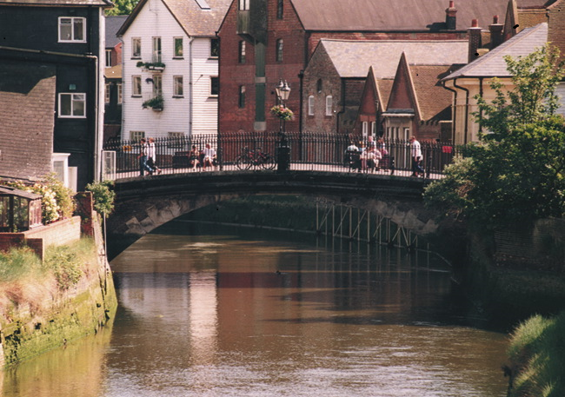

|  |  |
| --- | --- |
| Local Authority Officer | Melissa Bomford |
| Department | Environmental Health |
| Address | Lewes District Council,  Southover House,  Southover Road,  Lewes,  East Sussex, BN7 1AB |
| Telephone | 01273 471600 x5428 |
| E-mail | Melissa.bomford@lewes.gov.uk |
| Report Reference number | ASR LDC2016 |
| Date | June 2017 |

# Executive Summary: Air Quality in Our Area

## Air Quality in Lewes District Council

Air pollution is associated with a number of adverse health impacts. It is recognised as a contributing factor in the onset of heart disease and cancer. Additionally, air pollution particularly affects the most vulnerable in society: children and older people, and those with heart and lung conditions. There is also often a strong correlation with equalities issues, because areas with poor air quality are also often the less affluent areas[1],[2].

The annual health cost to society of the impacts of particulate matter alone in the UK is estimated to be around £16 billion[3]. Improving air quality can benefit those who may find their conditions are made worse through exposure to air pollution, for example people with heart or lung conditions. More information about the health effects of air pollution can be found at: <http://www.lewes.gov.uk/environment/824.asp>

The fraction of mortality attributed to particulate air pollution in Lewes District Council is lower than that calculated for south east England and England as a whole.

However, in urbanised areas such as Lewes and Newhaven, nitrogen dioxide concentrations were measured above annual objective concentrations and Air Quality Management Areas (AQMAs) were declared in June 2005 and July 2014, respectively. Air Quality Action Plans were put in place (Lewes, May 2009 and Newhaven, June 2016) to manage the reduction in air pollution and air quality monitoring stations established to assess the impact of the measures put forward by the action plans. In 2016, nitrogen dioxide monitoring took place at forty locations throughout the Lewes District Council area. Concentrations above the 40 µg/m3 annual objective concentration were still observed in both AQMAs. However, when corrected for fall-off of NO2 concentration away from the kerb[4] the concentrations drop below the annual objective concentration. Over the last 5 years (see Appendix A, Table A.3), NO2 annual means for Fisher Street and Station Street have shown some reduction in readings. Nitrogen dioxide concentration measurements should continue within the AQMAs to monitor progress of the respective action plans in reducing air pollution. The Lewes Town Centre AQMA also has a continuous automatic monitoring station situated within it, measuring: NO, NO2, NOx and particulates (PM10).

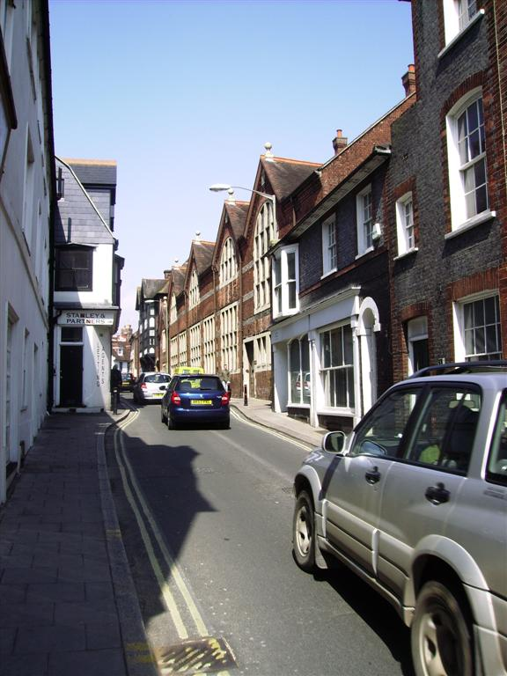 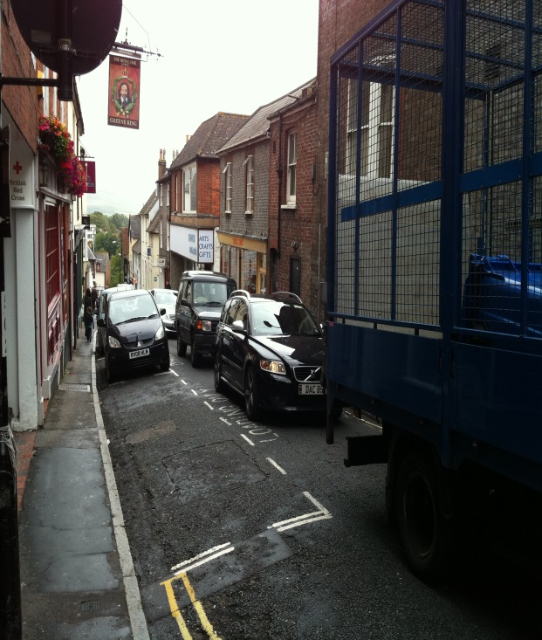

Figure 1 & 2: Fisher Street and Station Street in the Lewes Town Centre AQMA. Illustrates the historic narrow roads where vehicle pollutants can often get trapped

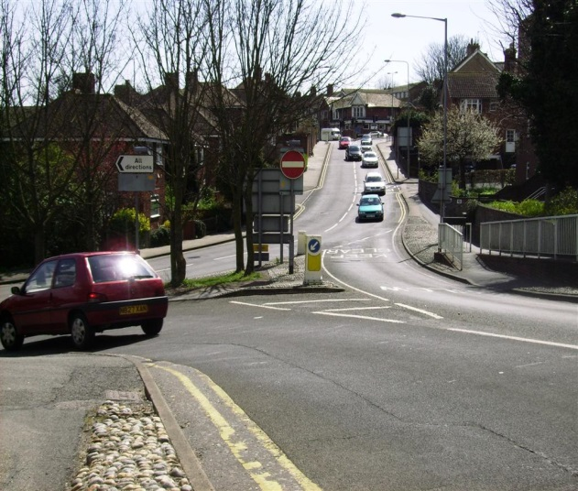 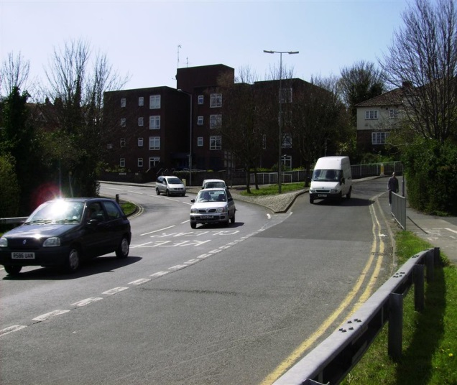

Figure 3 & 4: A259 Newhaven Ring Road AQMA. This area is frequently clogged with traffic particularly during rush hour and when the swing bridge is in operation.

For a full list of all countrywide council AQMA’s please follow this link: <http://uk-air.defra.gov.uk/aqma/list>

For both Lewes Town Centre and A259 Newhaven Ring Road AQMA’s please click on following link/s:

<https://laqm.defra.gov.uk/images/aqma_maps/404_lewes_town_centre_aqma.jpg.jpg>

<https://laqm.defra.gov.uk/images/aqma_maps/newhaven-aqma-2014.jpg>

## Actions to Improve Air Quality

Lewes District Council has taken forward a number of initiatives during the current reporting year of 2016 in pursuit of improving local air quality. Although funding for improvements is always an issue, East Sussex County Council (ESCC) managed to secure funding to deliver cycling and walking projects. Other measures can be found in Section 2.21 and 2.2.2 and Table 2.2

## Conclusions and Priorities

In order to fulfil its goal in producing quantifiable outcomes to appropriate timescales, Lewes District Council will work closely and in collaboration with all its delivery partners, such as ESCC. Collaborative working is vital e.g. reviewing, updating and implementing measures regarding Air Quality Action Plan (AQAP)’s.

The AQAP for Lewes requires reviewing and updating. This process has just started. It was delayed pending outcomes of large planning applications for the North Street Quarter. Consent has been completed and the first phase of construction will commence this year (2017). All AQAP’s should be seen as live documents and reviewed as necessary.

## Local Engagement and How to get Involved

*How can you be involved?*

By everyone ‘doing their bit’ we can all help to improve the environment we live. Have you thought about changing the way you travel? Instead of getting into your vehicle – could you catch a train or a bus? Could you cycle or walk? Not only does this give the added benefit of exercise but it can also improve general health and well-being. Use alternative routes to get from A to B. Instead of walking or cycling along a major road, use alternative quieter and less polluted routes.

*Idling engines: Did you know?*

If you are waiting outside school to pick up children or you are parked and stationery/waiting/loading or unloading your vehicle – turn the engine off!

Vehicle idling causes air pollution and engines should not be left running unnecessarily. Breathing polluted air is not only extremely unpleasant but is also detrimental to our health. Exhaust emissions contain a range of air pollutants such as carbon monoxide, nitrogen dioxide and particulate matter. Air quality is as important as exercise and diet for health. Reducing air pollutants can help reduce respiratory problems, heart disease, lung cancer and asthma attacks.

Turning off and restarting an engine after 1 minute causes less pollution then keeping the engine running. Idling wastes more fuel and therefore costs more money. Modern vehicle batteries need less engine running time to stay charged. It can take up to an hour for an engine to cool down, so turning off an engine but keeping the ignition and fan blowing will provide warm air for some time. Idling an engine will not keep a catalytic converter warm. They retain their heat for approximately 25 minutes after the engine is switched off. **So cut engine, cut pollution!**

When buying a new or second hand vehicle/s consider newer cleaner models. Have a good look at the vehicles emission credentials before buying.

There are various organisations and clubs which offer help and advice on getting active, for example: Sustrans: <http://www.sustrans.org.uk/what-you-can-do> Bikeability: <http://bikeability.org.uk/> programmes – involving schools and workplaces (cycling and walking activities).

Details, including local air quality monitoring data, annual air quality reports and the impact air quality may have on health can be found on the [Sussex-air website](http://www.sussex-air.net/PollutionEffects/AQHealth/Default.aspx). Sussex-air also runs the airAlert service providing warnings to people with respiratory and cardiovascular conditions, health professionals and carers in Sussex. The service is free to register/subscribe to and anyone can join. Alerts are sent direct to the airAlert app, email, mobile phone via text message or home phone. Sussex-air also provides a free coldAlert service – providing extreme cold weather warnings and information. Both airAlert and coldAlert are provided as a free service by the Sussex Air Quality Partnership and supported by the Public Health Bodies (East Sussex & West Sussex County Council). Further information can be found: [www.sussex-air.net](http://www.sussex-air.net) or telephone 01273 484337.

**Table of Contents**

Executive Summary: Air Quality in Our Area 1

Air Quality in Lewes District Council 1

Actions to Improve Air Quality 3

Conclusions and Priorities 3

Local Engagement and How to get Involved 3

1 Local Air Quality Management 7

2 Actions to Improve Air Quality 8

2.1 Air Quality Management Areas 8

2.2 Progress and Impact of Measures to address Air Quality in Lewes District

Council 10

2.3 PM2.5 – Local Authority Approach to Reducing Emissions and/or Concentrations 21

3 Air Quality Monitoring Data and Comparison with Air Quality Objectives and National Compliance 22

3.1 Summary of Monitoring Undertaken 22

3.1.1 Automatic Monitoring Sites 22

3.1.2 Non-Automatic Monitoring Sites 23

3.2 Individual Pollutants 23

3.2.1 Nitrogen Dioxide (NO2) 24

3.2.2 Particulate Matter (PM10) 28

Appendix A: Monitoring Results 30

Appendix B: Full Monthly Diffusion Tube Results for 2016 43

Appendix C: Supporting Technical Information / Air Quality Monitoring Data QA/QC 48

Appendix D: Map(s) of Monitoring Locations and AQMAs 52

Appendix E: Summary of Air Quality Objectives in England 55

Glossary of Terms 56

References 57

**List of Tables**

Table 2.1 - Declared Air Quality Management Areas 9

Table 2.2 – Progress on Measures to Improve Air Quality 15

Table C.1 – Sites where the annual mean of 40µg/m3 for NO2 has been exceeded and has been corrected for distance to receptor………………………………………..50

**List of Figures including graphs and photographs**

Figure 1 and 2 – Photographs of Fisher Street and Station Street in Lewes AQMA 2

Figure 3 and 4 – Photographs of part of the A259 Newhaven Ring Road AQMA 2

Figure 5 and 6 – Location of Lewes and Newhaven AQMA 8

Figure 7 – Fraction of mortality attributed to particulate air pollution in Lewes District area….……………………………………………………………………………………….21

Figure 8 – Annual average NO2 concentration in µg/m3 measured at automatic monitoring sites in Lewes district 2012-2016……………………………………………23

Figure 9 – Annual average NO2 concentration (diffusion tubes) in Lewes district from 2012-2016: Sites 1-10………………………………………………………………….…..24

Figure 10 - Annual average NO2 concentration (diffusion tubes) in Lewes district from 2012-2016: Sites 11-20……..………………………...…………………………………...25

Figure 11 - Annual average NO2 concentration (diffusion tubes) in Lewes district from 2012-2016: Sites 21-30 ……………………………………..…………………………….26

Figure 12 - Annual average NO2 concentration (diffusion tubes) in Lewes district from 2012-2016: Sites 31-40 …………………………………..……………………………….27

Figure 13 – Annual average PM10 concentration measured at LS5 Lewes Town West Street and LS6 Denton Community Centre (Automatic Monitoring sites) 2012-16…28

Figure 14 – Number of exceedances of the 50µg/m3 daily average at LS5 Lewes Town West Street and LS6 Denton Community Centre (Automatic Monitoring sites) 2012-2016…………………………………………………………………………………...29

Figure 15 – National Diffusion Tube Bias Adjustment Factor Spreadsheet 2016…..49

# Local Air Quality Management

This report provides an overview of air quality in Lewes District Council during 2016. It fulfils the requirements of Local Air Quality Management (LAQM) as set out in Part IV of the Environment Act (1995) and the relevant Policy and Technical Guidance documents.

The LAQM process places an obligation on all local authorities to regularly review and assess air quality in their areas, and to determine whether or not the air quality objectives are likely to be achieved. Where an exceedance is considered likely the local authority must declare an Air Quality Management Area (AQMA) and prepare an Air Quality Action Plan (AQAP) setting out the measures it intends to put in place in pursuit of the objectives. This Annual Status Report (ASR) is an annual requirement showing the strategies employed by Lewes District Council to improve air quality and any progress that has been made.

The statutory air quality objectives applicable to LAQM in England can be found in Table E.1 inAppendix E.

# Actions to Improve Air Quality

## Air Quality Management Areas

Air Quality Management Areas (AQMAs) are declared when there is an exceedance or likely exceedance of an air quality objective. After declaration, the authority must prepare an Air Quality Action Plan (AQAP) within 12-18 months setting out measures it intends to put in place in pursuit of compliance with the objectives.

A summary of AQMAs declared by Lewes District Council can be found in Table 2.1. Further information related to declared or revoked AQMAs, including maps of AQMA boundaries are available online at:

<https://uk-air.defra.gov.uk/aqma/details?aqma_id=78>

<https://uk-air.defra.gov.uk/aqma/details?aqma_id=1055>

Also, see Appendix D: Map(s) of Monitoring Locations and AQMAs, which provides for a map of air quality monitoring locations in relation to the AQMA(s).

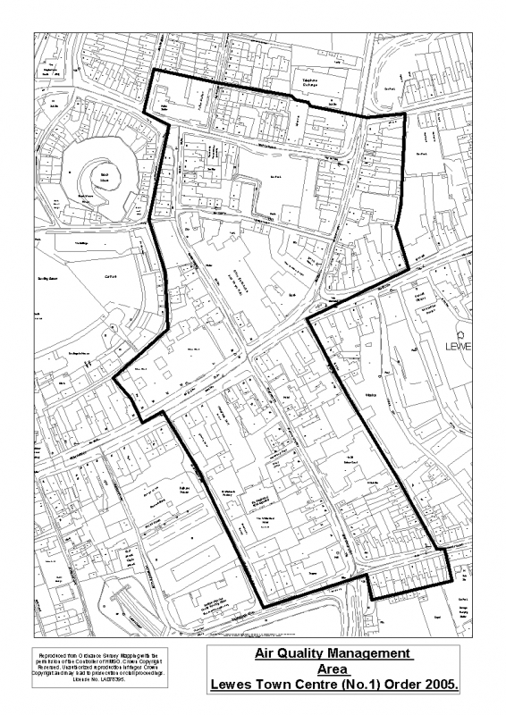[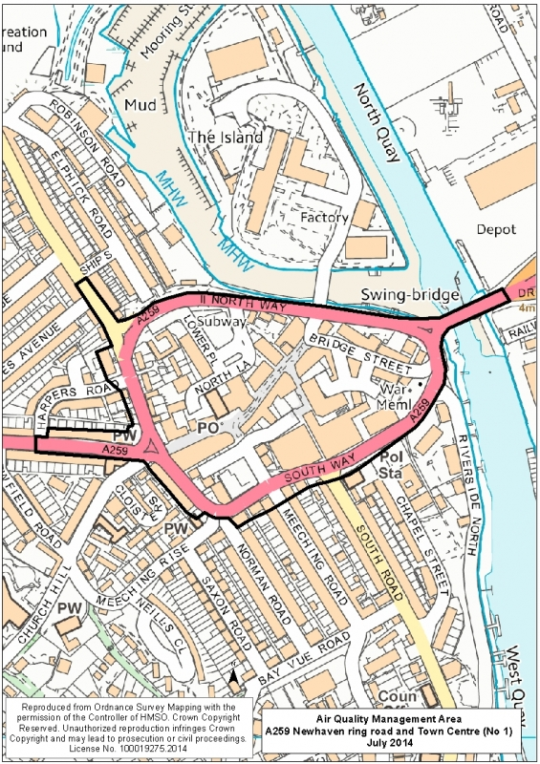](https://uk-air.defra.gov.uk/images/aqma_maps/newhaven-aqma-2014.jpg)

Figures 5 and 6: Lewes Town AQMA and A259 Newhaven Ring Road AQMA

Table .1 – Declared Air Quality Management Areas

|  |  |  |  |  |  |  |  |  |
| --- | --- | --- | --- | --- | --- | --- | --- | --- |
| **AQMA Name** | **Date of Declaration** | **Pollutants and Air Quality Objectives** | **City / Town** | **One Line Description** | **Is air quality in the AQMA influenced by roads controlled by Highways England?** | **Level of Exceedance (maximum monitored/modelled concentration at a location of relevant exposure)** | | **Action Plan (incl. date of publication)** |
| **At Declaration** | **Now** |
| Lewes Town Centre | 30.06.05 | NO2 Annual Mean | Lewes | An area encompassing a section of Lewes Town Centre extending north to the old police station, south to St Andrews Place | NO | 53ug/m3 | 43ug/m3 | http://www.lewes.gov.uk/Files/air_quality_action_plan_may_2009.pdf (May 2009) |
| A259 Newhaven Ring Road | 16.07.14 | NO2 Annual Mean | Newhaven | Incorporates Newhaven Town Centre, Southway, Northway and sections of the A259 Brighton Road, Lewes Road and the swing bridge | NO | 49ug/m3 | 49ug/m3 | http://www.lewes.gov.uk/Files/Newhaven_Air_Quality_Action_Plan.pdf (June 2016) |

**Lewes District Council confirm the information on UK-Air regarding their AQMA(s) is up to date**

## 

## Progress and Impact of Measures to address Air Quality in Lewes District Council

### Lewes Town Centre AQMA

Lewes District Council has taken forward a number of direct measures during the current reporting year of 2017 in pursuit of improving local air quality. Details of completed measures, those in progress or planned are set out in Table 2.2 and additional plans mentioned below.

The Lewes District Local Plan5, Part 1 Joint Core Strategy 2010-2030 (May 2016) includes Core Policy 9 – Air Quality: Link below

<http://www.lewes.gov.uk/Files/plan_Adopted_JCS_with_front_cover.pdf>

Its key strategic objectives are: *‘reducing the need for travel and to promote a sustainable system of transport and land use for people who live, work, study in and visit the district’* and *‘to ensure the district reduces locally contributing causes of climate change and is pro-active regarding climate change initiatives’*.

In brief: Local planning must have regard to AQMA areas and AQAP’s. Planning must ensure applications for developments: provide mitigation measures where traffic may adversely affect an AQMA, ensure development will not have a negative impact on the surrounding area in terms of its health, promote opportunities for walking, cycling and public transport and congestion management to reduce traffic levels in areas of reduced air quality and secure best methods to reduce levels of dust and other pollutants arising from construction.

The current Air Quality Action Plan for Lewes Town Centre can be found on this link: <http://www.lewes.gov.uk/Files/air_quality_action_plan_may_2009.pdf>

Table 2.2 illustrates some of the improvements already completed in Lewes Town Centre and further around the district. An example is measure 1 (Table 2.2) the change in priority of traffic flow appears to have contributed to the reduction of NO2 emissions in Fisher Street, 3 sites (See Appendix A, Table A.3).

A few other completed measures which should aid air quality mentioned in the Lewes Town Centre AQAP:

* Pedestrianized improvements on Station Street
* Establishment of 20 mph speed limits in and around parts of Lewes
* Creation of pedestrian zone in Cliffe High Street
* Lewes Railway Station Forecourt scheme completed (including bike storage)
* Ringmer to Lewes cycle route (encourage cycling between the two locations safely and therefore reduce vehicle use)

Other infrastructure schemes planned/or in design phase for this coming year 2017/18 in Lewes: (e.g. encourage walking/cycling – more safety)

* A controlled pedestrian crossing facility on Offham Road, Lewes - this is

a main road and currently there is nowhere safe for children to cross. By having this crossing hopefully more children will be able to walk to school and vehicles less likely to speed

* Zebra crossing facility on Church Lane adjacent to Malling Primary school
* Controlled pedestrian crossing facility on Brighton Road
* Improved bus stop facilities on A277 near Winterbourne Hollow

The ESCC Local Transport Plan6 – Implementation Plan 2016/17-2020-21 and Local Transport Plan 3 2011-2026 identifies the importance of various improvements to key walking and cycling corridors (e.g. improving signs for cycle Regional Route 90), focussing on improvements to public transport corridors, better use of technology e.g. Real Time Bus Information and charging points for electric vehicles. Further information can be found on: <https://www.eastsussex.gov.uk/roadsandtransport/localtransportplan>

The Lewes AQAP was completed in 2009 but has been delayed in reviewing pending outcomes of large planning applications for North Street Quarter (NSQ). The first phase of the NSQ is due to begin shortly. The Lewes AQAP review has begun.

**2.2.2 A259 Newhaven Ring Road AQMA**

Following the declaration of an Air Quality Management Area in July 2014 for the centre of Newhaven, an Air Quality Action Plan was prepared to address the high concentrations of nitrogen dioxide (NO2) which people are exposed to alongside the busy roads in the centre of Newhaven. Road transport is the main source of emissions relating to NO2, and particularly diesel vehicles in stop- start traffic which

6 ESCC Local Transport Plan – Implementation Plan 2016/17-2020-21 & LTP3 2011-2026

make the biggest contribution resulting in higher emissions. The AQAP has seven broad areas of action to help deliver better air quality, with specific measures then identified for each of these actions areas. The categories of action are as follows:

Action 1: Enable the use of sustainable travel choices through the delivery of transport infrastructure and initiatives

Action 2: Actively promote low emission vehicles and supporting infrastructure.

Action 3: Use the planning system to ensure that air quality is fully considered for new development.

Action 4: Use traffic management to reduce emissions within the AQMA.

Action 5: Work with Public Health colleagues to inform the public about health impacts of Air Pollution and how they can change behaviour to reduce emissions and reduce exposure.

Action 6: Continue to monitor and assess air quality in line with Government guidance on Local Air Quality Management (LAQM).

Action 7: Target point sources in Newhaven Town Centre

The above actions are evaluated in terms of their impact on:

* Air quality
* Cost & feasibility
* Timescale for implementation

The delivery of the Newhaven Action Plan is dependent on resourcing, both capital costs and staffing. Currently increases in traffic around the ring road are likely assuming planned development for Newhaven proceeds. Any improvements made will therefore be challenged by an increase in vehicles due to new developments. The plan can be found on this link:

<http://www.lewes.gov.uk/Files/Newhaven_Air_Quality_Action_Plan.pdf>

East Sussex County Council were successful in gaining funding from the *Active Access for Growth Programme* and will be focused on delivering cycling and walking initiatives in some of the county growth areas – one of them including Newhaven. A few of the ‘menu’ initiatives include: Pedal Power – cycle/electric cycle loan schemes, Living Streets – Active Travel Maps, East Sussex Wheels 2 Work, Sustrans – Active Steps scheme and Student led Walking and Cycling campaigns.

Other infrastructure schemes planned/or in design phase for this coming year 2017/18 in Newhaven: (e.g. encourage cycling/use of transport)

* Provision of new cycle stands at key locations in Newhaven town centre
* Shared pedestrian/cycle route in Avis Road area of Newhaven to National Cycling Route 2
* Installation of bus shelter on A259 between Newhaven & Peacehaven as part of wider shared pedestrian/cycle route scheme

The ESCC Local Transport Plan6 – Implementation Plan 2016/17-2020-21 and Local Transport Plan 3 2011-2026 identifies that Newhaven is a key growth area. ESCC seek to deliver sustainable economic growth. A few points; in brief, creating a transport interchange facility at Newhaven Town station to improve integration between rail, bus and other transport modes, reviewing the Ring Road layout and phasing of lights to improve traffic flow, and improvements to bus route network into and within Newhaven, particularly the A259 corridor.

The principal challenges to implementation of air quality improvements that Lewes District Council face, are firstly, obtaining necessary funding for various projects (e.g. education package to take into primary schools and updating continuous monitoring analysers). However, funding is not the only challenge – e.g. awaiting direction from central government on dealing with diesel vehicles, how quickly can/will company vehicle fleets change to cleaner vehicles? Tackling vehicle idling, changing people’s behaviour on their travel choices and linking of cycle routes to encourage and make cycling safer. In Newhaven, for example, the need for economic regeneration places pressure on air quality and the environment. There is significant investment in the Port area (following approval for a deep water berth at the harbour mouth) – which should grow the ferry service for both freight and passenger travel between Newhaven and Dieppe. Investment will also entail increased business premises and new homes in the Newhaven area, which in turn will increase traffic loading to the Ring Road. Careful planning measures will be required.

Whilst the measures stated above and in Table 2.2 will help to contribute towards compliance, Lewes District Council anticipates that further additional measures not yet prescribed will be required in subsequent years to achieve compliance and enable the revocation of Lewes Town Centre and Newhaven A259 Ring Road AQMA’s.

Table .2 – Progress on Measures to Improve Air Quality

|  |  |  |  |  |  |  |  |  |  |  |  |
| --- | --- | --- | --- | --- | --- | --- | --- | --- | --- | --- | --- |
| **Measure No.** | **Measure** | **EU Category** | **EU Classification** | **Organisations involved and Funding Source** | **Planning Phase** | **Implementation Phase** | **Key Performance Indicator** | **Reduction in Pollutant / Emission from Measure** | **Progress to Date** | **Estimated / Actual Completion Date** | **Comments / Barriers to implementation** |
| 1 | White Hill / Fisher Street / West street scheme (LTP) - Change of priority at Commercial Square to improve flow in Fisher Street; review traffic signals at Station Street; greater priority to pedestrians. Two phases: (a) Experimental change in junction priority (b) Formalise priority working including other works in the area | Traffic Management | UTC, Congestion management, traffic reduction | East Sussex County Council | Completed | Completed | NO2 | 4-6.5 ug/m3 or 9-12% red in NO2 (Fisher Street) Some air quality benefits will be achieved from the experimental scheme | Completed | Completed | Early indications a reduction in NO2 |
| 2 | Beddingham Crossing (LTP) - Rebuilding the Southerham and Beddingham roundabouts on the A27 outside Lewes and a new railway bridge to avoid queuing at Beddingham rail crossing. | Traffic Management | UTC, Congestion management, traffic reduction | Highways Agency | Completed | Completed | Traffic Count | None | Completed | Completed | Reduced congestion & emissions on A27 (potential increase in traffic through town likely during construction phase. Longer term better traffic flow so reduced traffic flow through Lewes. |
| 3 | Lewes Town Centre 20mph zone - Provision of 20mph area in addition to the existing 20mph Zone. Will include majority of the AQMA. | Traffic Management | Reduction of speed limits, 20mph zones | East Sussex County Council | Completed | Completed | Traffic Count/NO2/CO2 | None | Completed | Completed | Wider Impacts: Safety, walking, cycling, congestion |
| 4 | Phoenix roundabout and Eastgate bus priority (LTP) - introduce a roundabout at the Phoenix Causeway and two-way traffic for Eastgate Street; create a bus priority lane and introduce pedestrian and cycle friendly features. | Traffic Management | Strategic highway improvements, Re-prioritising road space away from cars, inc Access management, Selective vehicle priority, bus priority, high vehicle occupancy lane | East Sussex County Council & South Downs National Park | Yes | Long Term S.106 Linked | Traffic Count | None | Scheme funding was reliant on large redevelopment and associated s106 monies. Development proposal shelved. Now in communication with new developer considering shared space and two way junction for Waitrose site | Unknown | Any reduction could be offset by increased traffic generated from Phoenix development. Project is a development lead opportunity. |
| 5 | The Living Cliffe (LTP) - Creation of pedestrian zone in Cliffe High Street with restricted vehicular access. Introduction of 20mph zone to vehicles allowed to enter the zone (e.g. for deliveries) | Traffic Management | Strategic highway improvements, Re-prioritising road space away from cars, inc Access management, Selective vehicle priority, bus priority, high vehicle occupancy lane | East Sussex County Council | Completed | Completed | Traffic Count | None | Completed | Completed | Existing through-traffic in Cliffe High Street will tend to go across Phoenix Causeway via School Hill and Market Street until Phoenix Roundabout scheme is implemented. Improved safety, walking & cycling facilities, reduced impact of car outside the AQMA |
| 6 | Offham Road Pedestrian Priority Scheme (LTP) Improvement to pedestrian facilities and vehicle speed management. | Traffic Management | Reduction of speed limits, 20mph zones | East Sussex County Council | Completed | Partially Completed | Traffic Counts | None | Mini roundabout at The Avenue and Offham Road construction completed in August 2010. Remaining construction on hold due to funding constraints | Unknown | Improved safety, walking & cycling facilities, reduced impact of car outside the AQMA |
| 7 | Ringmer –Lewes cycleway (LTP) - Introduction of off-road cycleway on the Lewes-Ringmer road link – heavily used by commuters from Ringmer to the Town Centre. Scheme split into two, (a) Phase 1 (Eastern section), (b) Phase 2 (Western section) | Transport Planning and Infrastructure | Cycle network | East Sussex County Council | Completed | Partially Completed | Traffic Counts | None | Eastern section design completed, land negotiations closed and 600 metre completed 2010. Western section design work progressed in 2012/13. Funding now secured for construction by March 2015. | 01/03/2015 | Route very near completion, should encourage long term modal shift. |
| 8 | Lewes Railway Station Forecourt Scheme (LTP) Improved facilities for pedestrian, buses and taxis | Transport Planning and Infrastructure | Public transport improvements-interchanges stations and services | East Sussex County Council | Completed | Partially Completed | Increased use of sustainable transport modes | None | LSTF monies have allowed options to be explored and identify next design steps. New 150 covered bike storage to be installed in 2015. Public consultation “Lewes steps forward” consultation ion options undertaken in October 2013 | End 2015 | Ownership and repairs to bridge have delayed any progress. Should encourage modal shift |
| 9 | Target local freight distribution a) Work with local business & freight operators to collate relevant data (i.e. delivery times, parking issues) b) Encourage deliveries outside congested periods) Provide eco-driving training d) Investigate production of local “delivery maps” e) Increase or reallocate loading bays | Freight and Delivery Management | Route Management Plans/ Strategic routing strategy for HGV's | LDC | No | No | Traffic Counts | None | None | None | Potential redevelopment of large areas of Lewes envisaged in medium term should provide opportunity for engagement of non-statutory stakeholders, use of non-mandatory agreements |
| 10 | Better coordination of building and road works in the Lewes town area (LTP+) - Enhance existing LTP scheme to include building works and haulage route management | Policy Guidance and Development Control | Other policy | East Sussex County Council | Completed | Completed | Number of agreements and s.61 agreements | None | Informal p-partnership working between ESCC and LDC and also through the planning process and s61 agreements. | Ongoing | Improved flow resulting from better management of deliveries to sites. So emissions reduced in Lewes AQMA. |
| 11 | Target long-distance freight management & heavy traffic through town (LTP+) a) Intensification of existing LTP programmes b) Review signage on weight restrictions at access road links | Freight and Delivery Management | Route Management Plans/ Strategic routing strategy for HGV's | East Sussex County Council | Yes | No | Traffic Counts | None | ESCC started investigation into freight movement and impacts on town | Unknown | Linkage to M10. Reduction in HGV since Beddingham improvements completed (M2) |
| 12 | Reduce emissions from idling vehicles a) Install “cut engine cut pollution” signs (i.e. schools, taxi & bus terminals) b) Raise awareness through eco-driving campaign c) investigate enforcing legislation (issue fines) | Traffic Management | Anti-idling enforcement | LDC | Completed | Yes | NO2/Participation/Enforcements | None | None | Unknown | Public engagement work targeting schools has been carried out. LDC drivers have attended eco-driving session. LDC may not have monitoring in the areas of Lewes where the idling vehicle work is undertaken as such emissions reductions may have to be calculated rather than measured. |
| 13 | Vehicle Emission Testing in central Lewes to measure vehicles emissions at pollution hotspots, supermarkets, car parks a) Carry out VOSA roadside emission testing (RET) b) Use of remote sensing technology | Traffic Management | Testing Vehicle Emissions | LDC | Yes | No | Test Results | None | No further action unlikely to be taken forward due to the increased deliverability and benefit of LEZ. | Unknown | None |
| 14 | Lewes Parking Management (LTP+) - Intensification of existing/planned LTP programmes a) extension of parking controlled area b) re-allocation of parking/loading spaces c) higher charges for long stay parking d) higher charges for residents second parking permits e) discounted permits for low-emission vehicles f) introduce car spaces for low-emission vehicles, car-clubs and car share g) maintain/increase provision of two-wheelers parking | Traffic Management | Other | East Sussex County Council | No | Yes | reduced traffic and congestion at peak time, reduced re-circulation, reduced emissions; and modal shift and sustainable travel behaviour | None | Parking review and consultation undertaken 2013. c) New charges at longer stay car parks d) Residents permits now limited with new build *f) 4 off street car park spaces provided for community car club. 2 EV charging bays now installed at Lewes railway station Investigating the provision of a low emission car park within the AQMA to include preferential parking. | Unknown | None |
| 15 | Review of Lewes car parking system (LTP+) - a) Reallocation of existing car parks to reduce create a network of “park & walk” sites outside the AQMA b) Dedicated Short (3) and long stay car parks outside AQMA c) Installation of signage (i.e. with directions to car-parks) at access points to town | Traffic Management | Workplace Parking Levy, Parking Enforcement on highway | LDC | Yes | No | Reduction of veh/km & congestion | None | LDC Planning have carried out an off street parking provision study (options for managing future demand and supply for off street parking) this will feed into the Local Development Framework. All off street cars parks have been audited and changes to short and long term designation. Further feasibility work to be undertaken relating to low emission public P and D. | Unknown | Will reduce vehicle "churn" in the Lewes AQMA. |
| 16 | Partnership work with bus & train operators (LTP+) a) Reduce emissions: calculate emissions from existing bus fleet, route/fleet management (i.e. only cleaner vehicles through AQMA), eco-driving training b) Increase bus and train patronage: through supporting marketing campaign, extend use of subsidised/discounted fares, improve bus connection to key area, bus stop facilities, bus information c) Provision of additional undercover cycle parking at Lewes station | Vehicle Fleet Efficiency | Driver training and ECO driving aids | LDC | No | Yes | accessibility, awareness | None | a) Brighton and Hove bus drivers are now eco trained, preparing scheme to target other operators. New generation of LE buses starting to penetrate smaller fleets. b) LSTF monies invested in real time bus information on key routes through Lewes. In addition a travel choices marketing campaign will be delivered promoting bus and train patronage. c) New 150 space secure cycle hub to be installed at Lewes train station with card entry system. LDC now working and part of the Sussex community rail partnership current projects include route guide. | Unknown | Long term modal shift from car to bus. |
| 17 | Lewes Town Travel Plans (LTP+) - a) Review existing County & District Travel Plans b) Accelerate implementation of workplace travel plans c) Accelerating implementation/review of local school travel plans (including colleges) d) Link to other actions (i.e. school monitoring projects, cycling and car-sharing promotion) e) Target shorter journeys – investigate personal travel planning marketing | Promoting Travel Alternatives | Other | LDC | Completed | Yes | lead by example, change in travel behaviour, education, awareness | None | a) LDC travel plan currently being reprioritised with a number of actions agreed by CMT including reduction in kgCo2/KM allowance on contract cars to 120. b) LSTF monies have allowed employment of SUSTRANS officers for both school and workplace. Including support in delivery of revised workplace travel plans. e) Investigated Sustrans campaign model but not progressing at this stage. | None | Encouragement of modal shift and appropriate use of cars at workplace. |
| 18 | Car-sharing (LTP+) - Support LTP car-sharing & “travel-choice” campaign in Lewes town (i.e. through travel plans and ad-hoc events). | Promoting Travel Alternatives | Intensive active travel campaign & infrastructure | East Sussex County Council | Completed | Yes | Travel Behaviour | None | LSTF monies being used to enable a rebrand and new focus. | Unknown | Modal shift |
| 19 | Car clubs - a) Support existing club in Lewes town (i.e. marketing) b) Accelerate introduction of new clubs c) Provide parking locations for car parks (Require car-clubs for large new developments – M21) | Alternatives to private vehicle use | Car Clubs | LDC | No | Yes | Usage of Carclub | None | 2 vehicles launched July 2010. Four Cars in Lewes as of February 2015. | None | Modal shift and appropriate use of lower emission vehicles within and around the AQMA. |
| 20 | Walking and cycling (LTP+) - a) Accelerate implementation of LTP actions within Lewes town (i.e. improvement to existing cycle routes, identify new ones, improve signage and facilities) b) Promoting walking and cycling as a healthy and more preferable option to car for local journeys c) Promotion through travel plans, one-off events, “TravelChoice” campaign | Promoting Travel Alternatives | Intensive active travel campaign & infrastructure | East Sussex County Council | No | Yes | Delivery of LTP Actions | None | a) Work and school cycle challenge delivered September 2010. 2012 and 2013. Will run again in 2014 Full details at www.lovetoride/lewes. Cycle storage audit undertaken in Lewes and15 new sites identified for new storage provision. Installation Summer 2014. LSTF monies being used to improve National cycle route 2 through Lewes town. b) Cycle Lewes Map reprinted and redesign in 2012 continues to be distributed through outlets, now 20,000 copies in circulation. LSTF monies to promote. c) Lewes Hike and Bike festival to be delivered for second year, co funded with ESCC and SDNP. | None | Modal shift and long term habit forming intervention. |
| 21 | Better control of impact of new developments - a) Facilitate funding from S106 agreement b) Conditions to require reduced parking allocation, completion of Sustainability Checklist; travel plans for large developments and inclusion of pedestrian & sustainable transport facilities such as car-club dedicated car spaces and bus lanes | Alternatives to private vehicle use | Car Clubs | LDC | No | Yes | Number of s.61 agreements | None | a) Sustainable accessibility s106 agreements secured on numerous applications including increased car club provision. b) Conditions and sustainability checklist completed on all large planning applications including provision of car club by developer for town centre development. Car club policy note drafted to secure funding from developers for additional car club cars. | None | Modal shift and integration of new developments into the urban landscape to enable pedestrian access throughout the town. |
| 22 | Greater planning controls within or near the AQMA for new developments or applications a) Stricter conditions limiting permitted uses and changes of use for new applications b) Request detailed air quality assessment for developments affecting AQMA. c)Encourage the uptake of Low emission strategies by developers d) Investigate production of supplementary guidance notes on air quality for new developments | Policy Guidance and Development Control | Regional Groups Co-ordinating programmes to develop Area wide Strategies to reduce emissions and improve air quality | LDC | Yes | Yes | Planning Conditions and Guidance Production | None | a)LDC officers consulted on all planning applications, good awareness of AQMA including training session. b)AQ assessments requested for developments affecting AQMA | None | Sussex-air Guidance enables quantification of air quality impacts (health) and emissions mitigation options for new developments |
| 23 | Intensify promotion of national schemes on domestic heating and energy efficiency - Increase promotion of scheme aimed to improve insulation, replace/service boilers, encourage energy efficiency in the Town Centre | Promoting Low Emission Plant | Other | LDC | Completed | Yes | CO2/NO2 Reduction | None | 93.80 tonnes of CO2 annual saving from cavity wall and loft insulation based on 178 installs in Lewes Town from Insulation Campaign and My Home 2012. | Unknown | Reduction in point source emission within and around the AQMA from non-transport domestic sources. |
| 24 | Continue investing in new technologies and pilot projects through the LDC Waste & Recycling a) Electric vehicles for recycling fleet b) NOx reducing additive for HGV diesels c) Eco-driving training d) Route management (GPRS) e) Monitoring of fuel use & efficiency | Vehicle Fleet Efficiency | Other | LDC | No | Yes | Fuel Usage/Maintenance Records | None | a)Fleet being maintained b)NOx additive still used c)Eco driver training for operatives d)All vehicles GPRS controlled e)All fuel use monitored | Ongoing | Reduction of LDC fleet emissions in the AQMA. LDC is in the top 10 of EV users amongst councils in the UK: http://www.intelligentcarleasing.com/blog/new-study-compares-every-uk-council-electric-vehicles/ |
| 25 | Investigate use of innovative NO2 absorbing/reducing technologies a) NO2 absorbing paint/slabs b) Bio-fuels NOx reducing additives | Policy Guidance and Development Control | Other policy | LDC | Yes | No | NOx | None | Data from Congleton Borough and Camden Council trials show some promise though air quality community still on fence in terms of effectiveness. Historic building impact also a concern | None | Uncertainty regarding efficacy. |
| 26 | Raising awareness & engagement of non-statutory stakeholders a) Organise one-off events, talks, workshops and targeted campaigns on public transport marketing and eco-driving, involving the local community b) web-sites improvements to provide better information & allow feedback/participation from members of the public c) Pilot LDC internal pop-up messaging providing air quality/sustainable transport information | Promoting Travel Alternatives | Other | LDC | Completed | Completed | Participation in events | None | Measures in M20 and a) Second year of the Lewes Hike and Bike festival, numerous guided walks and cycle rides, bike training and information stall day. | Ongoing | Informative: potentially significant cumulative impact by modal shift. |
| 27 | Strengthen partnership work with ESCC (LTP), LDC Sustainability(Climate Change), Planning & Communities (LDF & LSP), Sussex Air (emissions inventory, air-alert) a) Intensify links to existing strategies b) Accelerate implementation of those schemes which may improve local air quality. c) Joint participation to events, campaigns, grants applications, data collation surveys d) Plan monitoring programme (i.e. traffic) to assess action plan effectiveness | Policy Guidance and Development Control | Regional Groups Co-ordinating programmes to develop Area wide Strategies to reduce emissions and improve air quality | LDC | No | Yes | climate change, transport, social inclusion, communication, effective partnership work | None | a)Working on links to LDF b)LES being promoted through RGI scheme c)Ongoing working with ESCC transport (LSTF), Dev control and environment team and local groups. d)Lewes town monitoring currently assessing M1 effectiveness | Ongoing | Informative: potentially significant cumulative impact due to modal shift and adoption of ULEV. |

## PM2.5 – Local Authority Approach to Reducing Emissions and/or Concentrations

As detailed in Policy Guidance LAQM.PG16 (Chapter 7), local authorities are expected to work towards reducing emissions and/or concentrations of PM2.5 (particulate matter with an aerodynamic diameter of 2.5µm or less). There is clear evidence that PM2.5 has a significant impact on human health, including premature mortality, allergic reactions, and cardiovascular diseases.

Work carried out by Public Health England as part of the Public Health Outcomes Framework (PHOF) shows that the mortality associated with particulate air pollution within Lewes District is 3.9% (2015 data), a small improvement on the previous year (2014 data) which was 4.1 %. This information is available from the following web link: <http://www.phoutcomes.info/search/air#page/0/gid/1/pat/6/par/E12000008/ati/101/are/E07000063>

Figure 7: Fraction of mortality attributed to particulate air pollution in Lewes District

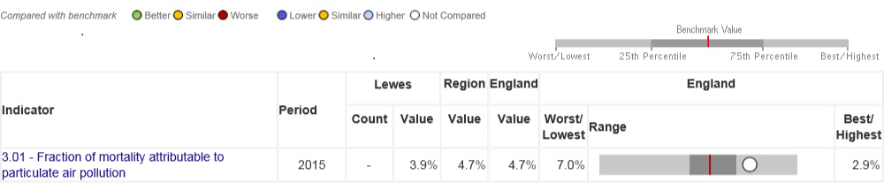

Figure 7 shows that the mortality calculated for Lewes District is less than that calculated for south east England (4.7 %) and England (4.7 %) as a whole.

Lewes District Council is developing its approach to address PM2.5 in partnership with public health local authority officers. The automatic analysers in the Lewes District Council area do not measure PM2.5

# Air Quality Monitoring Data and Comparison with Air Quality Objectives and National Compliance

## Summary of Monitoring Undertaken

### Automatic Monitoring Sites

This section sets out what monitoring has taken place and how it compares with objectives.

Lewes District Council undertook automatic (continuous) monitoring at two sites during 2016 (West Street, Lewes Town Centre (LS5) and Denton Community Centre (LS6)). Table A.1 in Appendix A shows the details of each site. NB. Local authorities do not have to report annually on the following pollutants: 1,3 butadiene, benzene, carbon monoxide and lead, unless local circumstances indicate there is a problem. National monitoring results are available at <http://www.sussex-air.net/> Sulphur dioxide is not monitored as there have been no significant changes to potential sources for many years.

Maps showing the location of the monitoring sites are provided in Appendix D. Further details on how the monitors are calibrated and how the data has been adjusted are included in Appendix C.

Figure 8 shows the annual average NO2 concentrations measured at the automatic monitoring sites from 2012-2016. Both sites demonstrate levels well below the 40µg/m3 annual objective. It is recognised that the site at Denton Community Centre is measuring significantly below the annual objective concentration. The monitoring station was placed at this site in July 2013 specifically to monitor any potential emissions and their possible impact on background concentrations from the Newhaven Energy Recovery Facility on North Quay Road, Newhaven. However, concentrations of NO2 and PM10 at this site fall well below the air quality objective and the council would like to relocate this station (when necessary funding is available) from this site and move it within the AQMA Ring Road situated in Newhaven.

Figure 8: Annual average NO2 concentration in µg/m3 measured at automatic monitoring sites in the Lewes district 2012-2016

Nitrogen dioxide concentration µg/m3

### Non-Automatic Monitoring Sites

Lewes District council undertook non- automatic (passive) monitoring of NO2 at 40 sites during 2016. Table A.2 in Appendix A shows details of each of these sites.

Maps showing the location of the monitoring sites are provided in Appendix D. Further details on Quality Assurance/Quality Control (QA/QC) for the diffusion tubes, including bias adjustments and any other adjustments applied (e.g. “annualisation” and/or distance correction), are included in Appendix C.

## Individual Pollutants

The air quality monitoring results presented in this section are, where relevant, adjusted for bias, “annualisation” and distance correction. No annualisation was necessary for 2016 data. Further details on adjustments are provided in Appendix C.

### Nitrogen Dioxide (NO2)

Table A.3 in Appendix A compares the ratified and adjusted monitored NO2 annual mean concentrations for the past 5 years with the air quality objective of 40µg/m3.

For diffusion tubes, the full 2016 dataset of monthly mean values is provided in Appendix B.

Figures 9 -12 show trends in nitrogen dioxide measured by diffusion tube from 2012 to 2016. Each figure illustrates the concentration for groups of 10 sites with data readings.

Figure 9: Annual average NO2 concentration (diffusion tubes) in Lewes DC from 2012-2016: Sites 1-10

**Annual objective**

Figure 9 shows one site, LDC 16 Southway (situated within the A259 Ring Road, Newhaven AQMA), which has levels above the 40µg/m3 annual objective and has done for the last 4 years. However, as per Table C.1 in Appendix C, when the figure is corrected after measured distance from the receptor, the concentration drops to 35.5µg/m3. LDC-18 Fisher Street has shown reductions in concentrations over 5 years, and this is most likely due to the change in priority at the end of this road which was a measure on the Lewes AQAP.

Figure 10: Annual average NO2 concentration (diffusion tubes) in Lewes DC from 2012-2016: Sites 11-20

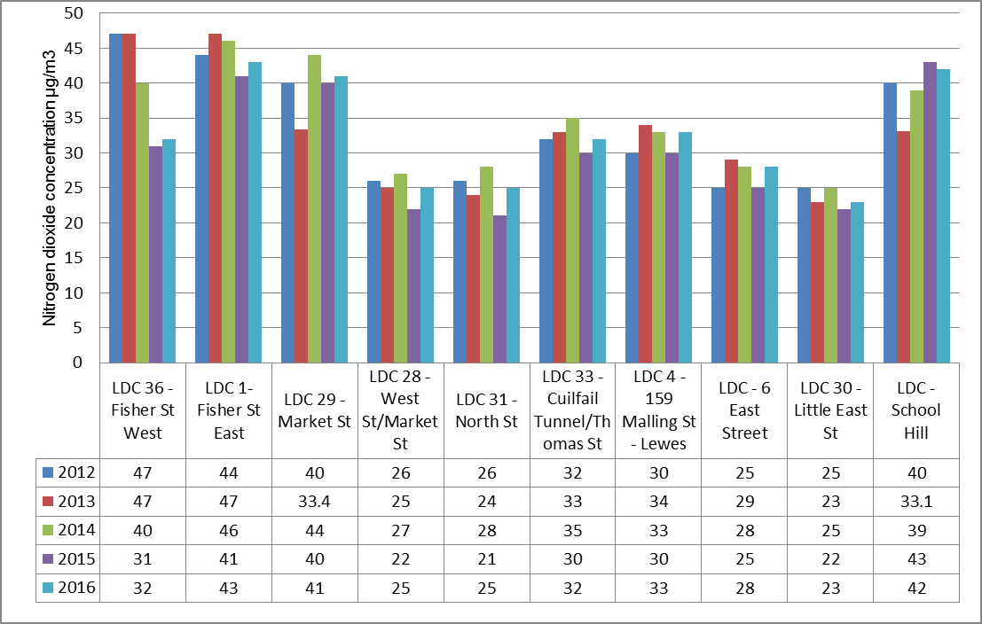

**Annual objective**

Three sites measured above the annual objective however two sites (LDC 1 and School Hill) have not been corrected for distance as deemed they are not near to a relevant receptor (e.g. permanent dwelling). However, the LDC School Hill site may possibly have a ‘receptor’ shortly as the building nearest it is currently undergoing development. LDC 1 Fisher Street East has shown concentrations over 40µg/m3 for the last 5 years but has demonstrated lower levels since the highest reading in 2013. The other site (LDC 29 – Market Street) has been corrected (see Table C.1, Appendix C) and the concentration falls below the annual objective to 28.1µg/m3.

Figure 11: Annual average NO2 concentration (diffusion tubes) in Lewes DC from 2012-2016: Sites 21-30

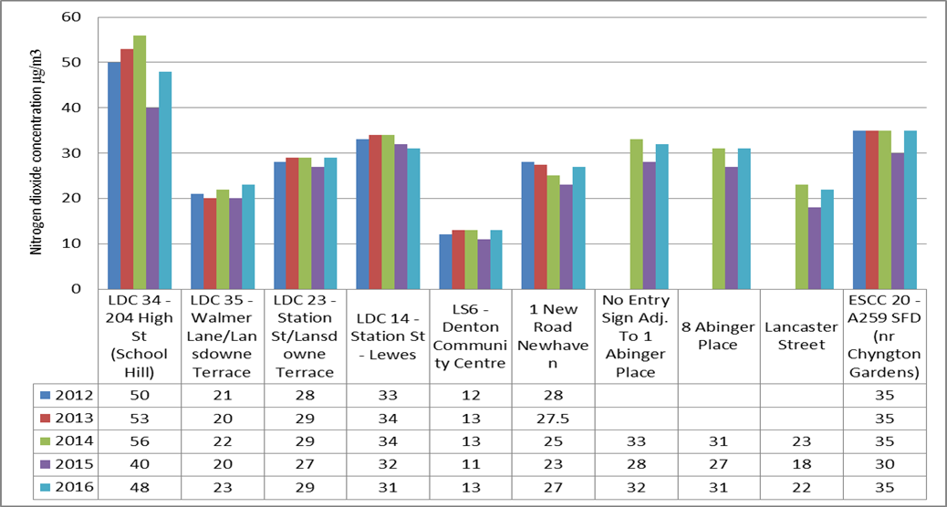

**Annual Objective**

Noticeable one site – LDC 34 – 204 High Str (School Hill) demonstrates NO2 concentrations for the last 5 years above 40 µg/m3. This site sits just outside the Lewes Town Centre AQMA. Due to this fact, it was deemed unnecessary to extend the AQMA boundary to include it, as any actions that we take to reduce NO2 concentrations would encompass this road.

Even with distance correction to the nearest receptor (see Table C.1, Appendix C) this site only just falls below 40µg/m3 at a figure of 39.9µg/m3. This part of School Hill is steep and therefore greater engine load is required, particularly with hill starts. It is a busy main road frequented by buses and lorries/delivery vans.

Figure 12: Annual average NO2 concentration (diffusion tubes) in Lewes DC from 2012-2016: Sites 31-40

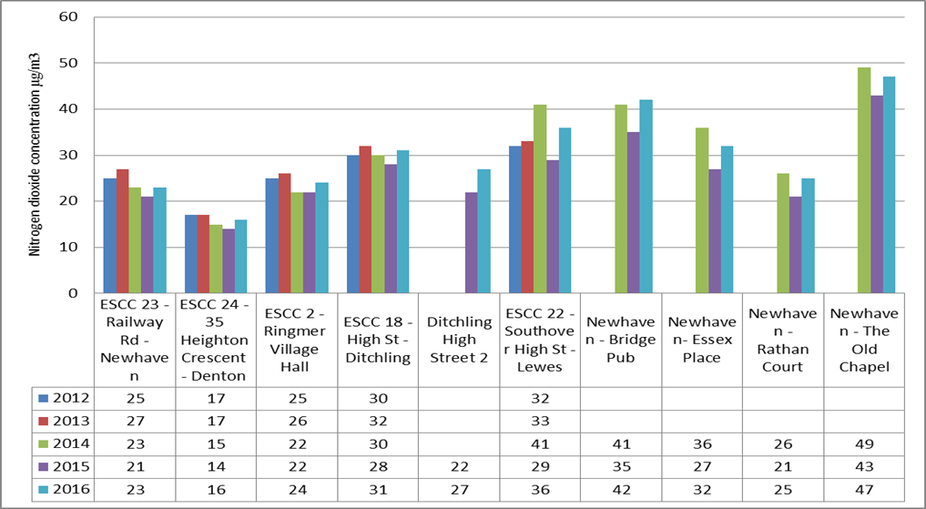

**Annual Objective**

Two sites illustrate concentrations over 40µg/m3 Newhaven Bridge Pub (not near a relevant receptor) and The Old Chapel. This has shown levels over the annual objective for the last 3 years, however on distance correction, levels drop below the objective. In this case, to 31.1µg/m3. This site is also on a hill near a pedestrian crossing therefore the loading of engines is greater. Both of these sites sit within the A259 Ring Road AQMA in Newhaven.

For diffusion tubes, the full 2016 dataset of monthly mean values is provided in Appendix B. A few things to note during the year: Fisher Street, mid-June - end of August would have received a greatly reduced number of vehicles (as did Station Street) due to a major sewer burst which closed Station Street during this period. A drop in NO2 concentrations can be seen at these locations during these months. Fisher Street West LDC 36 was encompassed in scaffolding from February 2016 and into 2017, so there may be potential under-reading for this tube site. There were also a few incidents of missing tubes.

Table A.4 in Appendix A compares the ratified continuous monitored NO2 hourly mean concentrations for the past 5 years with the air quality objective of 200µg/m3, not to be exceeded more than 18 times per year. There have been no exceedances of the hourly objective of 200µg/m3 since monitoring began at these sites.

### Particulate Matter (PM10)

Table A.5 in Appendix A compares the ratified and adjusted monitored PM10 annual mean concentrations for the past 5 years with the air quality objective of 40µg/m3.

Figure 13: Annual average PM10 concentration measured at LS5 LewesTown West Street and LS6 Denton Community Centre (Automatic Monitoring sites) 2012-2016

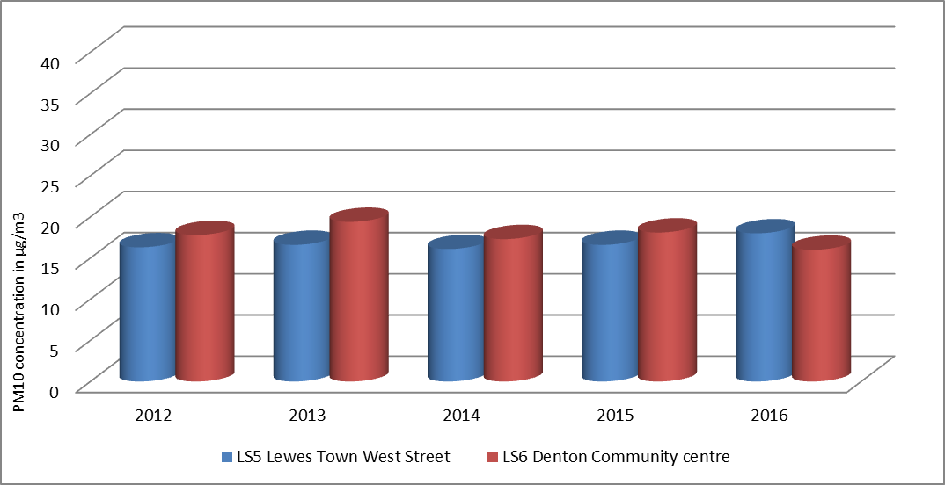

Annual Objective = 40µg/m3

NB: Newhaven background site moved from Denton School to Denton Community Centre mid-way through 2013. The daily mean PM10 concentrations for Denton School (Jan 2013-Jun 2013) were combined with daily mean PM10 concentrations for Denton Community College (Jul 2013-Dec 2013) to calculate the annual average

Figure 13 demonstrates that PM10 annual mean concentrations have remained well below the annual objective of 40µg/m3. LS5 Lewes Town West Street station sits within the Lewes Town AQMA.

Table A.6 in Appendix A compares the ratified continuous monitored PM10 24-hour mean objective (50µg/m3 not to be exceeded more than 35 times/year) concentrations for the past 5 years. Figure 14 shows that the number of daily exceedances are significantly lower than the 35 exceedances that would cause exceedance of the daily objective for PM10

Figure 14: Number of exceedances of the 50µg/m3 daily average at LS5 LewesTown West Street and LS6 Denton Community Centre (Automatic Monitoring sites) 2012-2016

### 

Number of exceedances that would cause exceedance of daily objective

# Appendix A: Monitoring Results

Table A. – Details of Automatic Monitoring Sites

|  |  |  |  |  |  |  |  |  |  |  |
| --- | --- | --- | --- | --- | --- | --- | --- | --- | --- | --- |
| **Site ID** | **Site Name** | **Site Type** | **X OS Grid Ref** | **Y OS Grid Ref** | **Pollutants Monitored** | **In AQMA?** | **Monitoring Technique** | **Distance to Relevant Exposure (m) (1)** | **Distance to kerb of nearest road (m) (2)** | **Inlet Height (m)** |
| LS5 | Lewes Town West Street | Roadside | 541541 | 110246 | NO2 PM10 | Y | Chemiluminescence  TEOM | 2m | Yes | 2 |
| LS6 | Denton Community Centre Newhaven | Urban background | 545209 | 102582 | NO2 PM10  Ozone | N | Chemiluminescence  TEOM | N/A | Yes | 3 |

**Notes:**

(1) 0m if the monitoring site is at a location of exposure (e.g. installed on the façade of a residential property).

(2) N/A if not applicable.

Table A. – Details of Non-Automatic Monitoring Sites

|  |  |  |  |  |  |  |  |  |  |  |
| --- | --- | --- | --- | --- | --- | --- | --- | --- | --- | --- |
| **Site ID** | **Site Name** | **Site Type** | **X OS Grid Ref** | **Y OS Grid Ref** | **Pollutants Monitored** | **In AQMA?** | **Distance to Relevant Exposure (m) (1)** | **Distance to kerb of nearest road (m) (2)** | **Tube collocated with a Continuous Analyser?** | **Height (m)** |
| 1 | LDC 12 - Valley Close - Newhaven | Background | 543933 | 101585 | NO2 | N | Y(10m) | SB | No | 2.5 |
| 2 | LDC 10 - 9 Southway – Newhaven | Roadside | 544354 | 101388 | NO2 | Y | Y(5m) | K (1) | No | 2.5 |
| 3 | LDC - 16 Southway – Newhaven | Roadside | 544414 | 101273 | NO2 | Y | Y(5m) | K(1) | No | 2.5 |
| 4 | LDC 11 - Lewes Rd – Newhaven | Roadside | 544273 | 101532 | NO2 | N | Y(5m) | K (2) | No | 3 |
| 5 | LDC 7 - Willow Estate, Avis Way – Newhaven | Roadside | 544981 | 101934 | NO2 | N | N | K (1) | No | 3 |
| 6 | LDC 8 - 8 Bay Vue Rd - Newhaven | Background | 544521 | 101089 | NO2 | N | Y(3m) | SB | No | 2.5 |
| 7 | LDC 25 - Westgate Chapel | Roadside | 541285 | 109969 | NO2 | N | Y(5m) | K (1) | No | 1.8 |
| 8 | LDC 26 - Mount Pleasant/Sun Street | Roadside | 541481 | 110277 | NO2 | Y | Y(1m) | R (2) | No | 2.5 |

|  |  |  |  |  |  |  |  |  |  |  |
| --- | --- | --- | --- | --- | --- | --- | --- | --- | --- | --- |
| **Site ID** | **Site Name** | **Site Type** | **X OS Grid Ref** | **Y OS Grid Ref** | **Pollutants Monitored** | **In AQMA?** | **Distance to Relevant Exposure (m) (1)** | **Distance to kerb of nearest road (m) (2)** | **Tube collocated with a Continuous Analyser?** | **Height (m)** |
| 9 | LDC 27 - West St Police Station | Roadside | 541541 | 110246 | NO2 | Y | Y(2m) | R (2) | Yes | 1.8 |
| 10 | LDC 18 - Fisher Street | Roadside | 541505 | 110236 | NO2 | Y | Y(1m) | K (1) | No | 2.5 |
| 11 | LDC 36 - Fisher St West | Roadside | 541519 | 110167 | NO2 | Y | N | K (1) | No | 3 |
| 12 | LDC 1- Fisher St East | Roadside | 541540 | 110130 | NO2 | Y | N | K (1) | No | 3.5 |
| 13 | LDC 29 - Market St | Roadside | 541598 | 110169 | NO2 | Y | Y(5m) | K (0.5) | No | 2.5 |
| 14 | LDC 28 - West St/Market St | Roadside | 541611 | 110235 | NO2 | Y | Y(5m) | K (1) | No | 2.5 |
| 15 | LDC 31 - North St | Roadside | 541646 | 110370 | NO2 | N | Y(5m) | K (1) | No | 3 |
| 16 | LDC 33 - Cuilfail Tunnel/Thomas St | Roadside | 542178 | 110454 | NO2 | N | Y (1m) | R (5) | No | 3 |
| 17 | LDC 4 - 159 Malling St – Lewes | Roadside | 542315 | 110733 | NO2 | N | Y(5m) | K (1) | No | 3.5 |
| 18 | LDC 6 East Street | Roadside | 541669 | 110278 | NO2 | N | Y (0m) | K (1) | No | 3 |
| 19 | LDC 30 - Little East St | Roadside | 541726 | 110335 | NO2 | N | Y (1m) | R(2) | No | 1.8 |
| 20 | LDC - School Hill | Roadside | 541755 | 110206 | NO2 | N | N | K(1) | No | 2.5 |
| 21 | LDC 34 - 204 High St (School Hill) | Roadside | 541684 | 110181 | NO2 | N | Y(3m) | R (2) | No | 3 |

|  |  |  |  |  |  |  |  |  |  |  |
| --- | --- | --- | --- | --- | --- | --- | --- | --- | --- | --- |
| **Site ID** | **Site Name** | **Site Type** | **X OS Grid Ref** | **Y OS Grid Ref** | **Pollutants Monitored** | **In AQMA?** | **Distance to Relevant Exposure (m) (1)** | **Distance to kerb of nearest road (m) (2)** | **Tube collocated with a Continuous Analyser?** | **Height (m)** |
| 22 | LDC 35 - Walmer Lane/Lansdowne Terrace | Roadside | 541709 | 109990 | NO2 | N | Y(2m) | R (1.5) | No | 3 |
| 23 | LDC 23 - Station St/Lansdowne Terrace | Roadside | 541615 | 109968 | NO2 | Y | N | R (2) | No | 3 |
| 24 | LDC 14 - Station St - Lewes | Roadside | 541603 | 110001 | NO2 | Y | N | R (1.5) | No | 3 |
| 25 | LS6 - Denton Community Centre | Urban background | 545142 | 102433 | NO2 | N | Y (50m) | SB | Yes | 3 |
| 26 | 1 New Road Newhaven | Roadside | 544703 | 102400 | NO2 | N | Y(10m) | R (1.5) | No | 1.8 |
| 27 | No Entry Sign Adj. To 1 Abinger Place | Roadside | 541438 | 110293 | NO2 | N | Y (4m) | R (1.5) | No | 2 |
| 28 | 8 Abinger Place | Roadside | 541430 | 110328 | NO2 | N | Y (1.2) | R (1.5) | No | 2.5 |
| 29 | Lancaster Street | Roadside | 541485 | 110386 | NO2 | N | Y (1.5) | R (1) | No | 4 |
| 30 | ESCC 20 - A259 SFD (nr Chyngton Gardens) | Roadside | 550077 | 99291 | NO2 | N | Y(10m) | R (1.5) | No | 3 |
| 31 | ESCC 23 - Railway Rd - Newhaven | Roadside | 544996 | 101264 | NO2 | N | Y(5m) | K (1) | No | 3 |

|  |  |  |  |  |  |  |  |  |  |  |
| --- | --- | --- | --- | --- | --- | --- | --- | --- | --- | --- |
| **Site ID** | **Site Name** | **Site Type** | **X OS Grid Ref** | **Y OS Grid Ref** | **Pollutants Monitored** | **In AQMA?** | **Distance to Relevant Exposure (m) (1)** | **Distance to kerb of nearest road (m) (2)** | **Tube collocated with a Continuous Analyser?** | **Height (m)** |
| 32 | ESCC 24 - 35 Heighton Crescent - Denton | Background | 544908 | 102704 | NO2 | N | Y(10m) | SB | No | 1.8 |
| 33 | ESSCC 2 - Ringmer Village Hall | Roadside | 544681 | 112441 | NO2 | N | N | R (1.8) | No | 2 |
| 34 | ESCC 18 - High St - Ditchling | Roadside | 532605 | 115203 | NO2 | N | Y(5m) | R (2) | No | 2.5 |
| 35 | Ditchling High Street 2 | Roadside | 532587 | 115410 | NO2 | N | Y (1m) | K (1) | No | 1.8 |
| 36 | ESCC 22 - Southover High St - Lewes | Roadside | 541032 | 109613 | NO2 | N | Y (1m) | K (1) | No | 3 |
| 37 | Newhaven - Bridge Pub | kerbside | 544603 | 101485 | NO2 | Y | N | K (0.5) | No | 2 |
| 38 | Newhaven- Essex Place | Roadside | 544497 | 101499 | NO2 | Y | Y (5m) | R (1.2) | No | 2 |
| 39 | Newhaven - Rathan Court | Roadside | 544330 | 101423 | NO2 | Y | Y (10) | R (1.5) | No | 2 |
| 40 | Newhaven - The Old Chapel | Roadside | 544497 | 101285 | NO2 | Y | Y (10) ) | R (1.5) | No | 2.5 |

**Notes:**

(1) 0m if the monitoring site is at a location of exposure (e.g. installed on/adjacent to the façade of a residential property).

(2) N/A if not applicable.

Table A. – Annual Mean NO2 Monitoring Results over the last 5 years

|  |  |  |  |  |  |  |  |  |  |
| --- | --- | --- | --- | --- | --- | --- | --- | --- | --- |
| **Site ID** | **Site Type** | **Monitoring Type** | **Valid Data Capture for Monitoring Period (%) (1)** | **Valid Data Capture 2016 (%) (2)** | **NO2 Annual Mean Concentration (µg/m3) (3)** | | | | |
| **2012** | **2013** | **2014** | **2015** | **2016** |
| LS5 Lewes Town West Street | Roadside | Automatic | 94 | 94 | 21 | 19 | 19 | 23 | 24 |
| LS6 Denton Community Centre | Urban background | Automatic | 94 | 94 |  | 124 | 12 | 10 | 11 |
| LDC 12 - Valley Close - Newhaven | Background | DT | 100 | 100 | 15 | 14 | 12 | 11 | 14 |
| LDC 10 - 9 Southway - Newhaven | Roadside | DT | 100 | 100 | 35 | 40.8(33.6) | 41 | 33 | 36 |
| LDC - 16 Southway - Newhaven | Roadside | DT | 100 | 100 | 39 | 49 | 47 | 42 | **49** |
| LDC 11 - Lewes Rd - Newhaven | Roadside | DT | 83 | 83 | 29 | 31.0* | 33 | 28 | 31 |
| LDC 7 - Willow Estate, Avis Way - Newhaven | Roadside | DT | 100 | 100 | 21 | 21 | 20 | 19 | 22 |
| LDC 8 - 8 Bay Vue Rd - Newhaven | Background | DT | 100 | 100 | 17 | 24 | 18 | 15 | 18 |
| LDC 25 - Westgate Chapel | Roadside | DT | 92 | 92 | 32 | 38 | 38 | 30 | 33 |

|  |  |  |  |  |  |  |  |  |  |
| --- | --- | --- | --- | --- | --- | --- | --- | --- | --- |
| **Site ID** | **Site Type** | **Monitoring Type** | **Valid Data Capture for Monitoring Period (%) (1)** | **Valid Data Capture 2016 (%) (2)** | **NO2 Annual Mean Concentration (µg/m3) (3)** | | | | |
| **2012** | **2013** | **2014** | **2015** | **2016** |
| LDC 26 - Mount Pleasant/Sun Street | Roadside | DT | 83 | 83 | 24 | 24 | 27 | 23 | 24 |
| LDC 27 - West St Police Station | Roadside | DT | 100 | 100 | 28 | 23 | 25 | 22 | 23 |
| LDC - 18 Fisher Street | Roadside | DT | 100 | 100 | 28 | 27 | 26 | 22 | 25 |
| LDC 36 - Fisher St West | Roadside | DT | 92 | 92 | 47 | 47 | 40 | 31 | 32 |
| LDC 1- Fisher St East | Roadside | DT | 92 | 92 | 44 | 47 | 46 | 41 | **43** |
| LDC 29 - Market St | Roadside | DT | 100 | 100 | 40 | 43.6(33.4) | 44 | 40 | **41** |
| LDC 28 - West St/Market St | Roadside | DT | 100 | 100 | 26 | 25 | 27 | 22 | 25 |
| LDC 31 - North St | Roadside | DT | 100 | 100 | 26 | 24 | 28 | 21 | 25 |
| LDC 33 - Cuilfail Tunnel/Thomas St | Roadside | DT | 100 | 100 | 32 | 33 | 35 | 30 | 32 |
| LDC 4 - 159 Malling St - Lewes | Roadside | DT | 92 | 92 | 30 | 34 | 33 | 30 | 33 |
| LDC 6 - East Street | Roadside | DT | 92 | 92 | 25 | 29 | 28 | 25 | 28 |
| LDC 30 - Little East St | Roadside | DT | 100 | 100 | 25 | 23 | 25 | 22 | 23 |

|  |  |  |  |  |  |  |  |  |  |
| --- | --- | --- | --- | --- | --- | --- | --- | --- | --- |
| **Site ID** | **Site Type** | **Monitoring Type** | **Valid Data Capture for Monitoring Period (%) (1)** | **Valid Data Capture 2016 (%) (2)** | **NO2 Annual Mean Concentration (µg/m3) (3)** | | | | |
| **2012** | **2013** | **2014** | **2015** | **2016** |
| LDC - School Hill | Roadside | DT | 100 | 100 | 40 | 41.2(33.1) | 39 | 43 | **42** |
| LDC 34 - 204 High St (School Hill) | Roadside | DT | 100 | 100 | 50 | 53 | 56 | 40 | **48** |
| LDC 35 - Walmer Lane/Lansdowne Terrace | Roadside | DT | 100 | 100 | 21 | 20 | 22 | 20 | 23 |
| LDC 23 - Station St/Lansdowne Terrace | Roadside | DT | 100 | 100 | 28 | 29 | 29 | 27 | 29 |
| LDC 14 - Station St - Lewes | Roadside | DT | 92 | 92 | 33 | 34 | 34 | 32 | 31 |
| LS6 - Denton Community Centre | Urban background | DT | 92 | 92 | 12 | 13 | 13 | 11 | 13 |
| 1 New Road Newhaven | Roadside | DT | 100 | 100 | 28 | 29.6(27.5 Annualised) | 25 | 23 | 27 |
| No Entry Sign Adj. To 1 Abinger Place | Roadside | DT | 100 | 100 |  |  | 33 | 28 | 32 |
| 8 Abinger Place | Roadside | DT | 100 | 100 |  |  | 31 | 27 | 31 |
| Lancaster Street | Roadside | DT | 100 | 100 |  |  | 23 | 18 | 22 |

|  |  |  |  |  |  |  |  |  |  |
| --- | --- | --- | --- | --- | --- | --- | --- | --- | --- |
| **Site ID** | **Site Type** | **Monitoring Type** | **Valid Data Capture for Monitoring Period (%) (1)** | **Valid Data Capture 2016 (%) (2)** | **NO2 Annual Mean Concentration (µg/m3) (3)** | | | | |
| **2012** | **2013** | **2014** | **2015** | **2016** |
| ESCC 20 - A259 SFD (nr Chyngton Gardens) | Roadside | DT | 100 | 100 | 35 | 35 | 35 | 30 | 35 |
| ESCC 23 - Railway Rd - Newhaven | Roadside | DT | 100 | 100 | 25 | 27 | 23 | 21 | 23 |
| ESCC 24 - 35 Heighton Crescent - Denton | Background | DT | 100 | 100 | 17 | 17 | 15 | 14 | 16 |
| ESCC 2 - Ringmer Village Hall | Roadside | DT | 100 | 100 | 25 | 26 | 22 | 22 | 24 |
| ESCC 18 - High St - Ditchling | Roadside | DT | 100 | 100 | 30 | 32 | 30 | 28 | 31 |
| Ditchling High Street 2 | Roadside | DT | 100 | 100 |  |  |  | 22 | 27 |
| ESCC 22 - Southover High St - Lewes | Roadside | DT | 92 | 92 | 32 | 33 | 41 | 29 | 36 |
| Newhaven - Bridge Pub | kerbside | DT | 100 | 100 |  |  | 41 | 35 | **42** |
| Newhaven- Essex Place | Roadside | DT | 100 | 100 |  |  | 36 | 27 | 32 |
| Newhaven - Rathan Court | Roadside | DT | 83 | 83 |  |  | 26 | 21 | 25 |
| Newhaven - The Old Chapel | Roadside | DT | 100 | 100 |  |  | 49 | 43 | **47** |

**Diffusion tube data has been bias corrected**

**Annualisation has been conducted where data capture is <75%**

**If applicable, all data has been distance corrected for relevant exposure – See Appendix C Table C.1 for those sites where distance from nearest receptor has been calculated where applicable**

**Notes:**

Exceedances of the NO2 annual mean objective of 40µg/m3 are shown in **bold**.

NO2 annual means exceeding 60µg/m3, indicating a potential exceedance of the NO2 1-hour mean objective are shown in **bold and underlined.**

(1) Data capture for the monitoring period, in cases where monitoring was only carried out for part of the year.

(2) Data capture for the full calendar year (e.g. if monitoring was carried out for 6 months, the maximum data capture for the full calendar year is 50%).

(3) Means for diffusion tubes have been corrected for bias. All means have been “annualised” as per Boxes 7.9 and 7.10 in LAQM.TG16 if valid data capture for the full calendar year is less than 75%. See Appendix C for details.

(4) Concentration for Denton Community Centre is the annualised value obtained from the 2014 Progress report.

**All automatic monitoring data for both sites – LS5 and LS6 has been ratified**

Table A. – 1-Hour Mean NO2 Monitoring Results over the last 5 years

|  |  |  |  |  |  |  |  |  |  |
| --- | --- | --- | --- | --- | --- | --- | --- | --- | --- |
| **Site ID** | **Site Type** | **Monitoring Type** | **Valid Data Capture for Monitoring Period (%) (1)** | **Valid Data Capture 2016 (%) (2)** | **NO2 1-Hour Means > 200µg/m3 (3)** | | | | |
| **2012** | **2013** | **2014** | **2015** | **2016** |
| LS5 Lewes Town West Street | Roadside | Automatic | 94 | 94 | 0 | 0 | 0 | 0 | 0 |
| LS6 Denton Community Centre | Urban Background | Automatic | 94 | 94 | 0 | 0 | 0 | 0 | 0 |

**Notes:**

Exceedances of the NO2 1-hour mean objective (200µg/m3 not to be exceeded more than 18 times/year) are shown in **bold.**

(1) Data capture for the monitoring period, in cases where monitoring was only carried out for part of the year.

(2) Data capture for the full calendar year (e.g. if monitoring was carried out for 6 months, the maximum data capture for the full calendar year is 50%).

(3) If the period of valid data is less than 85%, the 99.8th percentile of 1-hour means is provided in brackets.

**All automatic monitoring data for both sites – LS5 and LS6 has been ratified**

Table A. – Annual Mean PM10 Monitoring Results over the last 5 years

|  |  |  |  |  |  |  |  |  |
| --- | --- | --- | --- | --- | --- | --- | --- | --- |
| **Site ID** | **Site Type** | **Valid Data Capture for Monitoring Period (%) (1)** | **Valid Data Capture 2016 (%) (2)** | **PM10 Annual Mean Concentration (µg/m3) (3)** | | | | |
| **2012** | **2013** | **2014** | **2015** | **2016** |
| Lewes Town West Street | Roadside | 94 | 94 | 16.3  (88 %) | 16.6  (93 %) | 16.1  (84 %) | 16.6  (73 %) | 18  (94%) |
| Denton School until June 2013 then Denton Community Centre from July 2013 | Background | 98 | 98 | 17.8  (88 %) | 19.4(4)  (85 %) | 17.3(5)  (80 %) | 18.1(5)  (98%) | 16  (98%) |

**Annualisation has been conducted where data capture is <75% - N/A for 2016**

**Notes:**

Exceedances of the PM10 annual mean objective of 40µg/m3 are shown in **bold.**

(1) Data capture for the monitoring period, in cases where monitoring was only carried out for part of the year.

(2) Data capture for the full calendar year (e.g. if monitoring was carried out for 6 months, the maximum data capture for the full calendar year is 50%).

(3) All means have been “annualised” as per Boxes 7.9 and 7.10 in LAQM.TG16, valid data capture for the full calendar year is less than 75%. See Appendix C for details.

(4) 2013 concentrations for Denton School and Denton Community Centre combined to generate the 2013 average

(5) PM10 data downloaded from the Sussex Air Website were provisional for 2014 and 2015

**All automatic monitoring data for both sites – LS5 and LS6 has been ratified**

Table A. – 24-Hour Mean PM10 Monitoring Results for the last 5 years

|  |  |  |  |  |  |  |  |  |
| --- | --- | --- | --- | --- | --- | --- | --- | --- |
| **Site ID** | **Site Type** | **Valid Data Capture for Monitoring Period (%) (1)** | **Valid Data Capture 2016 (%) (2)** | **PM10 24-Hour Means > 50µg/m3 (3)** | | | | |
| **2012** | **2013** | **2014** | **2015** | **2016** |
| LS5 Lewes Town West Street | Roadside | 94 | 94 | 1 | 0 | 1 | 1 | 2 |
| LS6 Denton Community centre | Urban Background | 98 | 98 | 4 | 1 | 5(4) | 1(4) | 1 |

**Notes:**

Exceedances of the PM10 24-hour mean objective (50µg/m3 not to be exceeded more than 35 times/year) are shown in **bold.**

(1) Data capture for the monitoring period, in cases where monitoring was only carried out for part of the year.

(2) Data capture for the full calendar year (e.g. if monitoring was carried out for 6 months, the maximum data capture for the full calendar year is 50%).

(3) If the period of valid data is less than 85%, the 90.4th percentile of 24-hour means is provided in brackets.

(4) PM10 data downloaded from the Sussex-air website (2nd November 2016) were provisional for 2014 & 2015

**All automatic monitoring data for both sites – LS5 and LS6 has been ratified**

# Appendix B: Full Monthly Diffusion Tube Results for 2016

Table B. – NO2 Monthly Diffusion Tube Results - 2016

|  |  |  |  |  |  |  |  |  |  |  |  |  |  |  |  |
| --- | --- | --- | --- | --- | --- | --- | --- | --- | --- | --- | --- | --- | --- | --- | --- |
| **Site ID** | **NO2 Mean Concentrations (µg/m3)** | | | | | | | | | | | | | | |
| **Jan** | **Feb** | **Mar** | **Apr** | **May** | **Jun** | **Jul** | **Aug** | **Sep** | **Oct** | **Nov** | **Dec** | **Annual Mean** | | |
| **Raw Data** | **Bias Adjusted (0.94) and Annualised (1)** | **Distance Corrected to Nearest Exposure (2)** |
| LDC 12 - Valley Close - Newhaven | 13.56 | 17.82 | 13.62 | 14.84 | 12.63 | 12.15 | 9.85 | 9.37 | 19.55 | 10.37 | 18.80 | 22.96 | 14.6 | 13.7 |  |
| LDC 10 - 9 Southway - Newhaven | 34.19 | 40.29 | 32.69 | 40.85 | 38.55 | 34.9 | 27.12 | 30.97 | 39.41 | 43.79 | 37.28 | 59.23 | 38.3 | 36.0 |  |
| LDC - 16 Southway - Newhaven | 65.12 | 55.55 | 38.28 | 52.46 | 56.19 | 42.55 | 37.59 | 42.82 | 66.32 | 60.04 | 56.17 | 55.70 | **52.4** | **49.3** | 35.5* |
| LDC 11 - Lewes Rd - Newhaven | 39.68 | 33.73 | 29.02 | 34.24 |  | 29.13 | 28.27 | 28.96 | 36.7 | 35.78 | 38.16 |  | 33.4 | 31.4 |  |
| LDC 7 - Willow Estate, Avis Way - Newhaven | 26.89 | 25.80 | 21.47 | 22.57 | 18.15 | 18.18 | 19.39 | 18.21* | 21.03 | 25.48 | 25.25 | 30.30 | 23.1 | 21.7 |  |
| LDC 8 - 8 Bay Vue Rd - Newhaven | 16.46 | 21.58 | 19.98 | 18.17 | 17.71 | 18.36 | 13.89 | 13.31 | 18.95 | 20.43 | 24.81 | 28.25 | 19.3 | 18.2 |  |
| LDC 25 - Westgate Chapel | 39.02 |  | 31.55 | 33.39 | 34.95 | 30.94 | 28.34 | 29.37 | 32.23 | 41.17 | 41.61 | 41.03 | 34.9 | 32.8 |  |

|  |  |  |  |  |  |  |  |  |  |  |  |  |  |  |  |
| --- | --- | --- | --- | --- | --- | --- | --- | --- | --- | --- | --- | --- | --- | --- | --- |
| **Site ID** | **NO2 Mean Concentrations (µg/m3)** | | | | | | | | | | | | | | |
| **Jan** | **Feb** | **Mar** | **Apr** | **May** | **Jun** | **Jul** | **Aug** | **Sep** | **Oct** | **Nov** | **Dec** | **Annual Mean** | | |
| **Raw Data** | **Bias Adjusted (0.94) and Annualised (1)** | **Distance Corrected to Nearest Exposure (2)** |
| LDC 26 - Mount Pleasant/Sun Street |  |  | 24.16 | 24.07* | 22.14 | 20.58 | 21.87 | 22.72 | 25.83 | 26.46 | 31.05 | 33.97 | 25.4 | 23.9 |  |
| LDC 27 - West St Police Station | 30.83 | 26.54 | 22.67 | 24.07 | 20.76 | 18.76 | 18.23 | 19.20 | 22.82 | 24.61 | 28.58 | 32.31 | 24.1 | 22.7 |  |
| LDC - 18 Fisher Street | 31.56 | 27.82 | 25.59 | 27.71 | 23.79 | 22.46 | 17.83 | 21.08 | 27.72 | 27.28 | 34.16 | 36.00 | 26.9 | 25.3 |  |
| LDC 36 - Fisher St West |  | 36.53 | 31.71 | 40.7 | 36.58 | 30.74 | 17.86 | 25.46 | 40.35 | 39.38 | 39.01 | 36.25 | 34.1 | 32.0 |  |
| LDC 1- Fisher St East |  | 48.76 | 43.40 | 51.9 | 46.31 | 40.19 | 28.44 | 32.15 | 43.95 | 52.77 | 56.53 | 52.44 | **45.2** | **42.5** |  |
| LDC 29 - Market St | 53.77 | 43.88 | 36.44 | 42.94 | 42.55 | 39.21 | 44.22 | 43.78 | 42.10 | 39.29 | 45.73 | 46.27 | **43.3** | **40.7** | 28.1* |
| LDC 28 - West St/Market St | 29.92 | 29.90 | 25.12 | 25.46** | 23.38 | 21.48 | 19.76 | 21.09 | 29.37 | 29.72 | 30.13 | 36.53 | 26.9 | 25.3 |  |
| LDC 31 - North St | 27.89 | 27.78 | 21.00 | 24.79 | 21.58 | 26.85 | 20.78 | 21.54 | 29.56 | 28.61* | 30.21 | 34.90 | 26.1 | 24.5 |  |
| LDC 33 - Cuilfail Tunnel/Thomas St | 39.66 | 37.22 | 28.40 | 31.1 | 30.65 | 29.72 | 29.15 | 31.44 | 36.09 | 35.55 | 40.60 | 39.82 | 34.1 | 32.1 |  |
| LDC 4 - 159 Malling St - Lewes | 23.40 | 40.36 | 34.11 | 36.33 |  | 34.07 | 28.01 | 31.02 | 36.44 | 35.77 | 39.85 | 42.58 | 34.7 | 32.6 |  |
| LDC 6 - East Street | 30.28 | 34.76 |  | 30.02 | 28.38 | 28.05 | 23.35 | 24.89 | 27.24 | 31.21 | 36.61 | 36.96 | 30.2 | 28.3 |  |

|  |  |  |  |  |  |  |  |  |  |  |  |  |  |  |  |
| --- | --- | --- | --- | --- | --- | --- | --- | --- | --- | --- | --- | --- | --- | --- | --- |
| **Site ID** | **NO2 Mean Concentrations (µg/m3)** | | | | | | | | | | | | | | |
| **Jan** | **Feb** | **Mar** | **Apr** | **May** | **Jun** | **Jul** | **Aug** | **Sep** | **Oct** | **Nov** | **Dec** | **Annual Mean** | | |
| **Raw Data** | **Bias Adjusted (0.94) and Annualised (1)** | **Distance Corrected to Nearest Exposure (2)** |
| LDC 30 - Little East St | 25.29 | 26.81 | 21.23 | 23.99 | 21.55 | 19.8 | 22.48 | 20.36 | 28.33 | 25.35 | 25.65 | 36.92 | 24.8 | 23.3 |  |
| LDC - School Hill | 48.21 | 47.06 | 38.16 | 49.82 | 41.06 | 40.95 | 35.95 | 38.69 | 47.33 | 48.76 | 41.79 | 52.37 | **44.2** | **41.5** |  |
| LDC 34 - 204 High St (School Hill) | 58.51 | 53.24 | 42.29 | 51.93 | 43.21 | 49.79 | 47.86 | 48.07 | 63.58 | 47.51 | 50.34 | 54.06 | **50.9** | **47.8** | 39.9* |
| LDC 35 - Walmer Lane/Lansdowne Terrace | 28.45 | 29.05 | 21.52 | 22.44 | 22.69 | 20.04 | 19.25 | 19.27 | 20.90 | 25.82 | 29.04 | 29.07 | 24.0 | 22.5 |  |
| LDC 23 - Station St/Lansdowne Terrace | 37.40 | 33.33 | 27.65 | 31.79 | 24.57 | 26.68 | 24.86 | 26.13 | 31.65 | 30.50 | 35.98 | 36.85 | 30.6 | 28.8 |  |
| LDC 14 - Station St - Lewes | 45.23 | 37.47 | 30.67 | 34.26 | 33.44 | 29.19 | 19.01 | 23.08 | Tube missing, replaced later that day | 27.70 | 42.71 | 44.50 | 33.4 | 31.4 |  |
| LS6 - Denton Community Centre | 14.71 | 14.74 | 12.13 | 11.07 | 9.38 | 10.77 | 11.58 |  | 15.40 | 13.87 | 15.21 | 22.3 | 13.7 | 12.9 |  |
| 1 New Road Newhaven | 28.09 | 29.72 | 27.42 | 30.19 | 26.79 | 19.34 | 23.98* | 22.88 | 31.71 | 29.24 | 32.69 | 37.58 | 28.7 | 27.0 |  |
| No Entry Sign Adj. To 1 Abinger Place | 38.41 | 36.78 | 29.12 | 30.96 | 34.24 | 29.15 | 30.35 | 27.90 | 35.80 | 31.15 | 36.50 | 43.53 | 33.7 | 31.6 |  |

|  |  |  |  |  |  |  |  |  |  |  |  |  |  |  |  |
| --- | --- | --- | --- | --- | --- | --- | --- | --- | --- | --- | --- | --- | --- | --- | --- |
| **Site ID** | **NO2 Mean Concentrations (µg/m3)** | | | | | | | | | | | | | | |
| **Jan** | **Feb** | **Mar** | **Apr** | **May** | **Jun** | **Jul** | **Aug** | **Sep** | **Oct** | **Nov** | **Dec** | **Annual Mean** | | |
| **Raw Data** | **Bias Adjusted (0.94) and Annualised (1)** | **Distance Corrected to Nearest Exposure (2)** |
| 8 Abinger Place | 36.11 | 33.69 | 28.73 | 32.33 | 31.2 | 29.94 | 28.76 | 26.03 | 35.78 | 32.96 | 38.31 | 45.47 | 33.3 | 31.3 |  |
| Lancaster Street | 27.64 | 25.41 | 23.21 | 23.33 | 18.36 | 17.74 | 17.81 | 16.18 | 26.52 | 22.56 | 26.23 | 33.22 | 23.2 | 21.8 |  |
| ESCC 20 - A259 SFD (nr Chyngton Gardens) | 41.98 | 36.66 | 25.81 | 34.32 | 31.49 | 33.09 | 38.94 | 36.90 | 41.50 | 36.55 | 40.00 | 43.76 | 36.8 | 34.5 |  |
| ESCC 23 - Railway Rd - Newhaven | 26.15 | 28.08 | 23.04 | 22.32 | 21.61 | 20.02 | 21.53 | 20.24 | 26.47 | 24.60 | 28.75 | 32.89 | 24.6 | 23.2 |  |
| ESCC 24 - 35 Heighton Crescent - Denton | 20.01 | 19.25 | 17.18 | 15.84 | 14.32 | 14.78 | 16.38 | 15.03 | 18.92 | 15.32 | 18.50 | 24.18 | 17.5 | 16.4 |  |
| ESSCC 2 - Ringmer Village Hall | 28.10 | 26.81 | 25.35 | 23.47 | 22.32 | 21.06 | 22.72 | 20.87 | 27.16 | 27.03 | 29.87 | 33.75 | 25.7 | 24.2 |  |
| ESCC 18 - High St - Ditchling | 28.80 | 38.94 | 29.60 | 33.27 | 35.04 | 32.54 | 24.24 | 29.28 | 31.89 | 35.21 | 38.63 | 42.13 | 33.3 | 31.3 |  |
| Ditchling High Street 2 | 27.95 | 28.53 | 22.85 | 24.05 | 26.32 | 29.88 | 26.64 | 26.49 | 33.09 | 32.49** | 30.98 | 35.82 | 28.4 | 26.7 |  |
| ESCC 22 - Southover High St - Lewes | 35.74 | 39.06 | 32.95 | 37.16 | 35.84 | 37.4 | 30.43 | 38.36 | 39.98 | 39.25*** |  | 50.75 | 37.8 | 35.5 |  |

|  |  |  |  |  |  |  |  |  |  |  |  |  |  |  |  |
| --- | --- | --- | --- | --- | --- | --- | --- | --- | --- | --- | --- | --- | --- | --- | --- |
| **Site ID** | **NO2 Mean Concentrations (µg/m3)** | | | | | | | | | | | | | | |
| **Jan** | **Feb** | **Mar** | **Apr** | **May** | **Jun** | **Jul** | **Aug** | **Sep** | **Oct** | **Nov** | **Dec** | **Annual Mean** | | |
| **Raw Data** | **Bias Adjusted (0.94) and Annualised (1)** | **Distance Corrected to Nearest Exposure (2)** |
| Newhaven - Bridge Pub | 51.80 | 48.70 | 34.42 | 42.42 | 41.78 | 43.73 | 38.63 | 43.12 | 44.56 | 43.81 | 48.96 | 51.97 | **44.5** | **41.8** |  |
| Newhaven- Essex Place | 31.65 | 33.18 | 27.11 | 30.94 | 34.2 | 32.85 | 31.82 | 35.58 | 39.61 | 27.46 | 37.73 | 43.42 | 33.8 | 31.8 |  |
| Newhaven - Rathan Court | 29.91 | 30.31 | 26.09 | 28.93 | 30.67 | 24.09 | 19.38 | 24.82 | 30.01 | 26.17 |  |  | 27.0 | 25.4 |  |
| Newhaven - The Old Chapel | 56.80 | 51.28 | 45.55 | 42.96 | 45.72 | 49.98 | 51.67 | 48.29 | 52.90 | 44.42 | 58.73 | 56.89 | **50.4** | **47.4** | 31.1* |

**Local bias adjustment factor used**

**National bias adjustment factor used**

**Annualisation has been conducted where data capture is <75%**

**Notes:**

Exceedances of the NO2 annual mean objective of 40µg/m3 are shown in **bold**.

NO2 annual means exceeding 60µg/m3, indicating a potential exceedance of the NO2 1-hour mean objective are shown in **bold and underlined.**

(1) See Appendix C for details on bias adjustment and annualisation.

(2) Distance corrected to nearest relevant public exposure (e.g. dwelling).

*Please note that only diffusion tubes which exceeded the annual mean 40ug/m3 (bias adjusted figure) AND have a relevant receptor have been corrected as per note (2).

# Appendix C: Supporting Technical Information / Air Quality Monitoring Data QA/QC

**QC/QC of automatic monitoring**

The continuous monitoring stations in the Lewes District Council are managed by the Sussex Air Quality Partnership (<https://www.sussex-air.net>). All continuous monitoring activities are subject to the same quality assurance/quality control objectives set out in the AURN local site operator’s manual. These procedures are:

* Overnight 24 hour IZS calibration checks (NOx analyser);
* Fortnightly manual zero/span calibration using certified cylinders (carried out by Council employees fully trained in LSO duties);
* Full data analysis and ratification by the Environmental Research Group at King’s College London;

Six monthly service visits and site audits

**QA/QC of diffusion tube monitoring**

The Ambient, Indoor, Workplace Air and Stack Emissions Proficiency Testing Scheme (AIR PT) 7is an independent analytical proficiency-testing scheme, operated by LGC Standards and supported by the Health and Safety Laboratory (HSL). Defra and the Devolved Administrations advise that diffusion tubes used for LAQM should be obtained from laboratories that have demonstrated satisfactory performance in the AIR PT scheme. AIR NO2 PT forms an integral part of the UK NO2 Network’s QA/QC, and is a useful tool in assessing the analytical performance of those laboratories supplying diffusion tubes to Local Authorities for use in the context of Local Air Quality Management (LAQM). In 2016 Gradko participated in the AIR PT programme, and obtained a 100% rating for the whole year (AIR PT rounds AR012, AR013, AR015, AR016 and AR018). Further information can be found on this link:

<https://laqm.defra.gov.uk/assets/airptrounds7to18apr2015feb2017.pdf>

**National bias adjustment factor spreadsheet.**

The diffusion tubes are supplied and analysed by Gradko utilising the 20 % triethanolamine (TEA) in water preparation method. A bias adjustment of 0.94 for the year 2016 (based on 21 studies) has been derived from the national bias adjustment calculator. The spreadsheet is shown below in Figure 15:

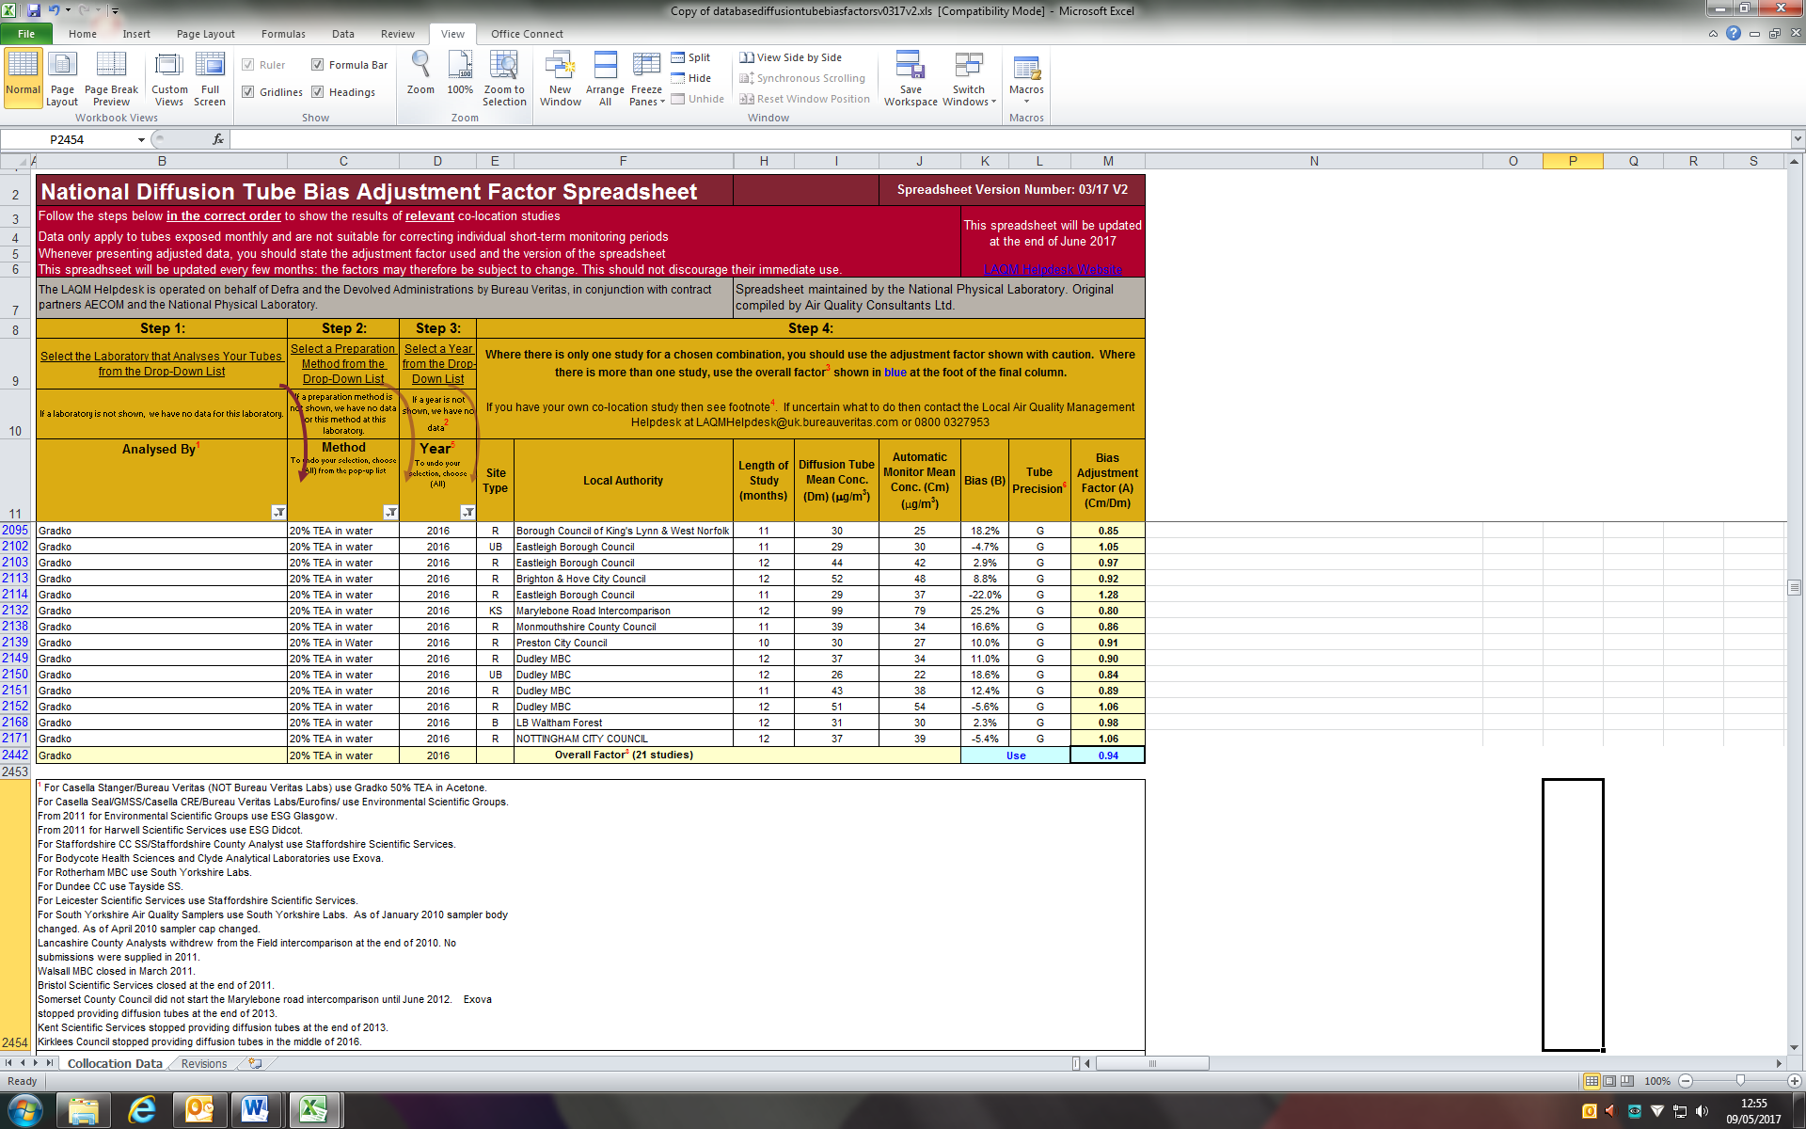

Spreadsheet can be downloaded from the link:

<http://laqm.defra.gov.uk/bias-adjustment-factors/national-bias.html>

Table C.1: Sites where the annual mean of 40µg/m3 for NO2has been exceeded and has been corrected for distance to receptor

|  |  |  |  |
| --- | --- | --- | --- |
| Site | Concentration before distance correction µg m‑3 | Concentration after distance correction, µg m‑3 | Screen capture for fall off with distance calculator. Background NO2 measured at Denton Community Centre in 2016 (11 µg m-3) |
| LDC 16 Southway Newhaven | 49.3 | 35.5 |  |
| LDC 29 - Market St | 40.7 | 28.1 |  |
| LDC 34 - 204 High St (School Hill) | 47.8 | 39.9 |  |
| Newhaven – The Old Chapel | 47.4 | 31.1 |  |

*Step 3 and 4* - The measurement and the background must be for the same year. The background concentration could come from the national maps published at [www.airquality.co.uk](http://www.airquality.co.uk) or alternatively from a nearby monitor in a background location (which was used in this case from LS6 Denton Community Centre).

*Result –*The results will have a greater uncertainty than the measured data. More confidence can be placed in results where the distance between the monitor and the receptor is small than where it is large.

# Appendix D: Map(s) of Monitoring Locations and AQMAs

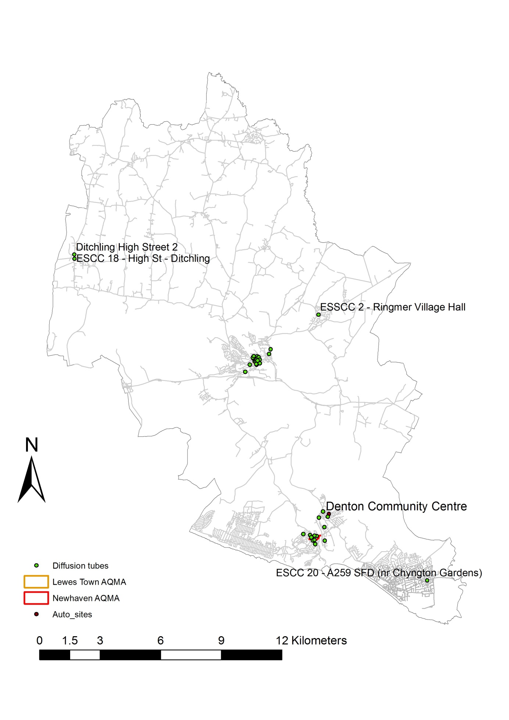

# Lewes

# newhaven

# Appendix E: Summary of Air Quality Objectives in England

Table E. – Air Quality Objectives in England

| **Pollutant** | **Air Quality Objective[5]** | |
| --- | --- | --- |
| **Concentration** | **Measured as** |
| Nitrogen Dioxide (NO2) | 200 µg/m3 not to be exceeded more than 18 times a year | 1-hour mean |
| 40 µg/m3 | Annual mean |
| Particulate Matter (PM10) | 50 µg/m3, not to be exceeded more than 35 times a year | 24-hour mean |
| 40 µg/m3 | Annual mean |
| Sulphur Dioxide (SO2) | 350 µg/m3, not to be exceeded more than 24 times a year | 1-hour mean |
| 125 µg/m3, not to be exceeded more than 3 times a year | 24-hour mean |
| 266 µg/m3, not to be exceeded more than 35 times a year | 15-minute mean |

# Glossary of Terms

|  |  |
| --- | --- |
| **Abbreviation** | **Description** |
| AQAP | Air Quality Action Plan - A detailed description of measures, outcomes, achievement dates and implementation methods, showing how the local authority intends to achieve air quality limit values’ |
| AQMA | Air Quality Management Area – An area where air pollutant concentrations exceed / are likely to exceed the relevant air quality objectives. AQMAs are declared for specific pollutants and objectives |
| ASR | Air quality Annual Status Report |
| Defra | Department for Environment, Food and Rural Affairs |
| DMRB | Design Manual for Roads and Bridges – Air quality screening tool produced by Highways England |
| EU | European Union |
| FDMS | Filter Dynamics Measurement System |
| LAQM | Local Air Quality Management |
| NO2 | Nitrogen Dioxide |
| NOx | Nitrogen Oxides |
| PM10 | Airborne particulate matter with an aerodynamic diameter of 10µm (micrometres or microns) or less |
| PM2.5 | Airborne particulate matter with an aerodynamic diameter of 2.5µm or less |
| QA/QC | Quality Assurance and Quality Control |
| SO2 | Sulphur Dioxide |
| … | … |

# References

1Environmental equity, air quality, socioeconomic status and respiratory health, 2010

2Air quality and social deprivation in the UK: an environmental inequalities analysis, 2006

3Defra. Abatement cost guidance for valuing changes in air quality, May 2013

4[http://laqm.defra.gov.uk/documents/NO 2withDistancefromRoadsCalculatorIssue 4.xls](http://laqm.defra.gov.uk/documents/NO%202withDistancefromRoadsCalculatorIssue%204.xls)

5Lewes District Local Plan, Part 1 Joint Core Strategy 2010-2030 (May 2016)

6ESCC Local Transport Plan – Implementation Plan 2016/17-2020-21 and Local Transport Plan 3 2011-2026

7Ambient, Indoor, Workplace Air and Stack Emissions Proficiency Testing Scheme (AIR PT)

1. Environmental equity, air quality, socioeconomic status and respiratory health, 2010
2. Air quality and social deprivation in the UK: an environmental inequalities analysis, 2006
3. Defra. Abatement cost guidance for valuing changes in air quality, May 2013
4. [http://laqm.defra.gov.uk/documents/NO 2withDistancefromRoadsCalculatorIssue 4.xls](http://laqm.defra.gov.uk/documents/NO%202withDistancefromRoadsCalculatorIssue%204.xls)
5. The units are in microgrammes of pollutant per cubic metre of air (µg/m3).